Hot news from P2/1!!!

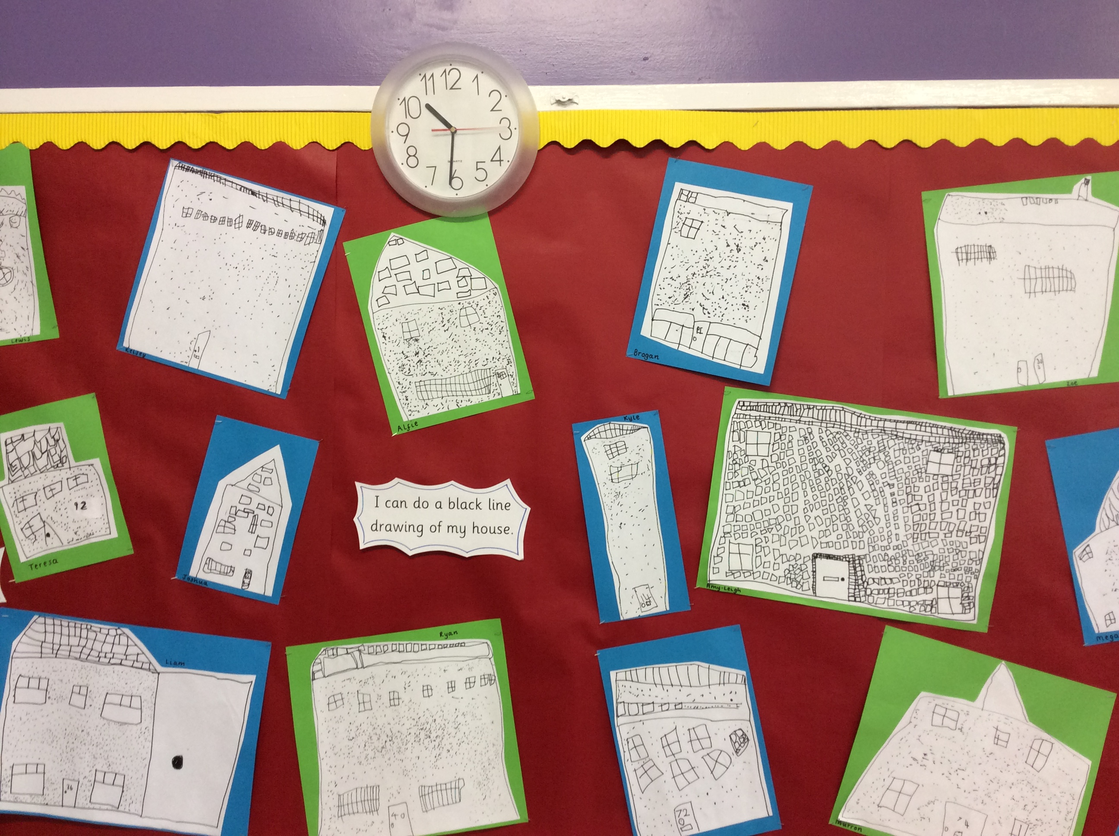
P2/1 Class Assembly

Do you want to know what we have been learning in class? Would you like to see us in action?
Yes!! Of course you would! Come along to our class assembly if you can make it. Its on Friday 5th June 9.15am
We are looking forward to sharing our learning.
TOPIC
Our new topic is ‘Houses and Homes’. We will be learning about different types of houses in our local community. We have teamed up with Al Taqwa Kindergarten in Abu Dhabi to learn about their local community with our new buddies.
P2/1 news reporters have the following to report on the subject of ‘achievements’:
‘I can remember the 3 jobs for a take away sum’ Kelsey
‘I can do take away sums in my head’ Alfie
‘I can be the leader of a group during a challenge.’ Brihanna
‘I can listen to instructions.’ Teresa
‘I can count in 10’s’ ’ Jamie
‘I can remember number stories to 11’ Kyle
‘I can add 10 and 2 to make 12.’ Joshua

P2/1 helpful reminders!!
- Homework will be given out every Monday and due back for a Thursday, however your child must bring their homework bag back into school every day with their reading book inside to allow for class reading activities. Please only complete pages of maths and reading workbook that is asked.
- Please NAME all items of clothing to avoid mix up with others, we have had several lost items of clothing.
- 18th May – Victoria Holiday
- 13th June – Blackburn Gala Day
- 16th June - Sports day

Watch out for our next edition of Newsflash for hot off the press news in P2/1!!!

