P2 Newsletter, MAY 2015

**Dates for your diary:**

* 18.05.15- Victoria Day HOLIDAY
* 05.06.15- BLACKBURN’S GOT TALENT
* 07.06.15- Gala Day races and Street Fair
* 13.06.15- GALA DAY
* 16.06.15- Sports Afternoon
* 17.06.15- Summer Outing
* 23.06.15- Meet the Teacher
* 26.06.15- Church Service, TERM ENDS

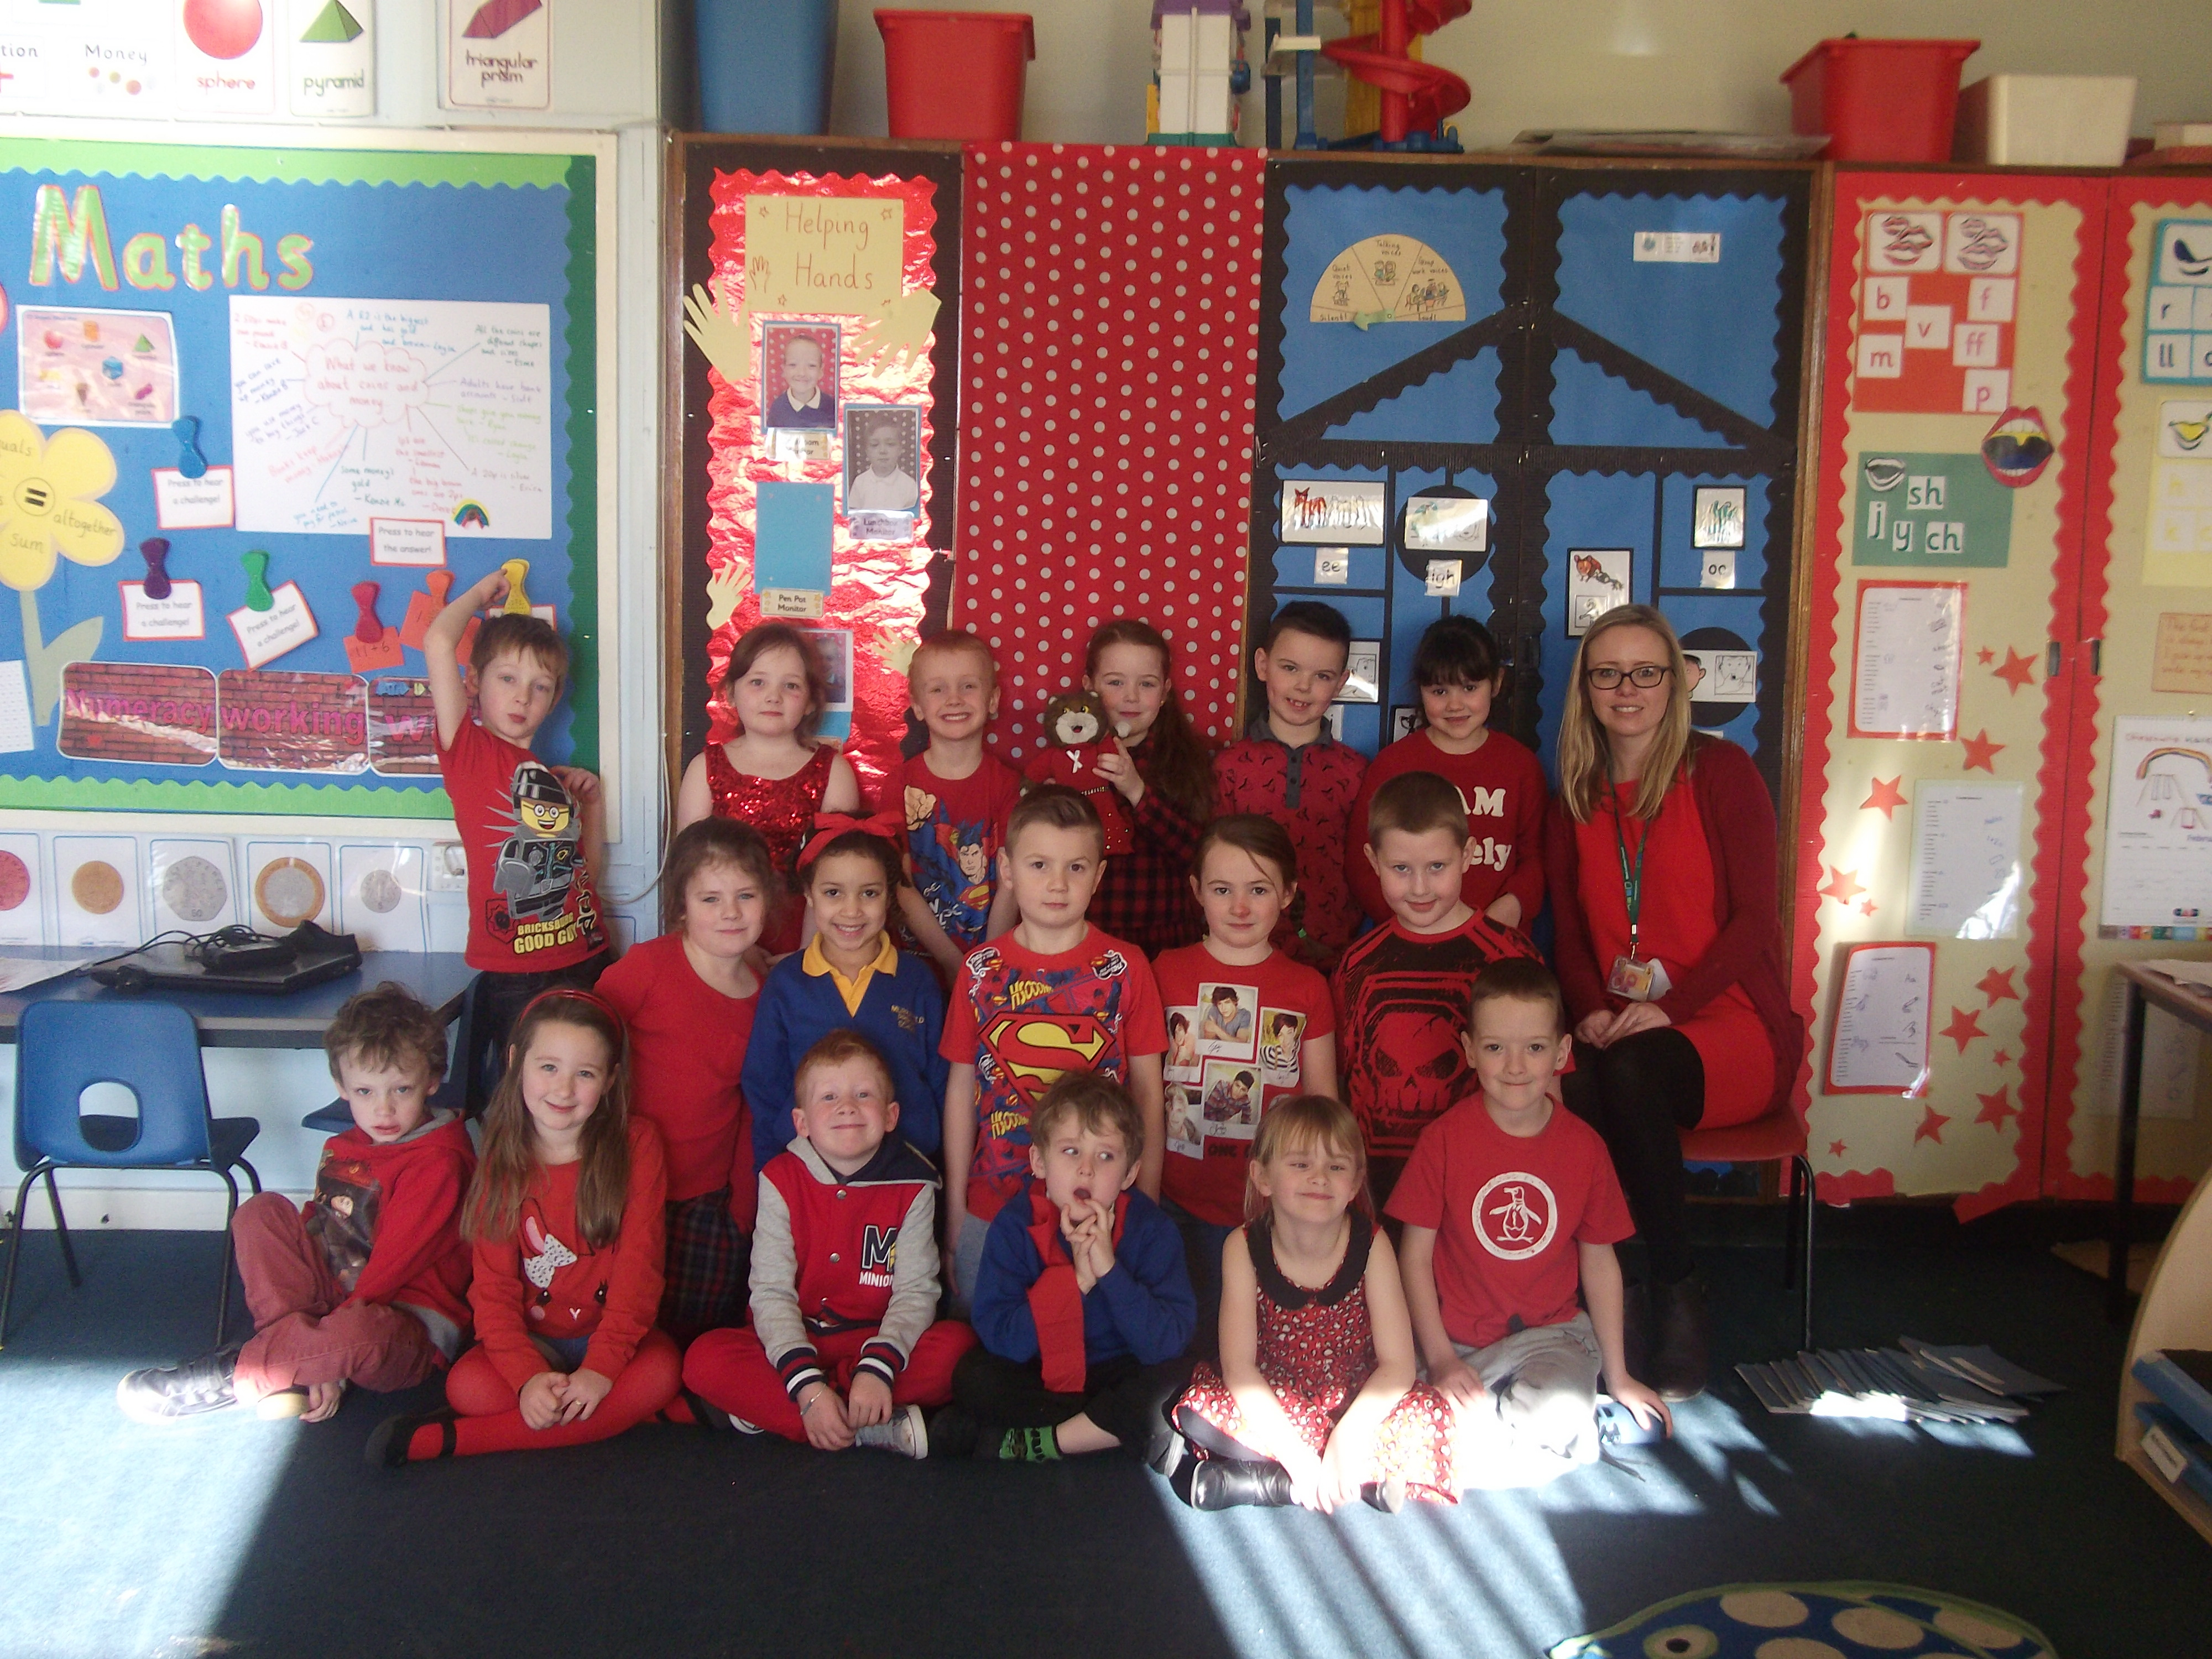

Dear Parents,

P2 have had a wonderful term learning all about Castles! We were very proud of our Castles assembly where we were able to showcase our learning! We are now experts on castle features and life within medieval castles!

This term we will be focusing on Houses and Homes as our interdisciplinary topic theme. We are looking forward to exploring the houses and homes in our local environment as well as comparing them with those within different environment. We are looking forward to another fun and exciting term!

Many thanks,

Miss Keay and P2

**Maths and Numeracy**

This term in Maths we will continue to develop our subtraction skills through the use of active games, ICT work and written activities.

P2 will be continuing to learn about money, we love role-play shop games!

We will also be introducing Time as an additional Maths topic.

**Writing**  C:\Documents and Settings\trudi.anderson\Local Settings\Temporary Internet Files\Content.IE5\76HH278B\MC900234134[1].wmf

There will be lots of opportunities for functional writing this term. We plan to write to a friend in Edinburgh to find out if her home is different to the homes here in Blackburn. We will also be creating travel agent adverts for houses.

PE C:\Documents and Settings\trudi.anderson\Local Settings\Temporary Internet Files\Content.IE5\ZDVSINT8\MC900310832[1].wmf

This term the children will be developing the skills necessary to play Rounders with Mrs Logan on a Wednesday. During our Monday classes we will be focusing on Athletics.

**Homework**

Please support your child to continue to complete quality homework activities, ensuring worksheets are named and dated.

**Outdoor Learning**

This term P2 hope to make the most of the summer weather! We have lots of outdoor learning opportunities planned. Where ever possible we hope to be able to take all aspects of the curriculum outdoors!

Please ensure that your child has a water bottle with them in school for hot days.