**Primary 1F May 2015 Newsletter**

Primary 1F have been working hard since returning back to school for the final term! We had lots of fun last term learning about castles and how people lived in the past. Our trip to Linlithgow Palace was very exciting. We received a fantastic tour and were able to link our learning from the classroom to the trip. Everyone had a great day even though it was very cold!

Dates for your diary

May holiday Mon 18th May

All resume Tuesday 19th May

Parent council meeting 3rd June

Sports afternoon 16th June

Last day of term – Fri 26th June

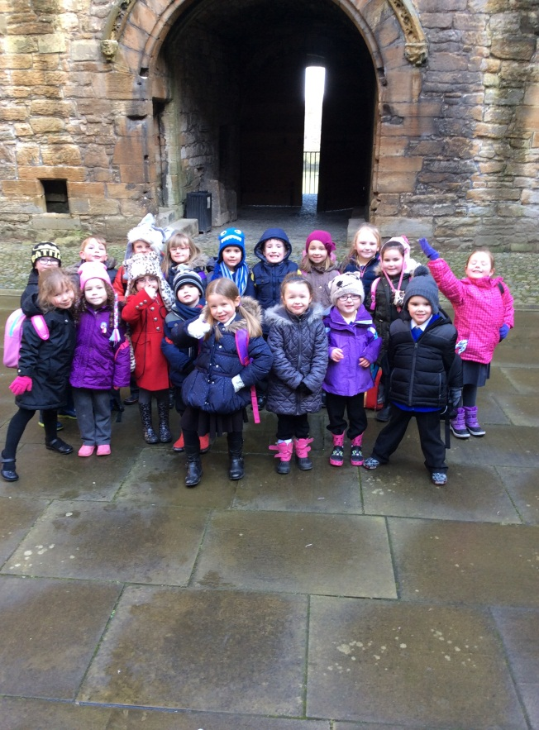

**What we will be learning…**

Numeracy and maths: This term in numeracy we will be learning about subtraction to 10 and numbers to 20. We are currently learning how to make amounts to 10p. We have enjoyed using games and role play to learn how to add money and give change.

Literacy: We are continuing to practice our reading skills and beginning to read with fluency. We will continue to explore fiction and non-fiction books. Our focus within writing this term will be function writing which will include learning how to write instructions and letters.

Class topic: Our class topic this term is going to be ‘Houses and Homes’. We will be learning about people and places in society through exploring the houses in our local town. We will learn about different kinds of houses, why we need a house and work in teams to build a junk model house of our own!

**Homework**Home work is issued on a Monday and returned on a Thursday. It is expected your child will practice their reading book and key words regularly at home.

**P1F gym days are Tues and Thurs.**