Congratulations!

As part of our literacy learning we created poems themed on “Out of this World” and the children produced good acrostic and kenning poems on astronauts. These poems were submitted to the young writers’ competition and some children’s poems were chosen to be included in the organizers book of poems. Well done Hannah, Aiden C, Brodie, Amyleigh, Logan R, Naomi, Ryan, Charlotte, Summer, Rachel, Ben, Juris and Aiden McC.



Science Masterclass

Our school wide science masterclasses were enjoyed by all the children. There was a wide range of science topics available for the children to choose form that explored various science topics. All topics allowed the children to experiment and research.

During our literacy work we created acrostic and kenning poems themed on space and astronauts. Therefore during this term we are going to build on this by looking at the solar system.

Law & Order

During our topic of Law & Order the children have looked at how laws are made, who makes the laws and who keeps order. We have now created our own country, Amazingland! We have even designed a flag for our new country. The children will now be creating the laws for their country, electing a government and deciding on who will maintain order. So exciting times ahead for Amazingland!

Getting Active!

The children were lucky to have a specialist visit weekly last term to show them the skills involved in Futsal. This allowed the children to practice teamwork and control skills. We are also scheduled to have Rugby tasters this term so we will be able to continue our active theme!

Burns Assembly

This term got off to a good start with our Burns assembly. P5 performed Burn’s poem Tam O’Shanter and did an excellent drama of this famous poem .

### Murrayfield Primary School

Blackburn, West Lothian

Newsletter May 2015

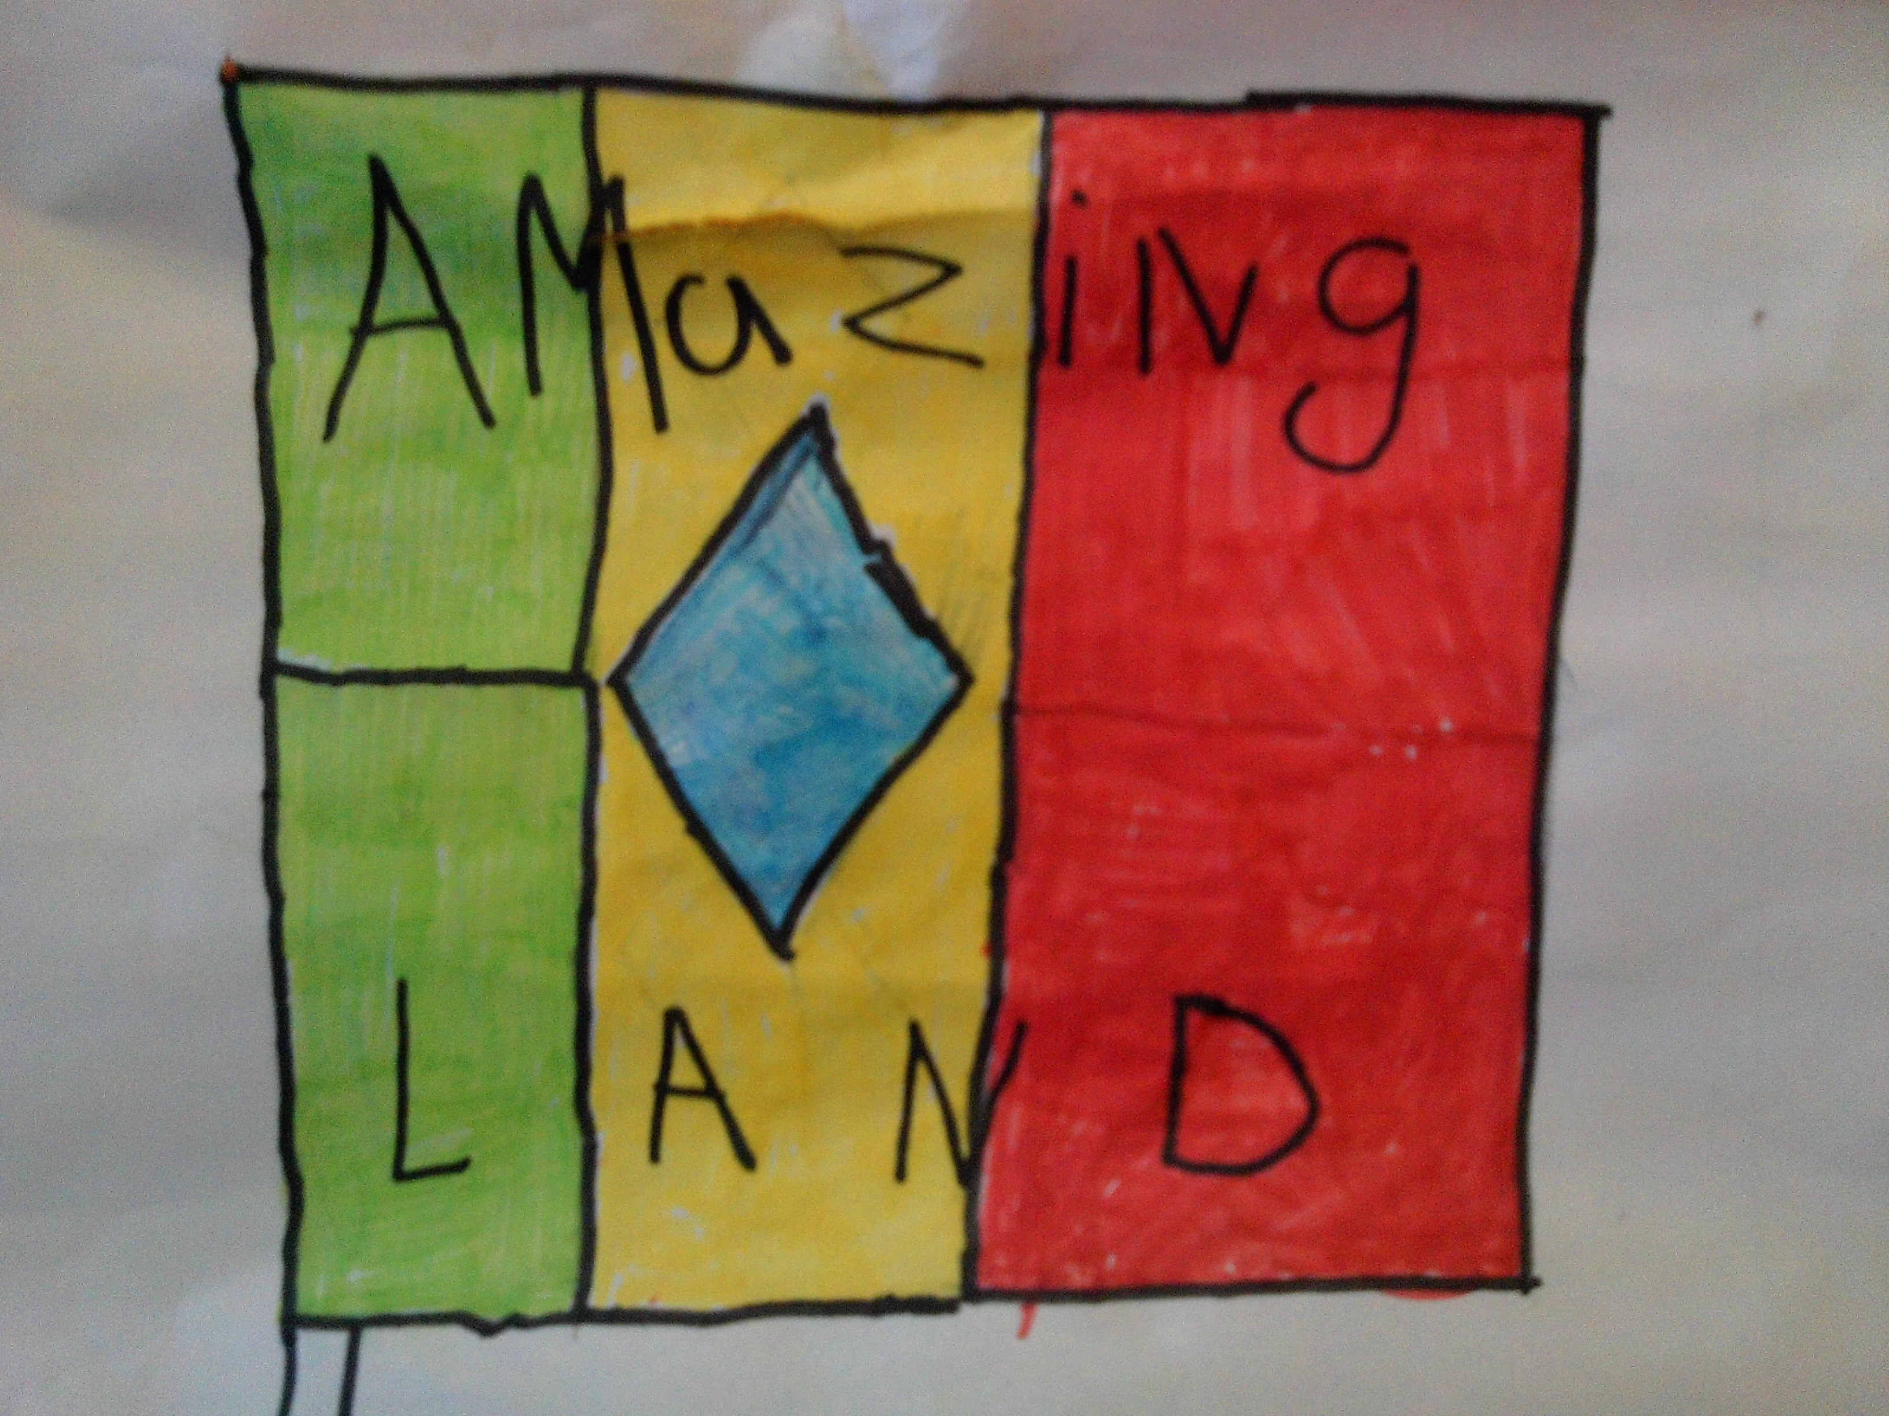

Mrs McGlynn and P5

Classroom Newsletter



Summer is coming!

w and Order.opic based on people in society and will explore both concepts of LAW tre. This was a fanttastic