Burns Assembly

The children are currently working hard on presenting their Burns Assembly on 23rd January. This will be a joint assembly with all three stages of P3, P4 and P5 performing songs and poems of Robert Burns.

Law and Order

P5’s next topic will be Law and Order. This is our topic based on people in society and will explore both concepts of Law and Order.

Homework

Homework will continue to be given out at the beginning of the week. It should be returned when specified, check the instructions. Homework is important as it allows your child to practice skills learned in the classroom and promotes independent learning, please encourage your child to complete homework on time.

Gym days have changed to Monday and Thursday, please ensure your child has a P.E. kit in school. Please also check regularly with your child that their gym shoes still fit and are safe to wear.

P5 Assembly

We finished off our topic of the Scottish Wars of Independence with a great assembly to show everything that we had learned about this interesting topic. This assembly also showed our learning on the 2014 Scottish Referendum debate. The children even held their own debate and voted on this subject. Our final event for this topic was a trip to the Battle of Bannockburn visitors centre. This was a fantastic interactive experience that provided the children with a fuller understanding of the topic.

Christmas party!

A great time was had by all! Our joint party with P4 & P5/4 went well with lots of dancing and games.

### Murrayfield Primary School

Blackburn, West Lothian

Newsletter January 2015

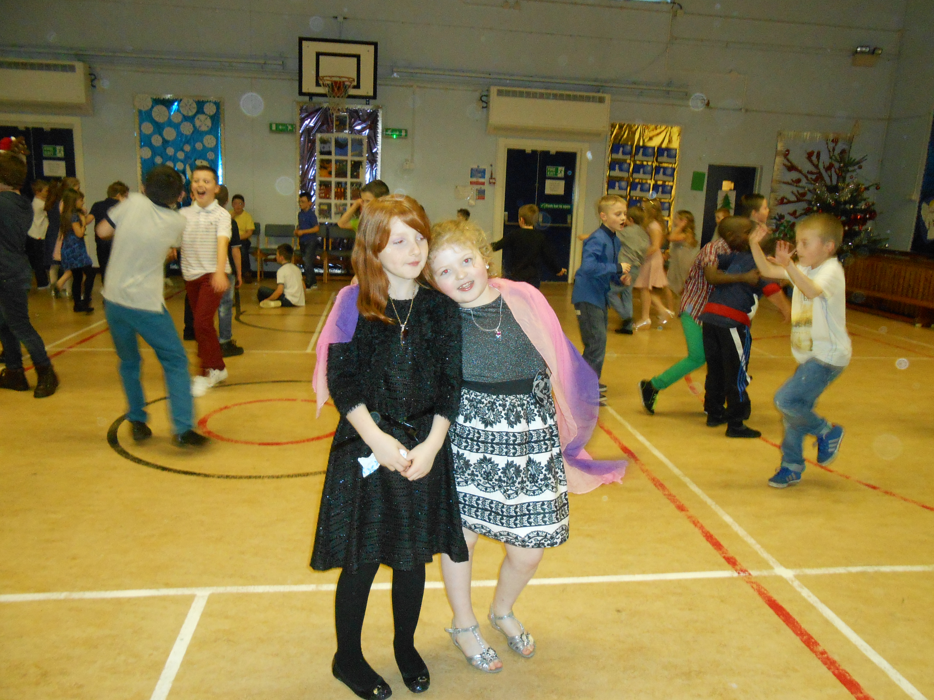

Mrs McGlynn and P5

Classroom Newsletter



Happy

New Year!w and Order.opic based on people in society and will explore both concepts of LAW tre. This was a fanttastic