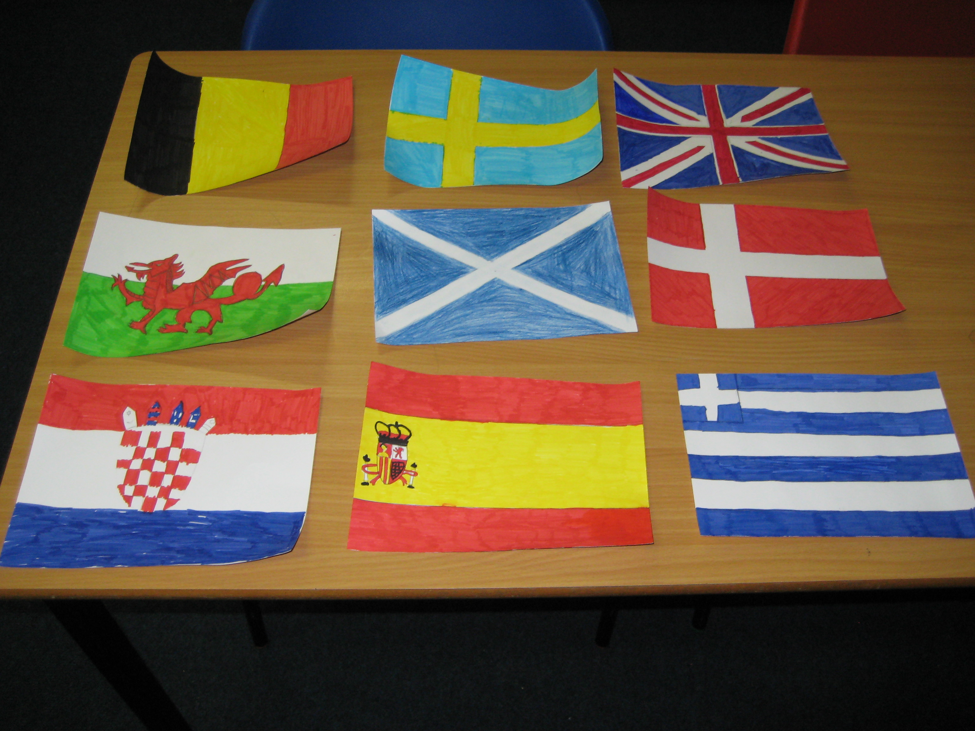
p6 class Newsletter
P6 TOPIC:
EUROPE!!
Dear Parents and Carers,
Happy New Year to everyone and hope you had a wonderful Christmas ☺
It has been chilly start to the year but the p6 children have had plenty of work to keep them occupied so far. It is going to be a very busy term for p6 but the children are looking forward to the challenges ahead of them.
We have just scratched the surface of our class topic of Europe and have decided the things we would like to learn. The children will be taught mapping skills, the countries and the capitals of Europe, flag work and even have a little tasting session of European food. These are just some of the highlights of the topic-there will be plenty of other things to keep them busy.
The children will also have the opportunity to take part in Champions in Schools this term. This is a role model programme, where they are led by a high performing athlete through three inspirational workshops. These workshops demonstrate the merits of working hard, overcoming setbacks and achieving personal goals. This is an excellent opportunity for p6 and I myself can’t wait to be a part of this wonderful workshop.

Homework:
Over last term homework was completed to a good standard in p6. Most children handed their homework in on time as well but it would be nice to up this from good to excellent this term.
Reading and Spelling homework will be handed out every Monday and must be handed in on a Thursday. Children must complete a chosen reading and spelling task and must complete this to an achievable standard. Reading will be heard on a Monday and a Wednesday.
Numeracy homework will be handed out on a Tuesday to be completed for Thursday
Reminder:
P.E for p6 will be on a Monday, Tuesday and Wednesday so please make sure your child has a suitable P.E kit.

Newsletter Date January 2015

Happy New year!

Dates for your Diary
- Wednesday 4th feb-p6/7 Ceilidh
- Friday 13h feb-Mon16th Feb Holiday!
- Wednesday 11th March-Masterclass
- Monday 16th March-British Science week
- Friday 20th March-P6 Assembly
- Thursday 26th March-Parents Evening
- Friday 3rd April-Easter Break
Fabby European Flags drawn by some p6 pupils

