Murrayfield Primary School

**Primary 7 Newsletter**

January 2015

Science & Technology 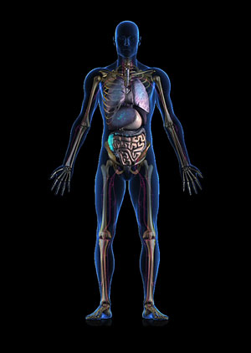

In Science we will explore the body, investigate the cardiovascular system and research how the brain works. Through the use of ICT we will develop our use of media to create animated clips to share our experiences. Finally, we will be working hard to host a Science Curriculum Event to share our learning experiences. More details will follow very soon!

Maths and Numeracy C:\Documents and Settings\trudi.anderson\Local Settings\Temporary Internet Files\Content.IE5\0RU00CMN\MC900332680[1].wmf

We will be revising multiplication and division and are looking forward to working on fractions and percentages. Topic Maths this term will be developing our knowledge of co-ordinates and angles.

Literacy C:\Documents and Settings\trudi.anderson\Local Settings\Temporary Internet Files\Content.IE5\76HH278B\MC900234134[1].wmf

We will be exploring a variety of genre this term, currently we are focusing on our use of literacy techniques to engage our readers in preparation for an imaginative writing piece. In addition to this we will look at functional writing like news reports and information leaflets linked to our India topic.

PE MONDAY & TUESDAY C:\Documents and Settings\trudi.anderson\Local Settings\Temporary Internet Files\Content.IE5\ZDVSINT8\MC900310832[1].wmf

Will continue on Monday and Tuesday, we have been developing our Scottish Country Dancing skills. We will apply these skills very soon!!

Tuesday 27th January - P7 Transition Ceilidh

Wednesday 4th February - P6/7 Community Ceilidh

We will also be developing our Rugby and Gymnastics skills.

Many thanks, Mrs Anderson ☺

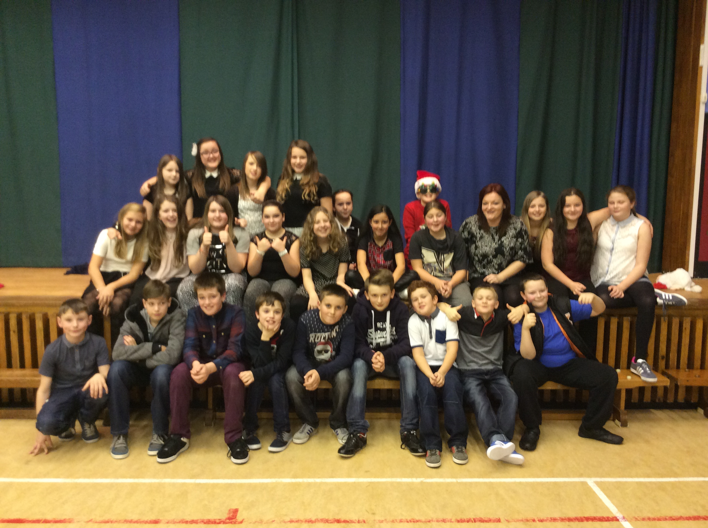

P7 – Christmas Party

Dear Parents/Carers,

Happy New Year to all! I hope you all had a wonderful Christmas holiday and enjoying the new term. The children have settled well and loved being involved in planning our learning for the term ahead!



India is home to a mind-stirring mix of landscapes, lifestyles and cultural traditions.

We will be researching the similarities and differences between life in Scotland and life in India and compare and contrast the effects of weather in Britain on people and society with those in India.

Primary 7 within their co-operative learning groups through a range of learning experiences explore key questions suggested during our planning session, including; House and homes, education , water, transport, landscape and entertainment.