May 2013

**Hakuna Matata!**

We are loving our new topic – Africa/The Lion King!

We have planned how the classroom should look and what we would like to learn about.

If you come to our assembly, we can show you all we have done – Hope to see you there!

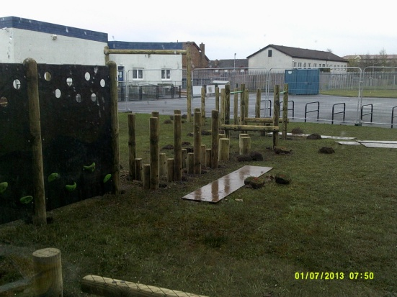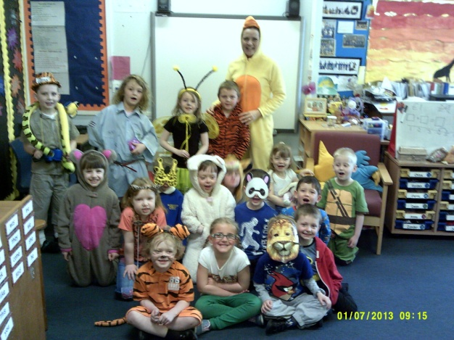

How cute are we??

We had so much fun raising money for the 5 Sisters Zoo!

We can see our new playground being built outside our window. We can’t wait until it is finished and we can play on it! Mrs Stewart says that she would like to play on it too!!!

Dates for your diary

School Holiday – Monday 20th May

Murrayfield action afternoon – Friday 24th May, 1.30pm

P1S Assembly - Friday 31st May!!!

Playground open morning – Friday 7th June (11.15-12.15)

Blackburn Gala day – Saturday 8th June

Fitness fortnight – 17th-28th June

End of term – Friday 28th June!!!

Money, Money, Money…!

We are learning about money, so put your feet up and let your children do the shopping for you!

Newsflash!...

Our caterpillar babies are doing fine and will soon become beautiful butterflies – we can’t wait! 