2nd November 2020

Dear Parents and Carers,

We had a lovely day last Friday. The children were thrilled to dress up to support the PSA and the teachers ensured they had a happy time with all their friends at school. We even had a visit from a dinosaur-never a dull moment at Mid Calder Primary School! We hope you also managed to get out and about to search for some special spooky “Mid Calder Rocks too!

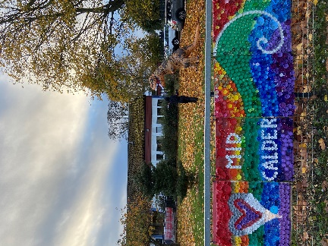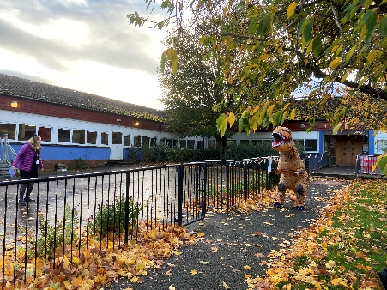

Important Dates Coming up

WCHS Open Evening for P7 Parents 18 November 7-8 pm on line Details on joining code to follow

Book Week Scotland, 16–22 November 2020

Flu vacinations in school Friday 27th November 2020

Reverse Advent Calendar Starts December 1st Support for West Lothian Food Bank

Save the Children`s Christmas Jumper Day Friday 7 December Donations to UNICEF

 An online STEM club has been uploaded here: <https://blogs.glowscotland.org.uk/wl/wlstem/2020/11/03/2nd-online-stem-club-tomorrows-engineers/>

It is linked to Tomorrow's Engineers week, this week and has information about engineer careers as well as engineering challenges.

We will soon be distributing the Bookbug Primary 1 Family Bag includes lots of fun activities and resources focused specifically on writing and counting. This forms part of the Scottish Government’s Read, Write, Count literacy and numeracy campaign, which aims to increase the literacy and numeracy skills of children in P1 to P3. Read, Write, Count bags will also be provided for children in Primary 2 and Primary 3. These will be gifted during Book Week Scotland.

Max Puttock's (P4) and Oliver Puttock's (P3/2) are celebrating sporting achievements last month Both boys competed in the 8 years and under category of the Stephen Gallagher Golf Foundation flag event at Linlithgow Golf Club Both both played incredibly well. Ollie was up against opponents up to 2 years older than him and was the second youngest overall. Impressively, Max came in 3rd place in his age category against some very talented players!! There were 70 boys and girls in total competing, so not a bad first result!

The school will once again be supporting the British Legion Poppy Appeal. Boxes of poppies will be available in each classroom and the children are welcome to bring a donation into school in exchange for a poppy to honour these heroic individuals.

Thank you so much for your co operation with recent updated Covid guidance and the need to social distance on drop off and collection of our children. A wee reminder that all adults should be wearing face coverings now too.  
Please may I remind parents/carers to refrain from parking on the opposite side of the school. There are double yellow lines so there should be **no vehicles waiting here at any time.** Thank you.

Please do get in touch with the school via e mail or phone and someone will respond to you as soon as possible [wlmidcalder-ps@westlothian.org.uk](mailto:wlmidcalder-ps@westlothian.org.uk) .

Kind regards,

Hazel Thurlow

<https://www.westlothian.gov.uk/back-to-school>

<https://www.nhsinform.scot/>