Mid Calder virtual Family Sports Day 2020

Welcome boys and girls to our Virtual Fun Sports Day, we realise this is not our usual Sports Day event but hope that you will enjoy taking part in the various activities and whilst we may be away from each other we are coming together as a School to engage and have fun with our family members. You should follow the activities below and record (video) your performance. Then, upload your best-performance daily activity (only one) to the P.E. files section.
On Friday 5th June), the judging committee (teachers) will choose the best videos from each activity.
Remember to be mindful that not everyone will have sports equipment at home so try and be creative about the different kinds of equipment you can use to take part in.
I am certainly looking forward to seeing all your videos.
Enjoy and take care everyone.
Mrs Davidov,

ACTIVITY ONE:
SKIPPING
Equipment Needed:  Skipping rope or skip 2b fit rope (if you have one)  Timer/stopwatch | 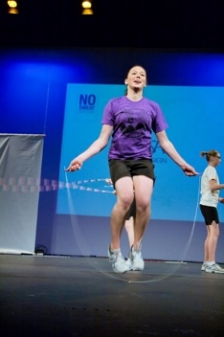
What you need to do;

You are going to skip non-stop for 1 minute counting how many skips you do.

Make sure you keep your hands wide either side of you like we have done in lessons
Give yourself plenty of space to skip
Keep going and don’t stop – Stamina and rhythm is key!

Maybe even play some music to keep you going!

ACTIVITY TWO:
TOE TOUCHES
Equipment Needed:  Timer/stopwatch | 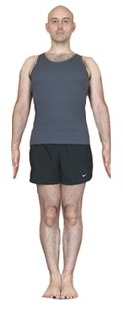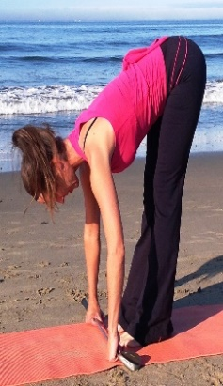  Stand Touch Toes Stand repeat
What you need to do;

You are going To see how many toe touches you can do in 30 seconds counting how many you do.

Starting in an upright position (Standing straight), bend down touch your toes and stand back up
That counts as 1 Toe Touch
Repeat as many times as you can in 30 seconds
Make sure you stand upright every time.

ACTIVITY THREE:
WALL THROW
Equipment Needed:  Ball that you can bounce against a wall  Clear wall and space  Timer/stopwatch | 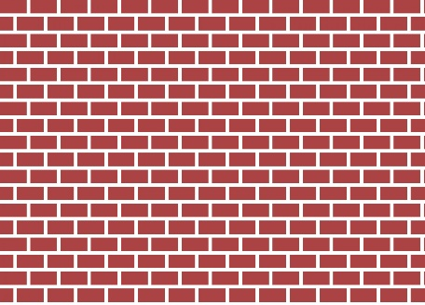  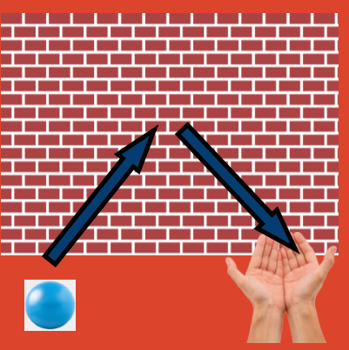
What you need to do;

You are going to see how many passes against the wall you can do in 1 minute

Stand facing the wall take 3 paces backwards away from the wall
When the timer starts throw and catch the ball against the wall as quickly as you can keeping a count for every successful catch against the wall

If you drop the ball that’s ok - keep going!

ACTIVITY FOUR:
SPEED BOUNCE
Equipment Needed:  Hurdle or towel or books  Timer/stopwatch | 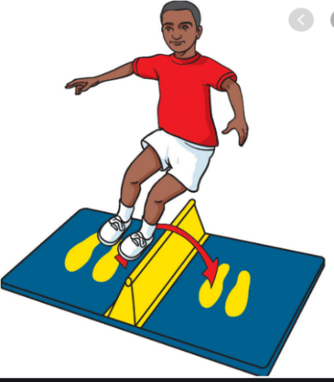
What you need to do;

How many times can you jump over the towel/books/hurdle in 20 secs. Use the video resource below to show you how to set this up correctly and safely,

Video Resource; https://youtu.be/jB1NWH0qpTA

ACTIVITY FIVE:
STANDING LONG JUMP
Equipment Needed:  Space  Marker to jump from  Clear landing spot  Measuring tape | 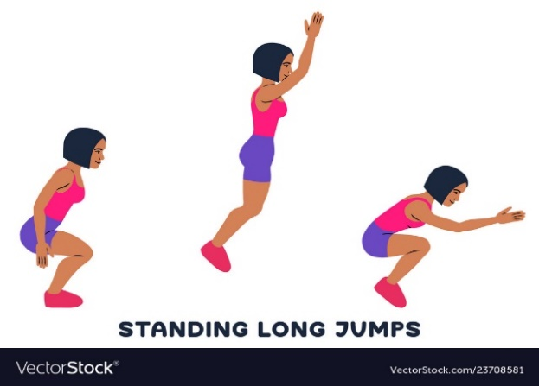
What you need to do;

How far can you jump? Using the link below to show you how to set this up. See how far you can jump from a standing position.

Remember to use your arms to help you jump and measure from the start point to the back of your heal where you first land.

Video resource: https://youtu.be/tf7YG9xwscA

ACTIVITY SIX:
TARGET THROW
Equipment Needed:  Space  Basket or object to throw into  10 balls, beanbags or rolled up socks | 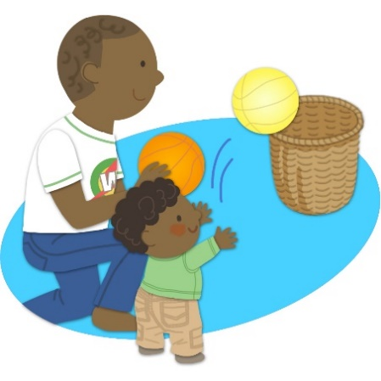
What you need to do;
You are going to see how many balls/socks you can get into the target.
Place your target/bin/washing basket 3 or 5 meters away from your start point

P1 – 3:
Start: 3m Basket

P4 – 7:
Start: 5m Basket

How many can you get in without missing?

ACTIVITY SEVEN:
JUMPING JACKS
Equipment Needed:  Space  Timer/stopwatch | 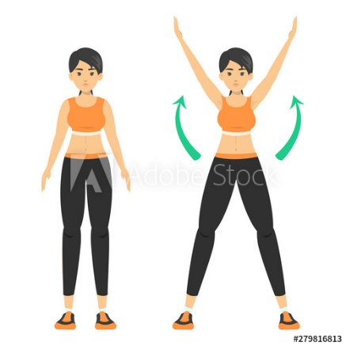
What you need to do;

You are going to complete a full jumping jack non-stop for 30 secs counting how many you do.

In a space starting with your feet together see how many jumping jacks you can do in 30 secs make sure you move your arms and legs out and back in to count as ONE

ACTIVITY eight:
EGG & SPOON
Equipment Needed:  Markers  Spoon  Boiled egg or small ball or pair of rolled up socks  Timer/stopwatch | 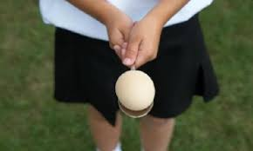
What you need to do;
You are going to balance the egg on the spoon from the start point, round a marker and back to the start to count as ONE

How many times can you do this in 1 minute without dropping the egg?

P1 – 3:
Start: 3m Marker

P4 – 7:
Start: 5m Marker

ACTIVITY nine:
SHUTTLE RUN
Equipment Needed:  Markers  Measuring tape  Timer/stopwatch | 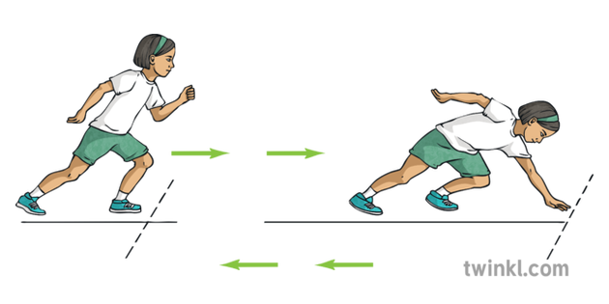
What you need to do;

How fast can you run a 5m distance 20 times? Use the link below to show you how to set this up.

You will need your Speed and agility when working on this task!

Video resource: https://youtu.be/_JlpNSOp8x8

ACTIVTIY TEN:
RACKET HIT
Equipment Needed:  Racket/bat  Ball  Or if you don’t have these you can use your hand with a balled up pair of socks or balloon  Timer/stopwatch | 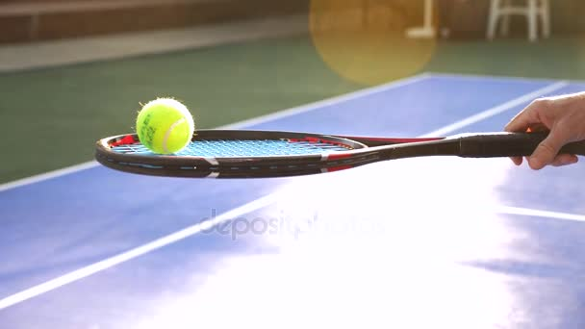
What you need to do;

You are going to see how many keepie ups you can do with the ball and racket non-stop for 30 sec counting how many you do.

Start with the ball on your racket/hand and every time you manage to keep the ball up in the air counts as one.

If you drop the ball don’t worry pick it up and keep going!

