**Literacy**

* Spelling

We already know the ee sound, but today we will learn that the same sound can be made with two different letters. Let’s learn this new sound. It‘s made like this **ea.**

.

<https://www.youtube.com/watch?v=U5KZNjV37Mo>

<https://www.youtube.com/watch?v=L6F4KRdhqak>

Here is a list of mild, spicy and hot spelling words.

Look at them carefully.

You should choose 10 words for your spelling task this week. You may want to choose words from just one column or from a mixture of columns!

1. In your Home Learning jotter, carefully write out each of your spelling words. Remember to join the two letters **e** and **a.**



1. Now choose 3 of your words and write each one in a sentence. Remember to use a capital letter, finger spaces and a full stop. Draw a picture to illustrate one of your sentences.

**OR**

Now choose 5 of your words and write each one in a sentence. Remember to use

a capital letter, finger spaces and a full stop. Can you also include a connective in

at least 1 of your sentences?

**Story Time**

Have a break and watch this story called ‘Taking Flight’. <https://www.literacyshed.com/takingflight.html>

In the film we do not see the alien. Can you describe what it would look like to an adult? Think about its colour, shape, size texture and body parts it might have.

**Writing**

Have a look at the picture below. Think about what we do in class when learning about recounts. We start by looking at a picture with **labels** and **key words**. We look at the picture, read the labels then use the key words to help share oral sentences about what might be going on. Try this with an adult.

* Listening/Talking

Listen to the story of The Town Mouse and The Country Mouse. Try to imagine the scenes in your head as you listen to the story.

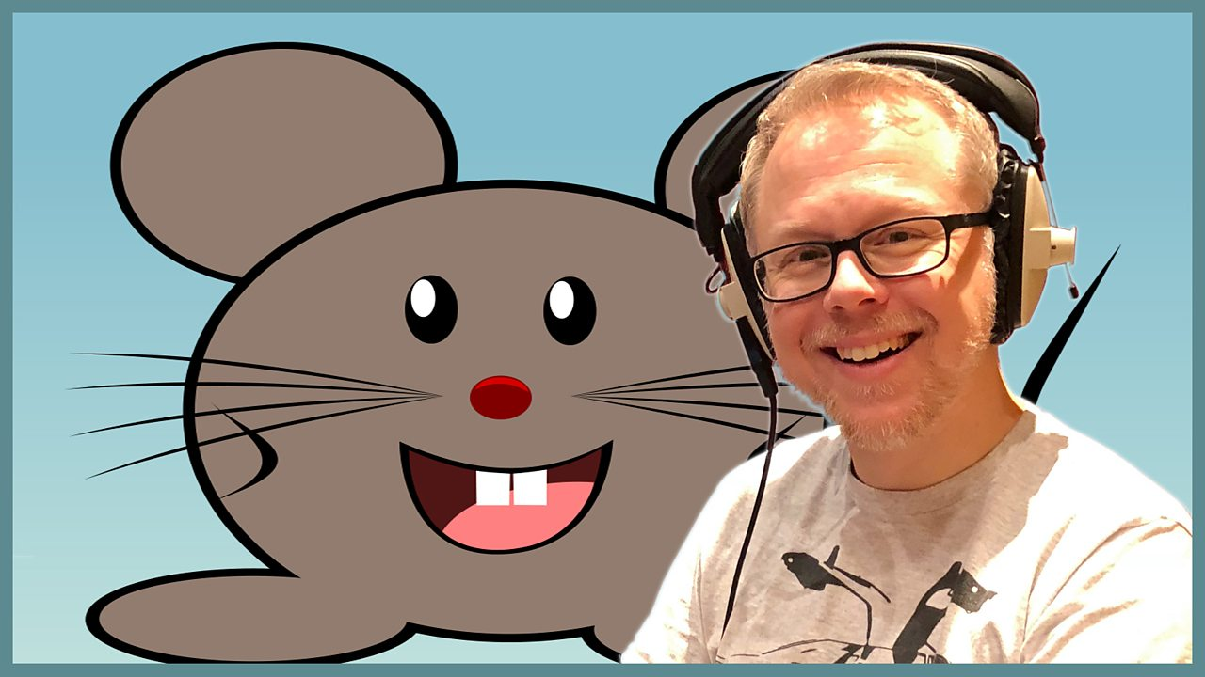

<https://www.bbc.co.uk/teach/school-radio/audio-stories-the-town-mouse-and-the-country-mouse/zrcrvk7>

What frightened Town Mouse?

What frightened Country Mouse?

Which mouse would you rather be? Why?

**Story Time**

Have a break and watch this story called ‘Taking Flight’. <https://www.literacyshed.com/takingflight.html>

In the film we do not see the alien. Can you describe what it would look like to an adult? Think about its colour, shape, size texture and body parts it might have.

**Writing**

Have a look at the picture below. Think about what we do in class when learning about recounts. We start by looking at a picture with **labels** and **key words**. We look at the picture, read the labels then use the key words to help share oral sentences about what might be going on. Try this with an adult.

**Numeracy**

* Skip Counting

Count in 2s to 20

Count in 5s to 50

Count in10s to 100

Challenge yourself to count as far as possible.

Challenge yourself to count backwards in 2s, 5s and 10s.

Try one of the tasks from the Number Wall that you chose last week. Remember to use your jotter if you need to write anything down

 

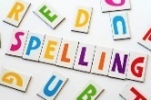

**French**

**Bonjour! Salut!**

Join in with the song <https://www.youtube.com/watch?v=l0a4jv-h4Ro>

Today we will look at colours.

What’s your favourite colour?

Do you know how to say it in French?

Let’s find out !



**PE**

Do you remember the ea sound we practised earlier?

Let’s go on an Under the Sea Adventure for PE today. I hope you can swim!

<https://www.bbc.co.uk/iplayer/episode/p06tmn51/andys-wild-workouts-series-1-1-under-the-sea>