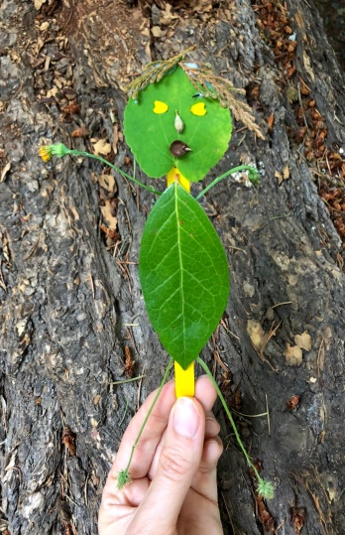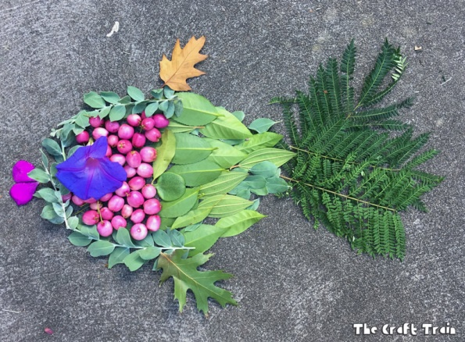**Nature art** – To mix things up, put the pencils and crayons to one side and look for natural art materials instead. Collect fallen leaves, petals and sticks and use them to make a picture or sculpture.

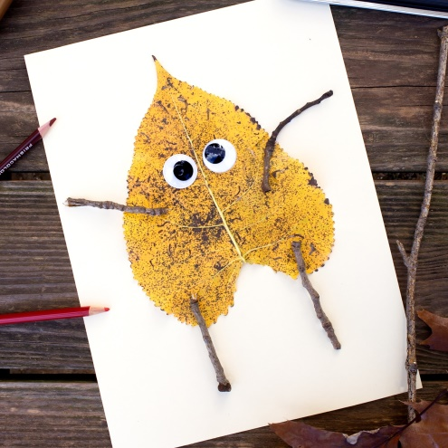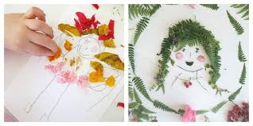What can you make? Maybe you can take a picture of your creation and post it on the blog!

**Outdoor maths**

**BALL GAMES**

**Can you:**

* Count how many times you or a partner can catch a ball without dropping it.
* Predict how many times you can bounce and catch a ball in a minute.
* Can you and a partner roll a ball 20 times between you in a minute?
* Who can throw and catch a ball in the air the most times without dropping it?
* Can you count up in 2’s, 5’s or 10’s each time you bounce/pass the ball? Can you challenge yourself and even count up in 3’s or 4’s,

**MEASURING**

You have been doing a lot of measuring. Can you:

Measure the length of your garden / how far from the door to the gate / how far around the grassy area. You can use various things to measure, try some of these ways.

* using footsteps (giant/fairy)
* by putting people in a line touching hands
* by laying out skipping ropes / lengths of ribbon / paintbrushes

Can you think of any other items you can measure with?

If you were measuring the path using hands, would you get the same measurement if you were using something different?

**STEM Challenge –**

[**KS1 Take it Outside STEM Activity.pdf**](KS1%20Take%20it%20Outside%20STEM%20Activity.pdf)

**Bug Count –** How many bugs can you find in your garden?

[Bug Count Outdoor Activity Sheet.pdf](Bug%20Count%20Outdoor%20Activity%20Sheet.pdf)

**Have a fab weekend!**