**Spelling**

In your home learning jotter, carefully write out each of your spelling words.

Use the Spelling grid below to give you some ideas about how to practise your words in different ways each week.

Here is a list of mild, spicy and hot spelling words.

Look at them carefully.

You should choose 10 words for your spelling task this week. You may want to choose words from just one column or from a mixture of columns!

|  |  |  |
| --- | --- | --- |
| Mild   1. were 2. make 3. been 4. which 5. made 6. would 7. find 8. each 9. could 10. have | Spicy  **ur** spelling pattern   1. not 2. sum 3. next 4. turn 5. nurse 6. turkey 7. purple 8. love 9. cover 10. hamburger   Can you write silly sentences or even a silly story using as many words as possible  Can you think of any other words with this spelling sound? | Hot  **oa** sound  spelling pattern: **oa** **ow** **o­_e**   1. such 2. luck 3. home 4. froze 5. foal 6. stone 7. toast 8. snowball 9. fifteen 10. sixteen   Can you write silly sentences or even a silly story using as many words as possible  Can you think of any other words with this spelling sound? |

Can you pick 5 words and write down the meaning of each word? You can use a dictionary or a tablet to help you find the meaning.

Spelling Tasks

|  |  |  |  |  |
| --- | --- | --- | --- | --- |
| **ABC-** Write all of your spelling words in alphabetical order | **Word parts**  Write your words then use a coloured pencil to divide them into syllables. | **Other handed**  Write the word 5 times switching the hand you are writing with. Say the word as you spell it. | **Vowel Spotlight**  Write your words using one colour for the vowels, a,e,i,o,u and another for the consonants. | **Use Technology**  Type our your spelling words on the computer. Try to use at least 4 fonts. |
| **Pyramid Words**  S  S P  S P E  S P E L  S P E L L I  S P E L L I N G  ( or make them in to a boat, star, circle, the choice is yours) | **Ransom Words**  ‘Write’ your words by cutting letters out of a newspaper or magazine and gluing them into your home learning jotter. | **Rainbow Words**  Write your spelling words with coloured pencils. Use a different colour for each word, | **Scrambled Words**  Write your words. Then write them again all mixed up. Can you unscramble them again.  Eg follow - wloflo | **Silly Sentences**  Use 5 of your words to write a silly sentence. If you are feeling really brave you could use then all in a silly story. |

Challenge yourself on Spooky Spellings - <http://www.ictgames.com/mobilePage/spookySpellings/index.html>

A game to practise common words - <http://www.ictgames.com/littleBirdSpelling/>

**Homophones**

**Homophones are words that sound the same but have different meanings. They also have different spellings.**

<https://www.bbc.co.uk/bitesize/topics/zqhpk2p/articles/zc84cwx>

Watch this wee video to remind you! Maybe you can sing along.

<https://www.youtube.com/watch?v=GJUqJyX5NSA>

Can you think of any other homophones?

Try out this game. Plenary - homophone game.ppt

Write down as many homophones as you can think of. You might need to check the spelling using a dictionary.

Remind yourself how to use a dictionary. <https://www.youtube.com/watch?v=r_NyZq-qDh4>

Can you find all the homophones that have been used incorrectly?

homophones 1.docx

Can you spot the homophones? Some of them are quite tricky, just try your best.

Spot the Homophone Puzzles - More x50.ppt

**Literacy**

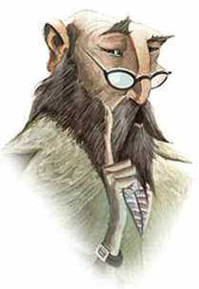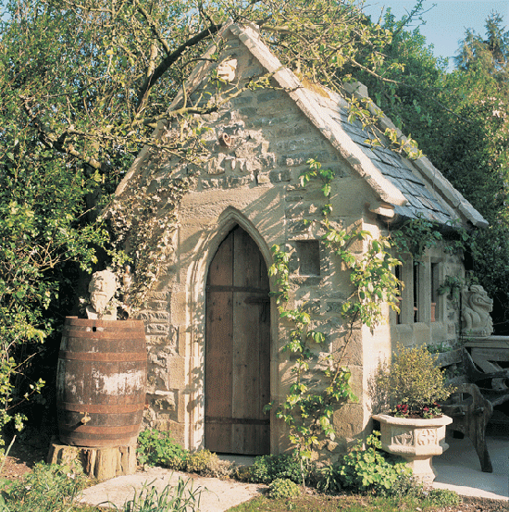Imagine you discover this shed at the bottom of your garden. What is inside? I can imagine it’s magical inside, much bigger than it seems on the outside. It might be lit with candles, strange items on the table, all cobwebbed and dusty.

Behind you the door closes gently and you spy this man sat in emerald green robes, peering at you over his glasses, the candles flicker and die out. Its pitch black and he whispers……….

**You only have 10 words. No more, no less. What does the wizard say to you? This will be the opening sentence to your story that you will write later on in the week.**

* **We use adjectives to describe a noun…. Remember a noun is the name of a thing, such as an object, a place or a person.**
* **Nouns are often described as a naming word.**

**You can use adjectives to describe your setting or characters in a story.**

**Think of the characters that you want to include in your story.**

**Have a wee look at this video to help you remember what an adjective is.** <https://www.bbc.co.uk/bitesize/topics/zrqqtfr/articles/zy2r6yc>

**Write a list of adjectives that you might use when writing your story.**

**Your story needs a setting……Your story starts off as above when you discover the shed at the bottom of your garden but what else is inside the shed? What do you see? What does it smell like? What can you hear?**

**Have a look at the adjectives that you have written down, how can you use these in your story to describe your setting? Your shed might have different rooms in it or different levels. Try to describe each one.**

**Have a wee look at this video to help with your setting.**

<https://www.bbc.co.uk/bitesize/topics/zfxtyrd/articles/zbgmmfr>

**You will need to add characters to your story. What will your character look like? What do they like/dislike? What do they wear?**

**Have a wee look at this video to help you with your characters. Your list of adjectives will come in handy for this.**

<https://www.bbc.co.uk/bitesize/topics/zfxtyrd/articles/z49hhbk>

.

**Maths**

|  |  |  |
| --- | --- | --- |
| **Mild**   1. 27 + 10 = 2. 53 + 10 = 3. 32 + 10 = 4. 39 + 10 = 5. 51 + 10 = 6. 58 + 10 = 7. 10 + 44 = 8. 75 + 10 = 9. ? + 10 = 89 10. ? + 10 = 48 11. 25 + 10 + 10 +10 = 12. 63 + 10 + 10 + 10 =   How many jumps on the number square do you need to make to add on 30? What direction are you jumping when adding a number?  **Here is a number square to help you. Can you see any patterns?**  <https://www.topmarks.co.uk/learning-to-count/paint-the-squares> | **Spicy**  **Find each total**   1. 76 + 8 = 2. 4 + 38 = 3. 57 + 6 = 4. Add 85 and 7 5. 8 plus 44 6. 26 add 5 7. Find the sum of 57 and 4 8. Add 8 to 66   **What must be added**   1. to 78 to make 81 2. to 7 to make 35 3. to 88 to make 96 4. to 3 to make 100 | **Hot**  **How many more are needed to fill each box?**   1. 426 sweets, the box holds 500. 2. 262 sweets, the box holds 300.   **How many more are needed to fill each jar?**   1. 475 lollipops, the jar holds 500. 2. 758 strawberry bon bons, the jar holds 800. 3. 607 smarties, the jar holds 700. 4. 312 chocolate buttons, the jar holds 400. 5. 110 + ? = 200 6. 560 + ? = 600 7. 819 + ? = 900 |

Here is a number square to help you with your maths - <https://www.topmarks.co.uk/learning-to-count/paint-the-squares>

In your home learning jotter, pick 10 or more sums to answer from the mild, spicy, hot page . Remember the strategies that you have used in class!

Can you put the numbers in the correct order? There are different levels on this game, try and challenge yourself once you have had a few goes.

<https://www.topmarks.co.uk/Flash.aspx?f=HigherAndLower>

Challenge yourself with the daily 10. You can pick any level but remember, the higher the level the harder the calculations. <https://www.topmarks.co.uk/maths-games/daily10>

Can you put the numbers in the correct order? Be careful not to knock the tower over.

<http://ictgames.com/rangeArranger/>

Challenge yourself: Think……What is important information? What operation do I use? + - / or x

1. Primary 3 did a survey of how people get to school. 12 children in P3 take their scooter to school. 6 more children than this walk to school. How many children walk to school?
2. In Primary 2, 19 children have scooters and 36 have bikes. How many more children have bikes than scooters?
3. 25 children like going on the bus best. 11 fewer children than this like going on the train best. How many children like going on the train best?

We were learning about dinosaurs before the Easter holidays. Here is a wee dinosaur game to check your dino knowledge. <https://www.bbc.co.uk/bitesize/topics/zdp4382/articles/znc3y9q>

Some dinosaur games to have some fun - <https://pbskids.org/games/dinosaur/>

We were learning about food chains during our Dinosaur topic. Have a wee look at ‘Local Safari’ there are some activities there that you will be able to do in your own area or even your own garden.

local safari.pdf

You have been learning French with Ms Brolls. Watch this short video to remind you of your French numbers.

<https://www.youtube.com/watch?v=evDuqXTfhkA>

Can you match the number to it’s French number?

<https://www.lightbulblanguages.co.uk/estrellas-resources/Matching/fr-nosto20-matching/fr-nosto20-matching.html>

French colours - <https://www.youtube.com/watch?v=JkQGN86qTag>

Can you match the French colours - <http://www.crickweb.co.uk/ks2french.html>

Here is a song to practise your French colours - <https://www.youtube.com/watch?v=3xNOstaLO-k>

How to make paper umbrellas. If you don’t have coloured paper, you can always colour in the paper first…….remember those colouring in skills!

<https://www.easypeasyandfun.com/how-to-make-paper-umbrellas/>

Take a little Peace Out: <https://www.youtube.com/watch?v=2TFuFd4iFOY>

Choose what you want to do on Go Noodle: <https://app.gonoodle.com/>

RSPB Bird Watch: On this website you’ll find a lot of fun activities that you can do in your garden, you might want to make this a personal project. Explore the website and find out more. <https://www.rspb.org.uk/fun-and-learning/for-teachers/schools-birdwatch/resources/>

What is coding - <https://www.bbc.co.uk/bitesize/topics/zvsc7ty/articles/zykx6sg>

Something a bit different : <https://www.bt.com/codeacake>

Try making your own programmes. With Scratch, you can program your own interactive stories, games, and animations.

<https://scratch.mit.edu/>