**Spelling**

In your home learning jotter, carefully write out each of your spelling words.

Use the Spelling grid below to give you some ideas about how to practise your words in different ways each week.

Here is a list of mild, spicy and hot spelling words.

Look at them carefully.

You should choose 10 words for your spelling task this week. You may want to choose words from just one column or from a mixture of columns!

|  |  |  |
| --- | --- | --- |
| Mild   1. were 2. make 3. been 4. which 5. made 6. would 7. find 8. each 9. could 10. have | Spicy  **ur** spelling pattern   1. not 2. sum 3. next 4. turn 5. nurse 6. turkey 7. purple 8. love 9. cover 10. hamburger   Can you write silly sentences or even a silly story using as many words as possible  Can you think of any other words with this spelling sound? | Hot  **oa** sound  spelling pattern: **oa** **ow** **o­_e**   1. such 2. luck 3. home 4. froze 5. foal 6. stone 7. toast 8. snowball 9. fifteen 10. sixteen   Can you write silly sentences or even a silly story using as many words as possible  Can you think of any other words with this spelling sound? |

Can you pick 5 words and write down the meaning of each word? You can use a dictionary or a tablet to help you find the meaning.

Spelling Tasks

|  |  |  |  |  |
| --- | --- | --- | --- | --- |
| **ABC-** Write all of your spelling words in alphabetical order | **Word parts**  Write your words then use a coloured pencil to divide them into syllables. | **Other handed**  Write the word 5 times switching the hand you are writing with. Say the word as you spell it. | **Vowel Spotlight**  Write your words using one colour for the vowels, a,e,i,o,u and another for the consonants. | **Use Technology**  Type our your spelling words on the computer. Try to use at least 4 fonts. |
| **Pyramid Words**  S  S P  S P E  S P E L  S P E L L I  S P E L L I N G  ( or make them in to a boat, star, circle, the choice is yours) | **Ransom Words**  ‘Write’ your words by cutting letters out of a newspaper or magazine and gluing them into your home learning jotter. | **Rainbow Words**  Write your spelling words with coloured pencils. Use a different colour for each word, | **Scrambled Words**  Write your words. Then write them again all mixed up. Can you unscramble them again.  Eg follow - wloflo | **Silly Sentences**  Use 5 of your words to write a silly sentence. If you are feeling really brave you could use then all in a silly story. |

**Homophones**

**Homophones are words that sound the same but have different meanings. They also have different spellings.**

<https://www.bbc.co.uk/bitesize/topics/zqhpk2p/articles/zc84cwx>

Watch this wee video to remind you! Maybe you can sing along.

<https://www.youtube.com/watch?v=GJUqJyX5NSA>

Can you think of any other homophones?

Try out this game. Plenary - homophone game.ppt

Write down as many homophones as you can think of. You might need to check the spelling using a dictionary.

Remind yourself how to use a dictionary. <https://www.youtube.com/watch?v=r_NyZq-qDh4>

Can you find all the homophones that have been used incorrectly?

[homophones 1.docx](homophones%201.docx)

**Literacy**

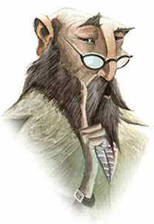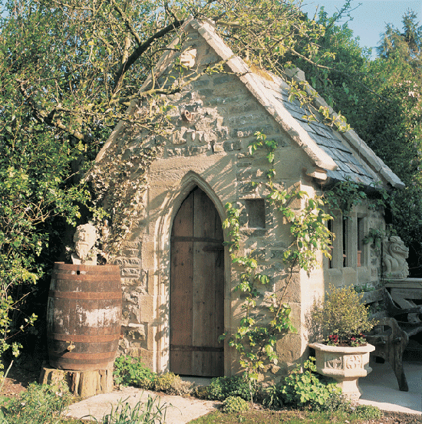Imagine you discover this shed at the bottom of your garden. What is inside? I can imagine it’s magical inside, much bigger than it seems on the outside. It might be lit with candles, strange items on the table, all cobwebbed and dusty.

Behind you the door closes gently and you spy this man sat in emerald green robes, peering at you over his glasses, the candles flicker and die out. Its pitch black and he whispers……….

**You only have 10 words. No more, no less. What does the wizard say to you? This will be the opening sentence to your story that you will write later on in the week.**

* **We use adjectives to describe a noun…. Remember a noun is the name of a thing, such as an object, a place or a person.**
* **Nouns are often described as a naming word.**

**You can use adjectives to describe your setting or characters in a story.**

**Think of the characters that you want to include in your story.**

**Have a wee look at this video to help you remember what an adjective is.** <https://www.bbc.co.uk/bitesize/topics/zrqqtfr/articles/zy2r6yc>

**Write a list of adjectives that you might use when writing your story.**

.

**Maths**

|  |  |  |
| --- | --- | --- |
| **Mild**   1. 32 + 4 = 2. 71 + 4 = 3. 85 + 4 =   There are 31 frogs in the pond. 3 hop in. How many now?  23 children in the hall. 4 come in. How many now?   1. 30 + ? = 38 2. 22 + ? = 27 3. 63 + ? = 69 4. ? + 2 = 92 5. ? + 4 = 55 6. ? + 6 = 78 | **Spicy**  Paint brush - 55p  Cellotape - 21p  Sponge - 73p  Scissors - 35p  Measuring tape - 43p  Paint scraper - 24p  **Find the total cost of:**   1. sponge & paint scraper 2. measuring tape & paint brush 3. scissors & cellotape 4. cellotape & sponge 5. scissors & measuring tape 6. paint brush & scissors   remember to write down p at the end of each answer to show that it is money you are dealing with  Draw   1. **two** things you can buy for 45p 2. **three** things you can buy for 80p | **Hot**   1. 320 + 320 = 2. 320 + 330 = 3. 310 + 320 = 4. 160 + 160 = 5. 170 + 160 = 6. 160 + 180 = 7. 280 + 280 = 8. 280 + 290 = 9. 270 + 280 = 10. 220 + 230 = |

In your home learning jotter, pick 10 or more sums to answer from the mild, spicy, hot page below. Remember the strategies that you have used in class!

Can you put the numbers in the correct order? There are different levels on this game, try and challenge yourself once you have had a few goes.

<https://www.topmarks.co.uk/Flash.aspx?f=HigherAndLower>

Challenge yourself: Think……What is important information? What operation do I use? + - / or x

1. Aysha planted sunflower seeds in her garden. One day she saw that 56 seeds had sprouted. A week later another 34 seeds had sprouted. How many seed have sprouted altogether?
2. Aysha was happy. 82 of her sunflowers had come up. She picked 9 of them to give to her sister. How many sunflowers were left in the garden?
3. There were 73 sunflowers still growing in the garden. 69 sunflowers wilted in the midday sun. How many sunflowers did not wilt?

We were learning about dinosaurs before the Easter holidays. Here is a wee dinosaur game to check your dino knowledge. <https://www.bbc.co.uk/bitesize/topics/zdp4382/articles/znc3y9q>

You have been learning French with Ms Brolls. Watch this short video to remind you of your French numbers.

<https://www.youtube.com/watch?v=evDuqXTfhkA>

Can you match the number to it’s French number?

<https://www.lightbulblanguages.co.uk/estrellas-resources/Matching/fr-nosto20-matching/fr-nosto20-matching.html>

French colours - <https://www.youtube.com/watch?v=JkQGN86qTag>

Can you match the French colours - <http://www.crickweb.co.uk/ks2french.html>

How to make paper umbrellas. If you don’t have coloured paper, you can always colour in the paper first…….remember those colouring in skills!

<https://www.easypeasyandfun.com/how-to-make-paper-umbrellas/>

Take a little Peace Out: <https://www.youtube.com/watch?v=2TFuFd4iFOY>

Choose what you want to do on Go Noodle: <https://app.gonoodle.com/>

RSPB Bird Watch: On this website you’ll find a lot of fun activities that you can do in your garden, you might want to make this a personal project. Explore the website and find out more. <https://www.rspb.org.uk/fun-and-learning/for-teachers/schools-birdwatch/resources/>

What is coding - <https://www.bbc.co.uk/bitesize/topics/zvsc7ty/articles/zykx6sg>

Something a bit different : <https://www.bt.com/codeacake>