February 27th 2020

Dear Parents and Carers,

It is with mixed feelings that we say goodbye to our lovely Lynn Findlay who has been such a super star here at Mid Calder. She leaves an impressive legacy here of inspiring creative practice within our Nursery. But more importantly, a life-long influence on all those children past and present who have been touched by her warmth and enthusiasm. We will miss her so much but I am sure you will agree with me that she thoroughly deserves her new ELC Area Support Manager role and now be able to share her expertise more widely.

We have appointed a new EYO Dawn Coatham, who hopefully will be joining us soon after the Council recruitment procedures have been completed.

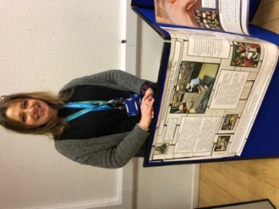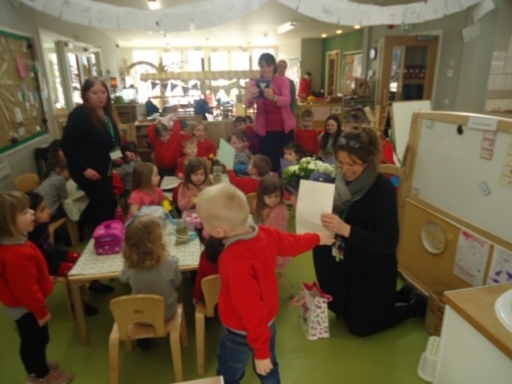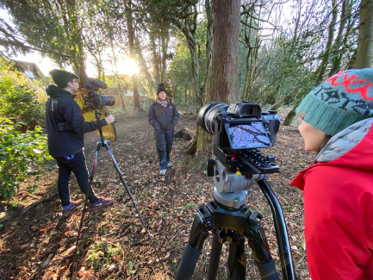

We are delighted to announce that a ministerial visit took place on 21st February to launch Realising the Ambition - a document which provides national practice guidance to support staff in providing high quality early learning and childcare.

Education Scotland planned this relaunch event at Mid Calder Primary Nursery Class since we have some excellent work in the setting and have worked with Education Scotland to produce a sketch note

- <https://education.gov.scot/improvement/practice-exemplars/sketchnote-mid-calder>

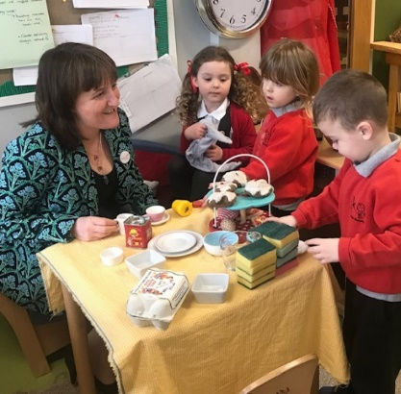

Following on from the recent publication of our Education Scotland Sketchnote, we were delighted to have a visit from Janie McManus to witness the experiences we offer our wee people. She took the time to visit our shelters in the snow and chatted with our children and parents.

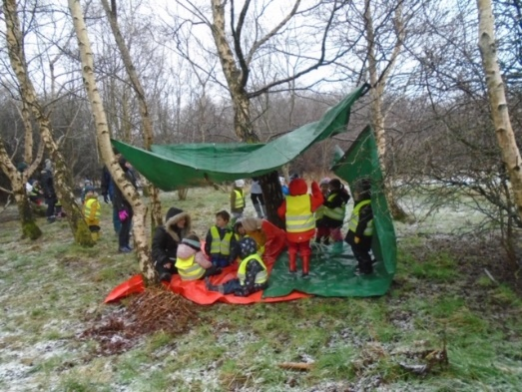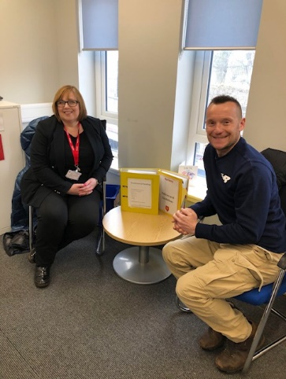

We are so pleased that we have WCHs student supporting our lessons on Mondays and Tuesdays and another student running a football club after school on Mondays. We continue to have a lunchtime club on Wednesdays. The Futsal programme continues with P5, P4 and P7/6 at the moment. This then will be followed with the infant classes after Easter.

P1 and P1/ 2 will be receiving music lessons from West Lothian music service starting this week.

The P4 pupils will be undertaking their SNASA assessments in the next few weeks. These will be embedded slowly within lessons and designed not to be stressful to your children.

We look forward to seeing the P7 School Camp parents on Monday 2nd March at 6 pm for a briefing for their forthcoming residential to Dukeshouse Wood Hexham Northumberland.

Next Wednesday The P7 pupils will be out and about again, attending a Transition Fair at WCHS including problem solving and Digital Technology tasks.

This week we welcomed the PDSA for workshops which our children thoroughly enjoyed.

Next Thursday 6th March, we welcome LUSH once again to Mid Calder as part of Fair Trade Fortnight. The team will run a whole school Fair Trade Talk

The children are invited to buy products if they so wish afterwards in class groups. There is no compulsion to buy and the follow up sessions are optional.

Here are a list of the available products :

Ickle Baby Bot Bath Bomb - £2.50

Creamy Candy Bubble Bar - £3.95

Rocket Science Bath Bomb - £3.95

Dragons Egg Bath Bomb - £3.95

Whoosh Shower Jelly - £5.00

Sunnyside Up Shower Jelly- £5.00

Charity Pot Hand and Body Lotion 10g - £1.00

Charity Pot Hand and Body Lotion 45g - £4.50

**Additional Dates for your diary**

Friday 6th March 9a m P1/2 assembly

Friday 6th March PSA Bingo Night 6.30 to 8 pm Masonic Hall Mid Calder

Friday 13th March 9 am P1/2 assembly

16th March – 20th March 2020 P7 Residential Camp – Dukeshouse Wood

Thursday 26th March Show Racism the Red card Workshops

Friday 27th March PSA Easter Egg Competition

Wednesday 1st April Parent consultation Evening (late)

Thursday 2nd April Parent consultation Evening (early)

Thursday 2nd April Church Easter Service 9.30 am

Friday 3rd April Celebration Assembly 9.00 am

Thank you once again for your continued support,

Kind regards,

Hazel Thurlow