December 19th 2019
Dear Parents and Carers,
Once again it has been a busy week here in Mid Calder and our children have impressed us with their talents!
Thank you to our P5 children who did so well at Cunnigar House sharing some Christmas cheer. The feedback has been amazing! Well done children and a special thank you to Mrs. Turner for organising this memorable experience.
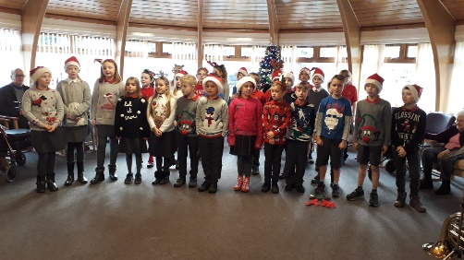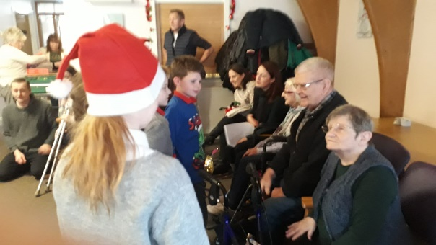
We all enjoyed our Christmas Service at the Kirk this week with cheerful singing and thoughtful readings. Thank you to Mr. Povey for once again hosting this Mid Calder family occasion. A special thank you to our amazing brass musicians who were incredible and are developing their musical skills superbly under the guidance of Caroline Farren.
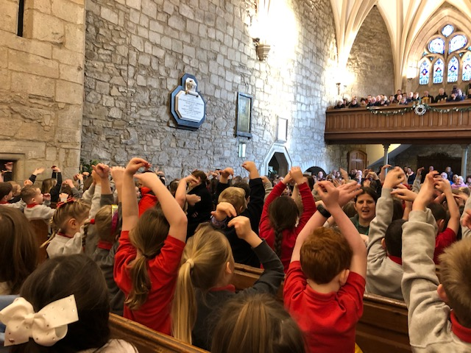

Euan Scott in P6 has continued to receive praise for supporting the Kit Aid charity. He has already won the Mid Calder Gala Junior Citizen Award for his charity work and then in August he won Livingston Centre Young Hero Award. Euan has managed to collect 144 pairs of boots and 27 full large boxes of football kits, full team strips and sportswear. He recently received a letter at school from the Scottish Parliament to say that the local MP Neil Findlay had submitted a motion to the Parliament to congratulate him. Well done Euan!

Staffing
We are currently looking for a full time PSWto work in our school. If you know anyone who may be interested please encourage them to contact the office. Thank you.
Mrs Lynn Findlay our current EYO in the Nursery, has been invited to join the Early Years Team as an area support manager. I am sure you will agree she will be a great loss to our superb nursery. Nevertheless we are delighted for her and this new exciting opportunity where she will share her talents with other nursery settings within West Lothian.
We will update you of any recruitment we make after Christmas. We do not have a confirmed departure date yet so we will continue to make the most of her after the Christmas holidays!

A wee reminder the school will be closed on Monday 6th January for our In Service day. Please note that the nursery will be open for its normal working hours.

Thank you again for your continued support this year already. We have been so delighted to see so many of you at our school events this term and hoping we will continue to see you all in 2020!
Wishing you a truly wonderful Christmas break with all your families and friends.
Kind regards,
Hazel Thurlow

Please take a few minutes to complete our on line Parental Survey. Thank you. https://www.esurveycreator.co.uk/s/6b30b67

