examined

Dear Parent/Carer,

Welcome to Term 1 in Primary 7. I hope you have all had a relaxing summer and are now feeling refreshed. The children have settled in well and have been working together on building a classroom community and extending this throughout the school. Some of our P7s have been excitedly preparing for our upcoming House Captain elections and have demonstrated all of our school values in this process. We have also raised awareness of internet safety, and how to be safe using a variety of technology. We have all really enjoyed reading and learning through our class novel, ‘The Nowhere Emporium,’ by Ross MacKenzie. His descriptions and creative style of writing have inspired us and we have enjoyed discussing what we might put in our very own ‘Book of Wonders.’

Miss Sherlow

September 2019

**English & Literacy**

Through the IDL context of Through the Decades, our writing will focus on a variety of genres, including biographies and autobiographies. We will also be looking at the key features of descriptions.

Our reading in Term 1 will focus on Higher Order Thinking Skills and establishing our Guided Reading sessions within class. We will also use our class novel ‘The Nowhere Emporium’ to develop our comprehension and prediction skills.

This term, we will continue to develop our knowledge of Vocabulary, Connectives, Openers and Punctuation (VCOP). The children have started to learn cursive handwriting with Mrs Ross. The children are continuing to use up-levelling techniques to improve the standard of their writing. This process also involves self and peer assessment.

**Maths & Numeracy**

This terms numeracy sessions will focus on number and number processes using place value to explain the link between a digit, its place and its value.

In preparation for the upper school show, pupils will look in more depth at finance, budgeting, fundraising and managing money.

In mental agility, the children will be continuing to develop their mathematical strategies through Number Talks. This approach encourages the children to find the most efficient way to reach an answer to a given problem.

Sumdog is also a fantastic resource to develop children’s mental agility and quick recall of maths facts. You can support your child’s maths development at home with regular multiplication facts and number bond revision, and links to maths in real life contexts.

**Interdisciplinary Learning: Through the Decades**

This term our context for learning is ‘Through the Decades’. We will be exploring this through the curricular areas of Social Studies, Expressive Arts and Technologies.

Following discussion with the children, we have decided to focus on the changes and developments over time in the following areas:

* Music
* Fashion
* Technology/Social Media
* Transport
* Employment
* Fame and what this entails

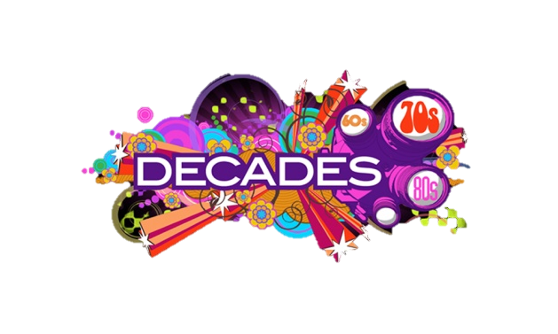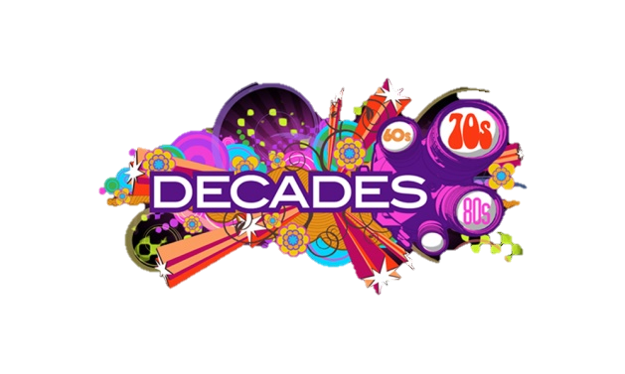

**Important Events**

**Parents Evening**

9th & 10th October 2019

**Upper School Show**

Details TBC

**Homework**

This year, spelling and numeracy/maths homework will be issued on alternate weeks. These tasks will be given in the form of a grid to allow for choice and flexibility at home. **Homework will be given on a Tuesday** and should be **returned on a Monday**. Maths Sumdog challenges will always be available to the children but are not compulsory. Please see you child’s homework jotter for a full explanation.

**Reading for Enjoyment** is encouraged and our A-Z Reading Challenge should motivate the children to read a variety of texts at home. On the first Monday of every month we will hold a reading ‘Swap shop’ where they can swap ideas and texts they have enjoyed reading.

**Additional Information**

**P.E. Days – Monday & Thursday**

Please ensure your child brings clothing suitable for taking part in P.E and that clothing is all labelled with your child’s name.

**Outdoor Learning**

As mentioned in a previous letter, this year MCPS will be embracing the outdoors as a learning environment. Please ensure that your child has weather appropriate clothing each day.