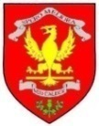

Dear Parent/Carer,

Welcome to Term 3 in Primary 2. We are certainly looking forward to a very busy term, and the children have already settled back into classroom routines.

The highlights of last term included our Sharing the Learning Afternoon. P2 enjoyed opening their own shop and selling the goods they had made. It was a great opportunity to handle money in a real life context. Thank you to everyone who also came along to our Open Afternoon during Scottish Book Week. The children very much enjoyed exploring the contents of their Read, Write, Count Bag with you. We have now started our new IDL context for learning – Homeward Bound. We are looking forward to helping our giraffe find his way back home to Africa.

Mrs Smith

**Primary 2 Learning Letter: Term Three**

January 2018



**Maths & Numeracy**

This term, our maths work will continue to focus on Stages of Early Arithmetical Learning (SEAL) strategies.

We will use these strategies to explore and develop our understanding of number structure, counting forwards and backwards, addition and subtraction, grouping and sharing.

We will also continue to use Number Talks to develop the children’s understanding of number and to encourage them to share their ideas and demonstrate their understanding.

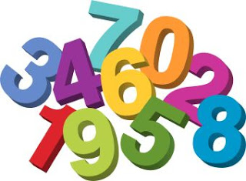 

We plan to investigate 2D and 3D shape, as well as fractions – finding halves and quarters of shapes and numbers.

Sumdog also helps to support the work being covered in class.

**English & Literacy**

Through the IDL context for learning, we will explore a variety of non-fiction texts to gather information about climates and landscapes around the world.

We will use books, images, audio clips and digital texts. We will use skimming and scanning skills to find information, and begin to develop some notetaking skills too.

In writing, we will continue to develop our knowledge of Vocabulary, Connectives, Openers and Punctuation (VCOP), and the children will use up-levelling techniques to improve the standard of their writing. This process will involve self-assessment, as well as learning how to give constructive feedback to a partner.

We will continue to learn and apply new spelling patterns using the Jolly Phonics and Jolly Grammar resource.

Listening and Talking tasks will focus C:\Users\shirley.smith\AppData\Local\Microsoft\Windows\Temporary Internet Files\Content.IE5\1A1G15CG\tango-style-pencil[1].pngon the skills needed to present to an audience eg making eye contact and using a loud, clear voice.

C:\Users\shirley.smith\AppData\Local\Microsoft\Windows\Temporary Internet Files\Content.IE5\2F2FZV92\pic2[1].jpg

**Interdisciplinary Learning: Homeward Bound**

This term our context for learning is Homeward Bound. We will be learning about this through the curriculum areas of English and Literacy, Social Studies and Technologies.

The key questions we will explore are:

1. What is a climate?

2. What climates can be found in different places around the world?

3. How does climate affect living things?

4. How are living things suited to their climate and landscape?

5. How do people travel across different landscapes around the world?





**Homework**

Spelling and maths homework activities have been set for Term 3. A different activity should be chosen from the Home Learning Wall each week. Homework should be handed in on Friday. A continued emphasis on neat presentation and accuracy is greatly encouraged.

Reading will be noted in the reading record each week. Please feel free to make a comment or ask a question. about

**Additional Information**

Enjoyaball for P2 will be on Mondays and we will have class PE on Wednesdays with Ms Brolls.

Thank you for ensuring that your child has the correct clothing to change into on PE days. Gym shoes will be sent home regularly to allow you to check that they fasten securely, and that they remain suitable for PE activities.

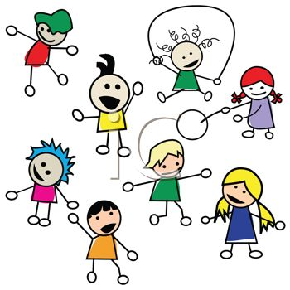

**Assemblies**

On 1st February we will be having an Assembly to celebrate the work of Robert Burns and other Scottish poets.

P2 children have already chosen the poem they wish to learn, and are working hard on learning the words and polishing their performance. Thank you for your support with this.

Our P2 class Asembly will be held on 9th February at 11.05am. We look forward to sharing our learning with you then.