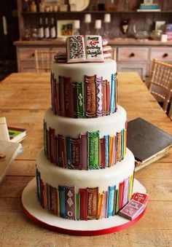
Mid Calder Bake-Off!
Why not read a recipe?
The Bake-Off is back! Bigger and better than ever! Mid Calder Primary School’s BookLions is proud to present The Mid Calder Bake-Off! Get out your whisks and put on your aprons because it’s coming to Mid Calder Primary School hall, on Thursday 3rd March 2016.
It will be at 1:30pm-2:30pm, so bring your cakes and bakes to the hall in the morning, where we will be waiting to collect your sweet treats. We promise we won’t eat them!
If you have any gluten-free or nut free cakes and bakes please inform us, and we will add this to your description card. If you have used any Fairtrade products in your bakes, we will have a table for that too.
The Categories are:
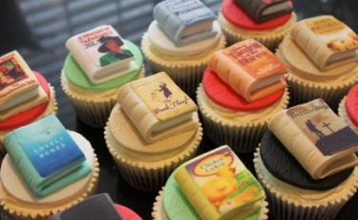
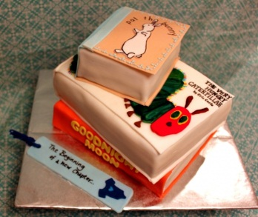
Nursery
P1-P3
P4-P5
P6-P7
The cake designs can be to do with your favourite book/character or they could just be a normal design. Remember to bring a copy of the recipe you used when baking or bring in the book for everyone to see. Reasons being to make sure everyone knows what they’re eating and that they’re allowed it, also reading is what we encourage and we thought it would be fun to let you read the recipes yourself!
We will have special guest judges and your parents, carers, grandparents will also be invited in during this time. We invite you to take another cake home to try (and the recipe) for a small donation, if you want to take your own cake home afterwards please let us know when delivering it to the hall. The donations you make are to raise money for our school library, to get it into better condition. Oh, and did we forget to tell you about the prize? Your cakes and bakes will be judged before parents and carers arrive. The prize will be a… surprise because that’s the best kind!
Finally, if you have any old books or books you don’t read anymore, we will be having a book swap table, to get you reading.
We hope you will put in the effort to get baking and bring in some delicious cakes and treats, for everyone to enjoy!
Hope you get busy and get baking!
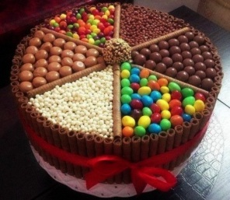
From, Erin Leitch, Eloise Cowie and Neve Cormack, members of the BookLions

