Named Person - The Children and Young People (Scotland) Act 2014
The Act requires the promotion, support and safeguarding of wellbeing, as a common approach across all services engaging with children and families. It relates to the Getting it right for every child (GIRFEC) approach to improving outcomes through the delivery of services to support the wellbeing of children and young people. GIRFEC will help realise the shared ambition of making Scotland the best place in the world to grow up. The Act becomes law on 1 Aug 2016.
The GIRFEC approach recognises that at different stages of their life each child will have specific needs. Services need to be responsive to how these needs differ between children, how they change as they get older and whether they can be met with the universal support available to all children.
Some children and young people may have temporary difficulties, such as illness, bereavement or moving school and some may live with challenges such as the effects of disability or long-term conditions. While most will get all the help and support they need from their parents, wider family and community, sometimes they and their families may seek extra support.
This is the Wellbeing wheel and guides staff in schools who help young people meet all 8 indicators
Safe
Healthy
Achieving
Nurtured
Active
Responsible
Respected
Included
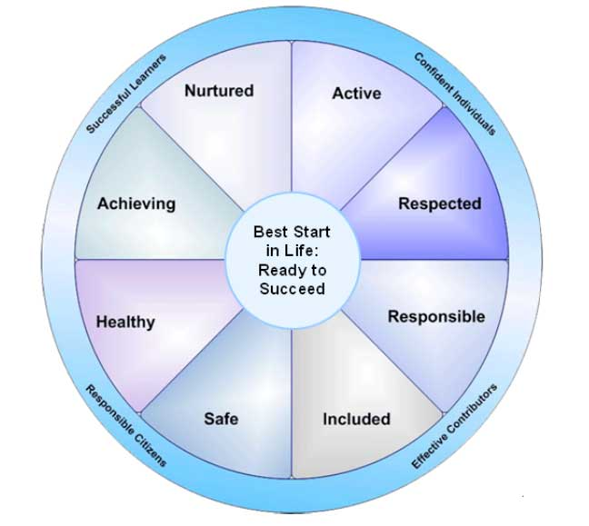
What will it mean for your son/daughter?
A Named Person is one point of contact that your son/daughter, or yourself, can go to for advice or support if required.
West Lothian schools already have a system in place to ensure that your child is supported and to communicate any information to you. Staff use a range of practices to ensure that all 8 indicators are considered when planning any additional support for your child. This may involve requesting input from other services. This will continue for your son/daughter.
Who will be the Named Person for your son/daughter?
The Named person will be your Health Visitor in Nursery provision and prior to school entry.
The Named person at school entry transfers to Education services:
- Primary and Special schools Head teacher
- Secondary schools Head teacher who will delegate responsibility to House/Year
Heads
Further information can be found on the Scottish Government website http://www.gov.scot/Topics/People/Young-People/gettingitright/named-person

