Mid Calder Primary School

Positive Ethos Policy



Created August 2014

Updated August 2015



*Every child deserves a champion*

*– an adult who will never give up on them,*

*who understands the power of connection,*

*and insists that they become the best they can be.*

Rita Pierson

**Contents**

School vision, aims & values 4

Celebrating Success 5

Corrective Actions 8

Wall Displays 10

Appendices:

Appendix 1: Self Registration

Appendix 2: Star Pupil Certificate

Appendix 3: Using Class Dojo

Appendix 4: Top Scorer

Appendix 5: House Points Totals

Appendix 6: iAchieve

Appendix 7: Uniform Letter

Appendix 8: Pupil Reflection Log

Appendix 9: Loss of Free Time Friday Reflection Log

Appendix 10: Behaviour Group Referral Form

Appendix 11: Free Time Friday Chart

Appendix 12: Playground Incident Form

**Our School Vision Statement**

# The staff are committed to providing an education of the highest quality which lays emphasis not only on the acquisition of the basic skills but also prepares multicultural society where a positive work ethic, combined with the active pursuit of leisure activities, can equip them to aspire to a happy, productive pupils for living in a technologically advancing and healthy future with a lifestyle of the highest quality.

**Our School Aims**

**Learning and Teaching**

* ensure a broad and balanced curriculum that provides young people with the best possible learning opportunities and experiences, laying emphasis on the acquisition of the basic skills.
* provide the highest quality of learning and teaching experiences that enable pupils to enjoy their education and develop positive attitudes towards learning.
* improve the quality of learning and teaching through the effective organisation and management of the school’s resources.
* enable teaching and learning to take place in rights-respecting classrooms.

**Vision and Leadership**

* equip pupils with the foundation skills, attitudes and expectations required to prosper in a changing society and to encourage creativity, ambition and a healthy, active leisure time.
* prepare pupils for responsible citizenship by developing values, beliefs and attitudes compatible with living in a modern, democratic and multicultural society.

ensure that the school’s promoted staff provide high quality leadership, management and support.

**Partnership**

* build and maintain effective partnerships between the school and its parental body, external support agencies and its wider community.

**People**

* provide effective support systems for all pupils that promote personal and social development and underpin academic achievement.
* improve the quality of educational experiences through a programme of continuing professional development for all staff.
* equip pupils to exercise a significant voice and participate actively in decision-making in the life of the school, nurture good health in all pupils through strategies that promote physical and mental wellbeing and self-esteem.

**Culture and Ethos**

* strive towards ensuring that all pupils are able to realise their potential by recognising their needs, together with the promotion and recognition of achievement and excellence.
* provide a welcoming, safe and caring environment in which each pupil is valued and supported.
* ensure children and adults are collaborating to develop and maintain a rights-respecting school community, based on the Convention of the Rights of the Child.
* ensure that all pupils are able to experience a calm, positive and safe learning environment that promotes good behaviour, self-discipline and respect for others.

**Our School Values**

**Enthusiastic** – I am passionate and excited by learning.

**Friendly** – I show compassion towards others and am considerate of their feelings.

**Inclusive** – I accept others and appreciate diversity.

**Respectful** – I am considerate and courteous to others.

**Responsible** – I am accountable for my learning and my actions.

**Successful** - I try my best individually and as a team member.

**Celebrating Achievements**

The following are a list of strategies that we use to celebrate successes and achievements at Mid Calder Primary.

**Celebrating Success**

**Community Contract:** At the beginning of each school year pupils and staff will use the UN Convention of the Rights of a child and the school values to determine the ‘rules’ for their class community. A copy of this charter will be shared with parents and on the wall in the classroom, this will be referred to and adjusted throughout the year.

**Community Builders/ Check in**: Community Builders and check ins are regularly used to help develop the pupils personal**,** social and emotional skills and knowledge. A check in is a circle time activity that classes can use to find out news, celebrate achievements or reflect on learning.

**Self –registration & Quick Start:** Between 8:45-9 all pupils self register in order to do the register and order their school dinner. The quick start activity enables the pupils to settle into the school day by completing a learning activity, which may include, Thunks, mental maths, spelling, VCOP, etc**.** (see Appendix 1)

**Star Pupil:** Each week a pupil from each class is nominated by their teacher for the Star Pupil Award due to their achievements within the four capacities. The pupils receive a certificate at assembly. (see Appendix 2)

**Living the Values:** Every class has a values nomination sheet. Pupils and staff can nominate pupils who have displayed one of the school values. Every second week and Nursery-P3 and P4-7 class receive the Living the Values trophy and certificate at Assembly.

**Free time Friday:** Pupils have the opportunity to receive 30 minutes of Free Time Friday. The activities available are negotiated between the teacher and the pupils on a Monday and pupils sign up for their activity. The activity will run for a series of 3 – 4 weeks. The organisation of Free Time Friday will be arranged by the staff in that area (P1-3, P4-5 and P6-7). Children who do not lose any Free Time Friday for:

* One term will receive a bronze certificate
* Two terms will receive a silver certificate
* Three terms receive a gold certificate
* Four terms receive a platinum certificate

**House system:** At Mid Calder Primary we have 4 houses; Almondell, Calderwood, Cunigar, and Linhouse. Each pupil and member of staff is assigned to a house and each house has a Primary Seven House Captain and Vice-Captain.

Each pupil will receive a badge with their house colour (if this is lost the pupil will have to replace the badge). Using Class Dojo (See Appendix 3) pupils can receive 1 house point by demonstrating the school values, displaying positive behaviour and for personal successes. Around the school and in the playground pupils can also receive catch me cards from members of staff, these points are added to their Class Dojo.

On a Friday pupils total their points; within each class there will be 4 top scorers, the top scorers names are submitted to a house raffle that will happen once a term, the winner for each house will receive a £10 book voucher. (see Appendix 4) Pupil’s individual points will also be added to the house points and these totals will be shared at assembly. (House and vice captains have the responsibility of collecting the house points and top scorers as part of their quick start on a Friday morning). (see Appendix 5) Each term the winning house receives the house trophy and negotiates a reward for their success.

Once a month the house captains and vice captains will lead a House Meeting for their house. This is opportunity for all the pupils in that house to get together and complete an activity.

**iAchieve Wall:** Each area has a display area to show pupils achievements inside and outside of school. The pupils write about their achievement and a photo goes up on the wall. Some classes are trailing the iAchieve Blog for recording achievements; you need a Glow log in to access this blog. (see Appendix 6)

<https://blogs.glowscotland.org.uk/wl/mcpsiachieve/>

**Star Writer & Mathematics:** Once a term a pupil from each class is nominated for the Star Writer Award. This year the Mathematicians Pupil Voice Group will create a STEM Award.

**Celebrating Success Assemblies:** Every term we have a Celebrating Success Assembly. At this assembly individuals or groups of pupils/staff/parents are nominated by their class and the class vote for the achievement that they would like to be celebrated. This could be an in or out of school achievement. Parents of children celebrating their successes are invited.

**Assemblies:** Each class has a parent assembly once a session, at this assembly they share their learning.

**Responsible Roles:** Senior school pupils have the opportunity to take on extra responsibilities. For example, playful pals, magical mediators and safe security. They apply for a specific role and receive training.

**Pupil Voice groups:** Each pupil has the opportunity to be part of a Pupil Voice group that will meet for 45 minutes once a fortnight. These groups include Pupil Council, Junior Road Safety Officers, Eco, Rights Respecting, etc. They will also have the opportunity to lead assemblies throughout the year.

**Buddies:** Primary Sevens have the opportunity to become a buddy, this means they are paired up with a Primary One pupil. Throughout the year various events will be arranged. Other classes have the opportunity to work with a different stage for paired learning activities:

P2 P5/4

P3/2 P5

P3 P6

P4 P7/6

**Newsletters and school blog:** As appropriate, achievements are shared through our newsletter, school blog and virtual ethos (TV Screen). Once a fortnight teachers blog about learning that has taken place in their class with a focus on Maths, Language or Interdisciplinary Learning.

<https://blogs.glowscotland.org.uk/wl/mcps/>

**Uniform**

Mid Calder Primary School actively encourages children to wear school uniform. The benefits of wearing school uniform are:

* Differences between pupils are reduced, which in turn reduces some of the causes of isolation and bullying;
* The self-esteem of particular groups can be improved;
* Security can be improved – it is easy to spot who does and does not belong to the school;
* It can improve the image of the school in the local community.

Pupils who do not wear the uniform which has recently been agreed bu the parent body will receive a letter home. (see Appendix 7)

**Supervision of Pupils**

Class teachers are responsible for the management of pupils within classrooms, central areas, corridors, when pupils are moving from one learning area to another and when pupils are moving in and out of the building for any reason. Teachers are also asked to supervise pupils when they are collecting coats, shoes, etc, lining up and departing from the building; this includes accompanying their class to the door and ensuring they are collected by an adult. All staff have a collective responsibility for the controlled movement of the pupils through the school. Pupil Support Workers are on duty at break times and lunch times. They are responsible for the safety and wellbeing of the pupils whilst outside.

**Corrective Actions**

**Restorative Practice:**

At Mid Calder Primary all staff adopt a restorative practice approach when dealing with incidents/disputes. The term ‘**’Restorative Approach”** is used in education to mean:

* Developing school ethos, policies and procedures that reduce the possibilities of ***conflict and harm***.
* Restoring good relationships when there has been ***conflict or harm***

**Restorative questions:**

* What happened? (Both parties have their say here. Be careful not to ask what the child’s version of the event is.)
* How did you feel at the time? (Both parties)
* How do you feel now? (Both parties)
* What do you need to make you feel better? (Both parties) (You may also decide upon a consequence at this stage)
* How can we fix this?
* What can we do to make sure this doesn’t happen again?
* End the conversation by asking everyone if this is the end of the issue and is everyone able to move on. You may also check-in with the child/ren a few days later to ask how everything is

**What skills are involved?**

* Remaining impartial and non-judgemental
* Respecting the perspective of all involved
* Actively and empathetically listening
* Developing rapport amongst participants
* Empowering participants to come up with solutions rather than suggesting or imposing ideas
* Creative questioning
* Warmth
* Compassion
* Patience

**Possible corrective actions to use when faced with problematic behaviour in class:**

* If pupils display unacceptable behaviour from their class charter they receive a warning.
* A second warning results in loss of 5 minutes of Free Time Friday.
* Moving to another area of the classroom (another seat or a chill out zone).
* Moving to another class for fifteen minutes. The pupil would complete a reflection log (See Appendix 8). This sheet is sent home with the pupil for the parents to discuss with the child. This should be signed and returned to school.
* If pupils loose Free Time they will complete a reflection log (See Appendix 9) with the Depute Head Teacher which will be sent home with the pupil for the parents to discuss with the child. This should be signed and returned to school. (Free Time Friday cannot be earned back).
* If behaviour continues to be a concern, staff can refer pupils to the support circle (See Appendix 10). During this time pupils will set individual targets with the Depute head teacher and look at conflict resolution strategies. These targets are shared with parents.
* When appropriate pupils may use a different Free Time Friday system in which they earn minutes each day. (see Appendix 11)
* In cases where behaviour is extreme, a member of the Senior Management Team could be sent for. These incidents are recorded in an Incident Log Book.
* If behaviour is still problematic after measures have put been put in place, the following options could be discussed:
* A request to meet with parents.
* A formal disciplinary letter home (procedures as detailed in West Lothian Council’s policy on exclusion from school).
* A temporary exclusion (short).
* A temporary exclusion (extended).
* **NB**. Exclusion would be considered in severe and exceptional circumstances. Procedures will be followed as per West Lothian Council’s policy on exclusion from school.

**Possible sanctions to use when faced with problematic behaviour in the playground:**

* Warning.
* Time out 3 minutes on reflective spot.
* If there is continued behaviour issues the pupils will be sent to SMT. This results in a playground incident form (See Appendix 12) being sent home, this should be signed by the parents and returned to school.

**Wall Displays**

At Mid Calder we recognise the importance of wall displays and that they enhance the learning environment. We believe they should fully support learning and teaching and create a stimulating atmosphere. We understand that wall displays celebrate our pupil’s successes as they show pupils that their work is valued and they should set standards that others can aspire to.

**Our wall displays have three aims:**

* **A stimulus for learning:** designed to arouse interest in a particular concept or context;
* **Information for pupils**: designed to inform; to introduce knowledge and skills; or provide summaries and reinforcement;
* **A celebration of success:** designed to present children's work to a wider audience to enable pupils to take pride in their work.

**In our classrooms you will find:**

1. **Our Class charter:** This is ahigh quality pictorial display of our class charter. This is important so pupils, staff and visitors know the values and standards in all classrooms.
2. **Information wall:** This wall provides information about the class and helps to keep pupils, teachers and visitors organised. It includes classroom responsibility jobs (which are rotated on a regular basis), Pupil Voice groups and our House Groups. (You might want a Free Time Friday display).
3. **Language Learning Wall:** It has experiences and outcomes in child friendly language and work relating to our learning in Language.
4. **Maths Learning Wall:** It has experiences and outcomes in child friendly language and work relating to our learning in Maths.
5. **IDL Learning Wall:** This wall demonstrates the class learning within our current IDL context. It has experiences and outcomes in child friendly language and the Rights of a Child Article, which are related to our learning.
6. **Celebrating Success Wall:** This wall displays the achievements inside and outside of school.

Each of these wall displays will have a clear label and will be a mixture, of text, pupils work and commercial displays. They will be refreshed on a termly basis.

In each classroom there will be a **visual timetable.** A visual timetable is displayed in the classroom so pupils know what they are learning about that day.

**Appendix 1: Self-Registration Guidelines**

At Mid Calder we recognise the importance of developing pupil’s independence and responsibilities. Self-registration helps pupils to develop their time and organisational skills while giving them responsibility of class routines. Self-registration happens each morning during the pupils Quick Start activity (8:45-9:00am).

**Routine for classes:**

* Each week classes should have 2 dinner monitors.
* Jane gives the dinner slip to the classroom.
* When children enter the classroom they self-register.
* If they are a school dinner that day the child goes to their tray, picks up their money container and puts the correct amount of money in the container and then puts it in lunch money box.
* Once self-registration is complete the 2 dinner monitors check the dinner slip (this way they can ensure everyone has ordered a dinner). They can mark children with a packed lunch with a P, the others should be marked with the appropriate colour.
* The dinner monitors should also check those pupils who have ordered a school dinner have put a money container in the box.
* The dinner slip and all money containers should be placed in the lunch money box.
* The PSW will collect the lunch money box at 9:00. They should check containers for the correct amount of money.
* The office should have the completed register and dinner slip and money by 9:15am.
* Change is returned to the child in their container, the containers are returned to the pupils at the end of the day.
* Children who have the incorrect money will receive a letter/phone call





This is to certify that

Miss Burton

P7B

Cunigar Linhouse Almondell Calderwood

**//2015**

**Has received the Star Pupil Award for**

being a Successful Learner

by writing an interesting report using different openers.

**//2015**

**Appendix 3: Using Class Dojo**

**How to access your class:**

* Using Google Chrome or Firefox, go to www.classdojo.com
* Click on *log in* and select *teacher*
* Log in: your glow email address
* Click on your class

**How to reset points on a Friday:**

* Click on *reset bubbles*
* *Select all*
* Scroll down and click *reset bubbles*

**Optional: House coloured avatars**

* Click on *edit class*
* Click on the pupil avatar
* Click on new avatar
* Scroll down and click *save and close*

**Optional: Attendance:**

* Click on Attendance
* If the pupil is absent click on their name, it will turn red.
* Click on save attendance
* To mark them present if they arrive late do the same as above, the name will turn green.

**How to add a pupil:**

* Click on *edit class*
* Add the name in the box
* Scroll down and click *save and close*

**How to remove a pupil:**

* Click on *edit class*
* Click on the pupil name not avatar
* Click *remove from class*

**How to add a point:**

Individuals:

* Click on the pupil
* Click on the point

Group:

* Click on *Award multiple students*
* Click on names
* Click on point

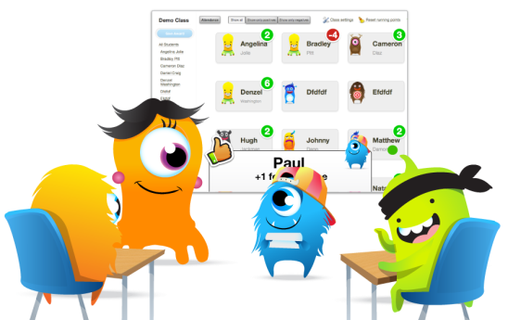

**House system:**

At Mid Calder Primary we have 4 houses; Almondell, Calderwood, Cunigar, and Linhouse.

Each pupil and member of staff are assigned to a house and each house has a Primary Seven House Captain and Vice-Captain. Each pupil will receive a badge with their house colour (if this is lost the pupil will have to replace the badge). Using Class Dojo pupils can receive house points by demonstrating the school values, displaying positive behaviour and for personal successes. Around the school and in the playground pupils can also receive catch me cards from members of staff which will have one house point, these points are added to their Class Dojo. On a Friday pupils total their points; within each class, the top 4 pupil scores receive top scorer, the top scorers names are submitted to a house raffle that will happen once a term, the winner for each house will receive a prize. Individual points will also be added to the house points and these totals will be shared at assembly. (Primary Sevens have the responsibility of collecting the house points and top scorers). Each term the winning house can negotiate a reward for their success.

MC900389772[1]MC900389772[1]

Cunigar Top Scorer

Pupil:

Class:

Date:



Almondell Top Scorer

Pupil:

Class:

Date:



Almondell Top Scorer

Pupil:

Class:

Date:



Linhouse Top Scorer

Pupil:

Class:

Date:



Cunigar Top Scorer

Pupil:

Class:

Date:



Cunigar Top Scorer

Pupil:

Class:

Date:



Linhouse Top Scorer

Pupil:

Class:

Date:



Cunigar Top Scorer

Pupil:

Class:

Date:



Calderwood Top Scorer

Pupil:

Class:

Date:



Linhouse Top Scorer

Pupil:

Class:

Date:



Almondell Top Scorer

Pupil:

Class:

Date:



Cunigar Top Scorer

Pupil:

Class:

Date:

Cunigar Top Scorer

Pupil:

Class:

Date:

Calderwood Top Scorer

Pupil:

Class:

Date:



Calderwood Top Scorer

Pupil:

Class:

Date:



**House Point Totals**

|  |  |  |  |  |
| --- | --- | --- | --- | --- |
|  | Class: | | | |
| Total House Points | | | |
| Date | Almondell | Calderwood | Cunigar | Linhouse |
|  |  |  |  |  |
|  |  |  |  |  |
|  |  |  |  |  |
|  |  |  |  |  |
|  |  |  |  |  |
|  |  |  |  |  |
|  |  |  |  |  |
|  |  |  |  |  |
|  |  |  |  |  |
|  |  |  |  |  |
|  |  |  |  |  |
|  |  |  |  |  |
|  |  |  |  |  |
|  |  |  |  |  |
|  |  |  |  |  |
|  |  |  |  |  |
|  |  |  |  |  |
|  |  |  |  |  |
|  |  |  |  |  |
|  |  |  |  |  |
|  |  |  |  |  |
|  |  |  |  |  |
|  |  |  |  |  |
|  |  |  |  |  |

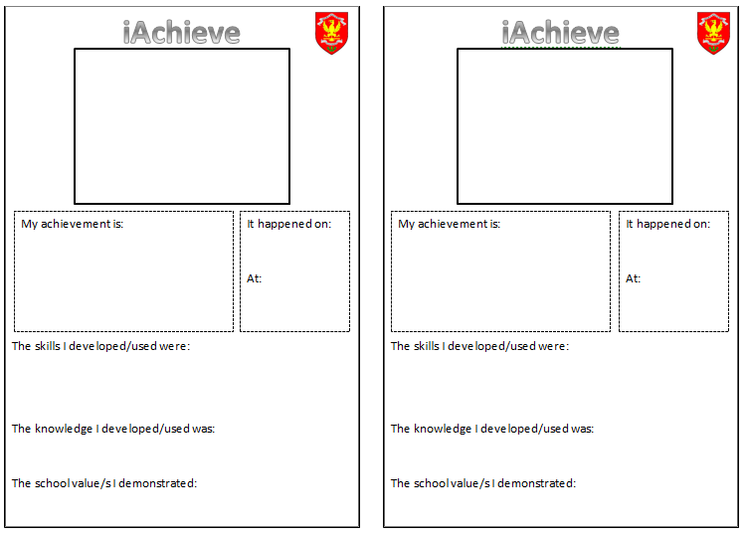

**Appendix 7: Uniform Letter**

Date:

Dear Parent/Carer,

Mid Calder Primary School actively encourages children to wear school uniform. The benefits of wearing school uniform are:

* Differences between pupils are reduced, which in turn reduces some of the causes of isolation and bullying;
* The self-esteem of particular groups can be improved;
* Security can be improved – it is easy to spot who does and does not belong to the school;
* It can improve the image of the school in the local community.

In school session 2014/15 we issued a uniform consultant to parents, pupils and staff and the following school uniform was agreed:

* Red polo shirt and **grey** school jumper/ school cardigan

or

* Shirt/blouse and tie and grey v neck jumper/ v neck cardigan
* Grey trousers/ skirt/ pinafore/ school shorts
* Grey tights preferred
* In the warmer weather children can wear a red cheque summer dress with a red cardigan.
* A defined gym kit was also requested which consists of black shorts and a plain white t-shirt or school t-shirt.
* It was also agreed that children should not be wearing make-up or nail varnish.
* With regards to jewellery children should only wear a watch and stud earrings.
* Today …………………. attended school not wearing the correct school uniform. Please can you ensure that your child wears the agreed uniform as set out above. If the school can support you with this please contact the school office.

Yours sincerely

N Thompson

Head Teacher

**Uniform Letter**

Pupil Name: …………………………………………………………………….………… Class: …………………………………………………………

Dear Miss Thompson

I confirm I have received a uniform letter from you dated ………………………………

Signed: …………………………………………………………………….…………

**Appendix 8: Pupil Reflection Log**

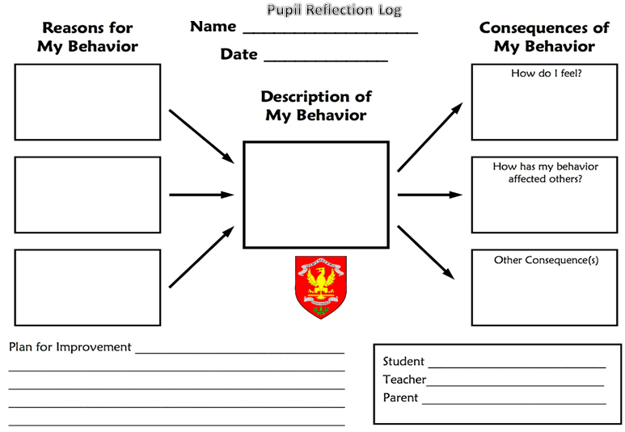

**Loss of Free Time Friday Reflection Log**

Name: Class: Date:

(To be completed by teacher)

_________________ has lost ________ minutes of Free Time Friday because:











(To be completed by pupil)

Which part of your class charter/school values did you not follow?

(To be completed by pupil)

Ways I can make better choices are:











(To be completed by parent)

Parent comment:

Teacher: Pupil: Parent:

Please return to school on Monday.

**Appendix 10: Behaviour Group Referral Form**

Pupil name: Class: Date:

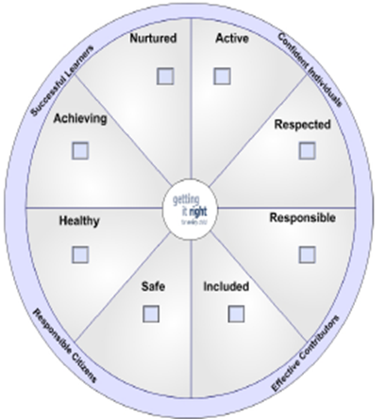

Description of concern:

Strategies already implemented/ trialled:

DHT follow up:

Teacher signature:

**Appendix 5: Playground Incident Form**

**Free Time** **Friday Chart**

Name: Class:

My target:

|  |  |  |  |  |
| --- | --- | --- | --- | --- |
|  | **Morning – Break**  **(3 minutes)** | **Break – Lunch**  **(3 minutes)** | **Lunch – Home**  **(3 minutes)** | **Total amount** |
| **Monday** |  |  |  |  |
| **Tuesday** |  |  |  |  |
| **Wednesday** |  |  |  |  |
| **Thursday** |  |  |  |  |
| **Friday** |  |  |  |  |

|  |  |  |  |  |
| --- | --- | --- | --- | --- |
|  | **Morning – Break**  **(3 minutes)** | **Break – Lunch**  **(3 minutes)** | **Lunch – Home**  **(3 minutes)** | **Total amount** |
| **Monday** |  |  |  |  |
| **Tuesday** |  |  |  |  |
| **Wednesday** |  |  |  |  |
| **Thursday** |  |  |  |  |
| **Friday** |  |  |  |  |

 **Free Time** **Friday Chart**

Name: Class:

My target:

**Appendix 12: Playground Letter**

Date:

**Playground Incident**

Dear Parent/Carer

It is with regret that I have to inform you that …………………………… was involved in an incident in the Playground today.

Details are as follows:

* Fighting
* Causing Injury
* Swearing
* Wilfully damaging school property
* Refusing to follow Supervisor’s instructions
* Giving cheek to the Supervisor
* Leaving school without permission
* Spitting
* Other ……………………………………………………………………………………

Action taken by the school is as follows:

* Warning given
* Detention for 1 days
* Letter home

Yours sincerely

N Thompson

Head Teacher

………………………………………………………………………………………………………………………………………………………………………………………………………………………………………………………………………………

**Playground Letter**

Pupil Name: …………………………………………………………………….………… Class: …………………………………………………………

Dear Miss Thompson

I confirm I have received a Playground letter from you dated ………………………………

Signed: …………………………………………………………………….…………