Porridge playdough
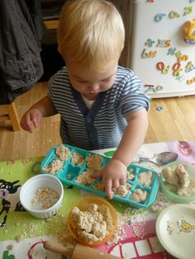
2 cups of plain flour
1 cup of salt
2 tablespoons of oil
2 tablespoons of cream of tartar
2 cups of hot water
1-2 cups of oatmeal or porridge oats
Mix the flour, salt and cream of tartar, add the oil and stir, add the hot water one cup at a time, stirring in between. When cool enough knead until it stops being sticky then add the oats to make the desired consistency.
This makes a lovely textured, gooey, lumpy sensory playdough, add some cutters, spoons, rolling pins, baking trays etc. and let the fun begin.

