Activity ideas for an at home sports day! 2020

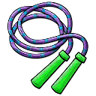  Activity 1 – Skipping  Equipment : skipping rope, timer  Can you skip for 1 minute?  Don’t rush; find a steady rhythm, playing music helps. Don’t’ worry if you get tangled; try again until the end of the minute!  Hot & Spicy - Can you try crossing your arms while skipping? | 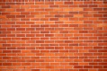  Activity 2 – Wall throw  Equipment : ball, wall, timer  How many bounce throw & catches off the wall can you do in 1 minute?  If you drop the ball, that’s okay –keep going!  Can you clap or touch your head before catching the ball? | Activity 3 – Water cup challenge  Equipment : plastic cup with water, 2 markers ie plant pots, chalk crosses, timer  Place your markers with 4 long strides/paces between each other. Fill your cup with water.  In 1 minute how many times can you travel around your markers, with water left in your cup at the end of the minute! There and back counts as one.
Activity 4 – Target throw  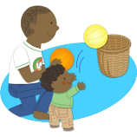  Equipment: basket, marker, ball or, balled socks, helper, timer  Place your basket and walk -  3 long strides away then place a marker  In 1 minute how many times can you throw your ball or socks into the basket? | Activity 5 – Star jumps  Equipment : timer, upbeat music  In 30 seconds how many star jumps can you do?  Make sure you move your arms and legs out into a star and back together to count as 1.  For half the minute can you perform Burpees? | Activity 6 – Racket Keepie ups  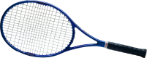  Equipment: bat or racket, ball, balled socks or balloon.  How many keepie ups can do with the ball and racket non-stop for 30 sec.  If you drop the ball, I’ts okay, pick it up and keep going!  Can you turn your racket over as you catch and bump the ball up?

Activity 7 – Astronaut Moon Jump or Standing long jump  Equipment: best on grassy area, measuring tape, marker  How far can you jump? Using the link below to show you how to set this up. See how far you can jump from a standing position.  Remember to use your arms to help you jump and measure from the start point to the back of your heal where you first land.  Video resource: https://youtu.be/tf7YG9xwscA | Activity 8 – Under & Over Family Challenge  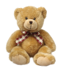  Equipment : something fun to pass like a toilet roll or teddy  Stand with members of your family one behind the other. The first person in line passes fun item over head to person behind, who passes it through their legs .Keep passing over & under till lasts person receives item and runs to the front and to begin again! Stop when person who started game arrives back at the front. How quick can you do it? | Activity 9 – High Knees  Equipment: timer  Can you run on spot with high knees for a 30 seconds/ a minute? Who keeps I up the longest?  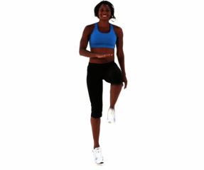
Activity 10 – Footie Dribble  Equipment: 2 markers, ball ,timer  How many times can your dribble the ball with your feet from the start point, round a marker and back to the start to count as one? Place the markers 4 large paces away from each other. You have 1 minute!  Place two more markers in between the starting and ending marker to dribble around. | Activity 11 – Tattie & Spoon  Equipment: A tattie, spoon, markers, timer  Place your markers with 4 long strides/paces between each other.  Can you balance the tattie on the spoon from the start point, round a marker and back to the start to count as one.  How many times can you do this in 1 minute without dropping the tattie?  Include an obstacle that you have to travel over or under. | Other Ideas  - Can you make medals for the competitors  - Find out about an Olympic hero in a sport you like  - Write a newspaper report about the events  - Make a poster about your Sports Day  - Make a film about it – You could add your own amusing commentary

