P2/1 and P2 Home Learning Grid - Week 12
Literacy
Story Time from Home will continue this week but the last story will be on Friday.
https://blogs.glowscotland.org.uk/wl/lpsblog/?s=story+time+from+home
Please continue to use the Oxford Owls website to choose and read books.
https://home.oxfordowl.co.uk/
Phonics – you can practise the sounds we have learned on this website. No login needed.
http://www.letters-and-sounds.com/phase-2-games.html
Numeracy
Please continue to practise number and maths activities using Numbots, Sumdog and Heinemann Active Maths.
STEM Challenges
Choose a challenge. Remember to draw a plan of your design and make a list of what you will use.
Water Slide  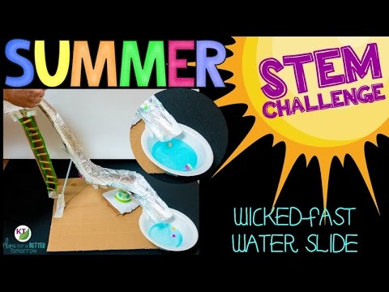  Make a water slide for a marble or bead to slide down.  Rules  There must be a way of getting up the slide.  It must have a pool at the bottom of the slide.  Only one marble or bead to come down at a time. | Mini Golf  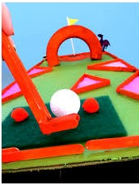  Make a mini course for playing during the holidays.  Rules  It must have only one hole.  It must have a flag at the hole.  It must have at least two obstacles. | Umbrella  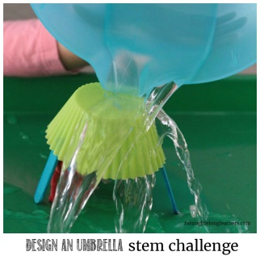  Make a mini umbrella.  Rules  Pour on one small cup of water to test.  Can you find a waterproof material to use?

P2/1 and P2 Health & Wellbeing Fitness Activity Grid
Please make sure you are being careful when completing any of these activities and that you are supervised by an adult.
SMOOTHIE MAKER  Can you make up your own smoothie and share with your family as a healthy start to the day?  What ingredients will you put in?  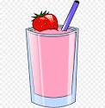 | STAMINA  Can you cycle, walk, jog, run or scoot for;  15 minutes without stopping?  How far did you go?  Who completed it with you? | ASSAULT COURSE  Can you design your own assault course?  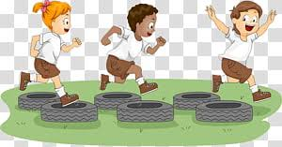  What different things will you include?  How long did it take you to complete?  Who else can you get to complete it? | VIDEO MAKER  Can you create your own;  Just Dance  Joe Wicks  Cosmic Kids  What actions will you put in?
DANCE  Can you play a game of musical statues with others in your house?  Who stayed still the best?  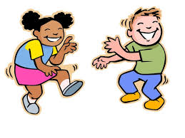 | MINDFULNESS  Complete a Cosmic Kids yoga session, here’s some to choose from;  FROZEN:  https://youtu.be/xlg052EKMtk  TROLLS:  https://youtu.be/U9Q6FKF12Qs  TWILIGHT THE UNICORN OF DREAMS:  https://youtu.be/RLOOOjGAM1s | BE THE TEACHER  What is your skill?  Can you teach someone in your family/house your skill?  For example; a sporting skill, karate, dance move, Yoga pose | NATURE WALK  Can you take a walk with your family and play eye spy?  How many different things did you spy along the way?  How many animals?  Plants?  Water ways?
SPELLING FITNESS CHALLENGE  Spell your full name and complete the challenges;  A – 10 Jumping Jacks N – 4 Lunges  B – 30 Second plank O – 3 Burpees  C – Crab walk 5 metres P – 10 second Rocket jumps  D – 10 press ups Q – Run on the spot 1 min  E – 10 sit ups R – 7 Jumping Jacks  F – 5 Cartwheels/egg rolls S – 4 leg kicks  G – Headstand/Balance T – 5 sit ups  H – 4 rolls of your choice (be careful) U – 15 second plank  I – 10 Toe touches V – 3 cartwheels/egg rolls  J – 5 tuck jumps W – Arabesque/Starship balance  K – 5 press ups X – 2 rolls of your choice (be careful)  L – 3 spins Y – 5 lunges  M – 10 leg kicks Z – 8 Jumping Jacks |  |  | DAILY CHALLENGES  Go to the Daily PE Challenges on Twitter  @WLPENetwork  How many challenges can you do?  What did you score?  Can you challenge someone in your house to complete them too?

Please make sure you share with us what you are doing!
Here are some more links you might like to try if you’re not too tired out by now!
Joe Wicks Daily PE Workout
https://www.youtube.com/playlist?list=PLyCLoPd4VxBvQafyve889qVcPxYEjdSTl
Cosmic Kids Yoga
https://www.youtube.com/user/CosmicKidsYoga
This plan has been amended from one created by staff at Simpson Primary School in Bathgate. We would like to acknowledge and thank them for this!
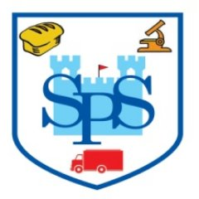
Just Dance
https://www.youtube.com/channel/UChIjW4BWKLqpojTrS_tX0mg
Kidz Bop
https://www.youtube.com/user/KidzBopKids/videos
Oti Mabuse & Marius Lepure Online Dance Class
https://www.youtube.com/user/mosetsanagape/videos
Zumba Kids on Go Noodle
https://app.gonoodle.com/channels/zumba-kids
Mindfulness on Go Noodle
https://app.gonoodle.com/channels/flow
Super Movers
https://www.bbc.co.uk/teach/supermovers
Jumpstart Jonny
https://www.jumpstartjonny.co.uk/home

