Looking for different colours of flowers in the local area
Now that the seasons are changing from Spring to Summer, the trees are covered with green leaves and lots of flowers are beginning to blossom with lovely colourful flowers, here are some I have in my garden or have seen while out for a walk. Why don’t you have a look in your garden or when out on your travels for different colours of flowers in your area. Ask a grown up to tell you the name or if they don’t know you can take a photo and research the name at home. Count how many different colours and species you can find. You can use the ‘PlantSnap: Identify Plants’ app to identify the flowers, Mrs Hawthorn.

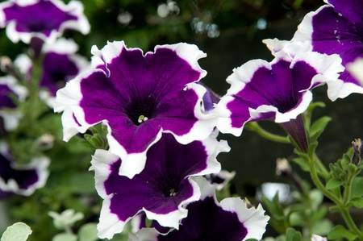 Purple and white petunias
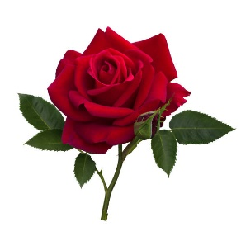 Red rose
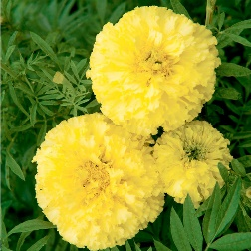 Yellow marigolds
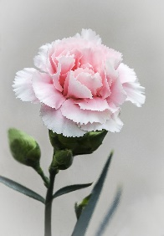 Pink carnations
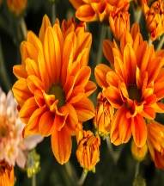 Orange chrysanthemums
Maybe you could draw some lovely colourful flowers to show us.

