P3 Spelling Hunt 9/6/20
Can you find all the spelling words ‘ow’ and ‘wa’ words. They are each marked with a cross. There are 9 of each to find. Good luck!
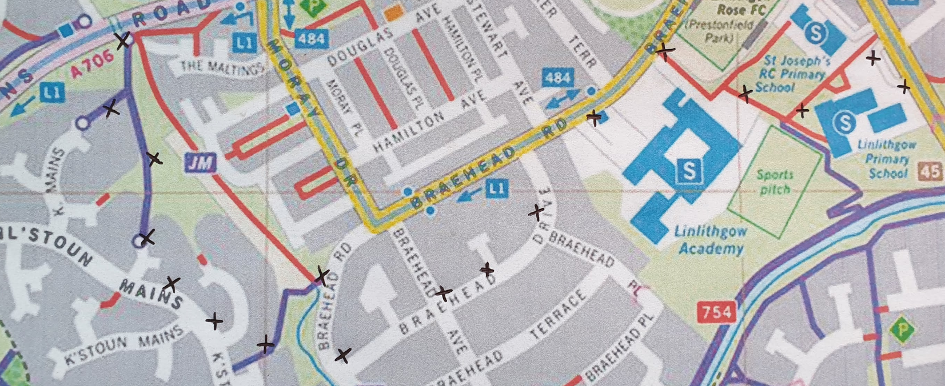

Complete the table below when you find the words.
wa words | ow words

