Put what you completed in here

Colour or write in your medal | 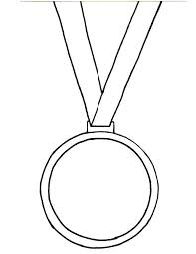 | 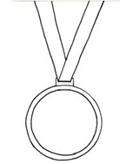
My Healthy challenge log
1 activity a day is a bronze medal, 2 activities is a silver medal, 3 activities is a gold medal!
(If you don’t have those colours choose your own for each medal)

