Healthy challenge grid
Can you complete the activities on the chart? Tick them off when you do them.
DANCE  Can you play a game of musical statues with others in your house?  Who stayed still the best? | 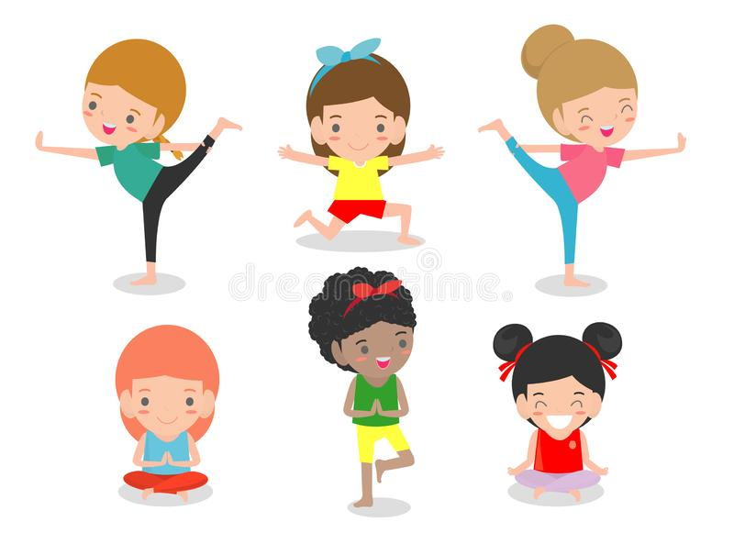  What other activities can you think of? | STAMINA  How long can you cycle, walk, jog, run or scoot for?  Can you do 15 minutes without stopping?  How far did you go?
ASSAULT COURSE  Can you design your own assault course?  What different things will you include?  How long did it take you to complete? | SMOOTHIE MAKER  Can you make up your own smoothie and share with your family as a healthy start to the day?  What ingredients will you put in? | MINDFULNESS  Complete a Cosmic Kids yoga session.  Can you practise one of the breathing exercises?
BE THE TEACHER  What is your skill?  Can you teach someone in your family/house your skill?  For example; Sporting skill, karate, dance move, Yoga pose | DANCE  Can you play a game of musical statues with others in your house?  Who stayed still the best? | VIDEO MAKER  Can you create your own exercise video?  It could be a dance, yoga, gymnastics video or even like Joe Wicks.  What actions will you put in?

