P3 Spelling Hunt
Black Circles are ‘ea’ words and black crosses are ‘sp/spr’ words. Complete the table below when you find the words.
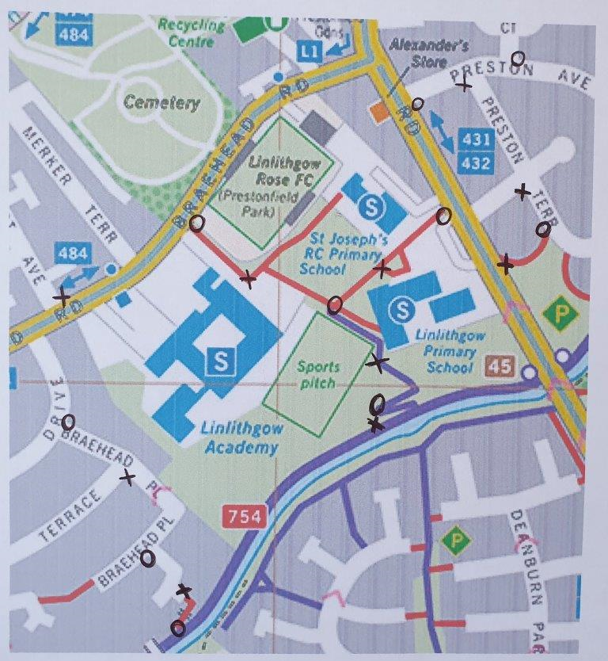
sp/spr words | ea words

