Oxford Owl Ebooks
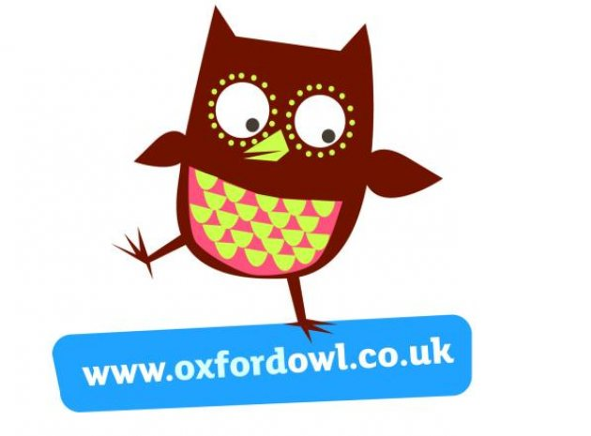
- Login to the following website: https://www.oxfordowl.co.uk/

- Click on the following ‘My class login’ at top of page

- Username: P2/1lps
Password: My books

- Click on ‘My Bookshelf’ 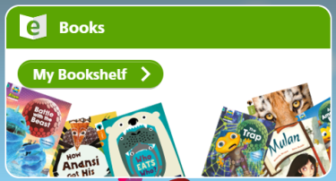

- Click on age groups and choose a book that is appropriate for and interests your child.
