Numeracy  Complete the emoji multiplication array activity on Seesaw. Use your laminated log in details to access your account. | Times Tables  Practise quick fire times table questions on Hit the Button.  https://www.topmarks.co.uk/maths-games/hit-the-button  Focus on the 2, 5 and 10 times tables! | Word Wizard  Can you use a dictionary to find 5 new words? Remember to write down the definition to teach the class. These words will be added to our Vocabulary wall display. Use an online dictionary or ask to borrow a class one.  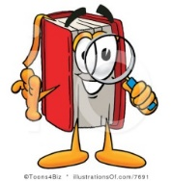
Read for Enjoyment  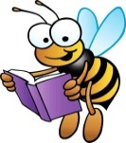  Pick up a book, comic or any other text and spend some time reading for enjoyment. Write down the title and author so you can keep track of everything you have read. Would you recommend it to a friend? | Remembrance  Look at any piece of rememberance art.  What do you like about it? What features make it stand out and effective? Think about the image that it creates in your mind – draw or represent this image, using any media. | In the News  Choose a news item (TV/radio/internet/magazine) that interests you. Can you summarise the main points? Write it down and draw a picture if it helps you to remember.
P.E.  Try to do 30 minutes of exercise each day. What you do is up to you! | Family Time  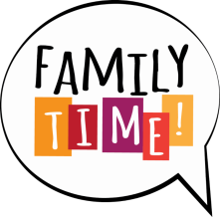  Spend some time with your family doing something fun! You could go for a walk or play a board game… It’s up to you! | Glow Blogs  Visit the school website and have a read of the class blogs. Leave a comment to let the class know what you enjoyed reading about!
Name ________________

What do I do?
Choose at least one task from each row. You can do more if you want to. We will be discussing our home learning in class time so you do not need to hand in completed tasks. Just be prepared to share your learning on
Monday 7th December.

Self-Assessment
When you complete a task colour the circle to show how you felt about it. If you don’t have the colours just write
R-A-G.

Red – I found this challenging.
Amber/Yellow – I needed some help.
Green – I’m confident.

Please remember that if you need paper or other resources to complete a task, ask the teacher!

P3 November Home Learning
Name _______________

