Follow the instructions for each day. There are no rules. Just use your imagination.

Day 15
There is a circus in town. Build a place for the performance.
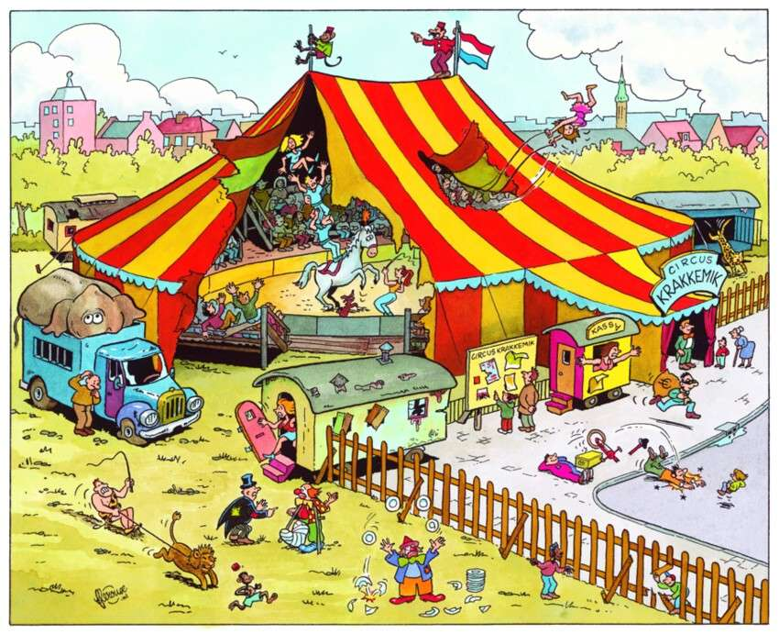

Don’t forget to share your photos with us.

