Follow the instructions for each day. There are no rules. Just use your imagination.

Day 14
Mr Hilton hires you to build a new hotel.
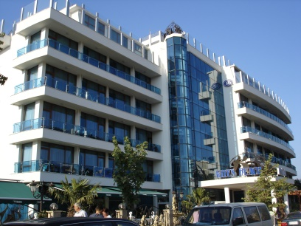

Don’t forget to share your photos with us.

