Weekly Focus
Spelling pattern: Revision of the spelling patterns taught. Choose a couple of spelling patterns from the last few weeks to practise.  Maths: I can find numbers to 100, I can partition numbers, I can compare numbers, I can say one more and one less within 100  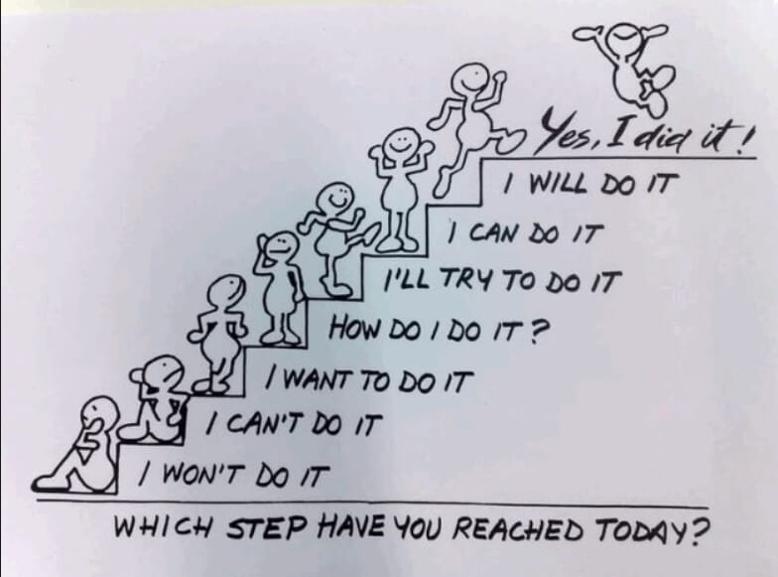 | Spelling  Choose one of the spelling cards (outdoor or other) each day to help you learn your spelling words. | Summer Word search  Can you complete the summer word search? | Reading  Continue to use EPIC! Or Oxford Owls for reading. | My Favourite Memories from This Year  Write about your highlights of P2. Maybe it was the Nativity, class talk, Music with Dave, PE, numeracy, reading, writing, class assembly, science, construction…
 | Lesson 1: Counting to 100  Watch the video  https://whiterosemaths.com/homelearning/year-1/  Play https://www.topmarks.co.uk/learning-to-count/helicopter-rescue | Lesson 2: partitioning numbers  Watch the video  https://whiterosemaths.com/homelearning/year-1/  Play Shark Numbers  http://www.ictgames.com/sharkNumbers/mobile/index.html | Lesson 3: Comparing numbers  Watch the video  https://whiterosemaths.com/homelearning/year-1/  Play http://www.learnalberta.ca/content/me3usa/flash/index.html?goLesson=5 | Lesson 4: Comparing numbers (2)  Watch the video  https://whiterosemaths.com/homelearning/year-1/  Lesson 5: One more One less  Friday’s Maths Challenge  https://whiterosemaths.com/homelearning/year-1/
 | Write an email to your teacher and tell them the best things about being a Marine Biologist this term. | In your family, take turns to say what you have seen in the sea. Start by saying when I went out in my submarine I saw… Each person has to start the same way and repeat the list of things that have been seen before and then adding on something new. How many things can you remember? Can you find something for each letter of the alphabet? | Make an observation window for your bath! I am not sure that we are ready to swim in the sea yet so let’s stick to bath time or using a big bowl/bucket of water for our observations! Add some bubbles to your bath/bowl and then get your adult to hide/sink some objects in the water. Now find a glass jar/small bowl /a clear plastic container, that don’t have holes in it. Hold the sides of the container and push it through the top of the water just a little. Don’t let the water go over the sides of the container! You should be able to see what is at the bottom of the ocean without getting wet! | If you want to continue your journey as a marine biologist check out these websites which will give you lots of ideas how to help support the oceans and the sea creatures. · https://www.mcsuk.org/explore-and-discover/  ·https://www.wwf.org.uk/where-we-work/oceans  https://plasticoceans.uk/  · https://oliveridleyproject.org/

