Weekly Focus |  |  |  | 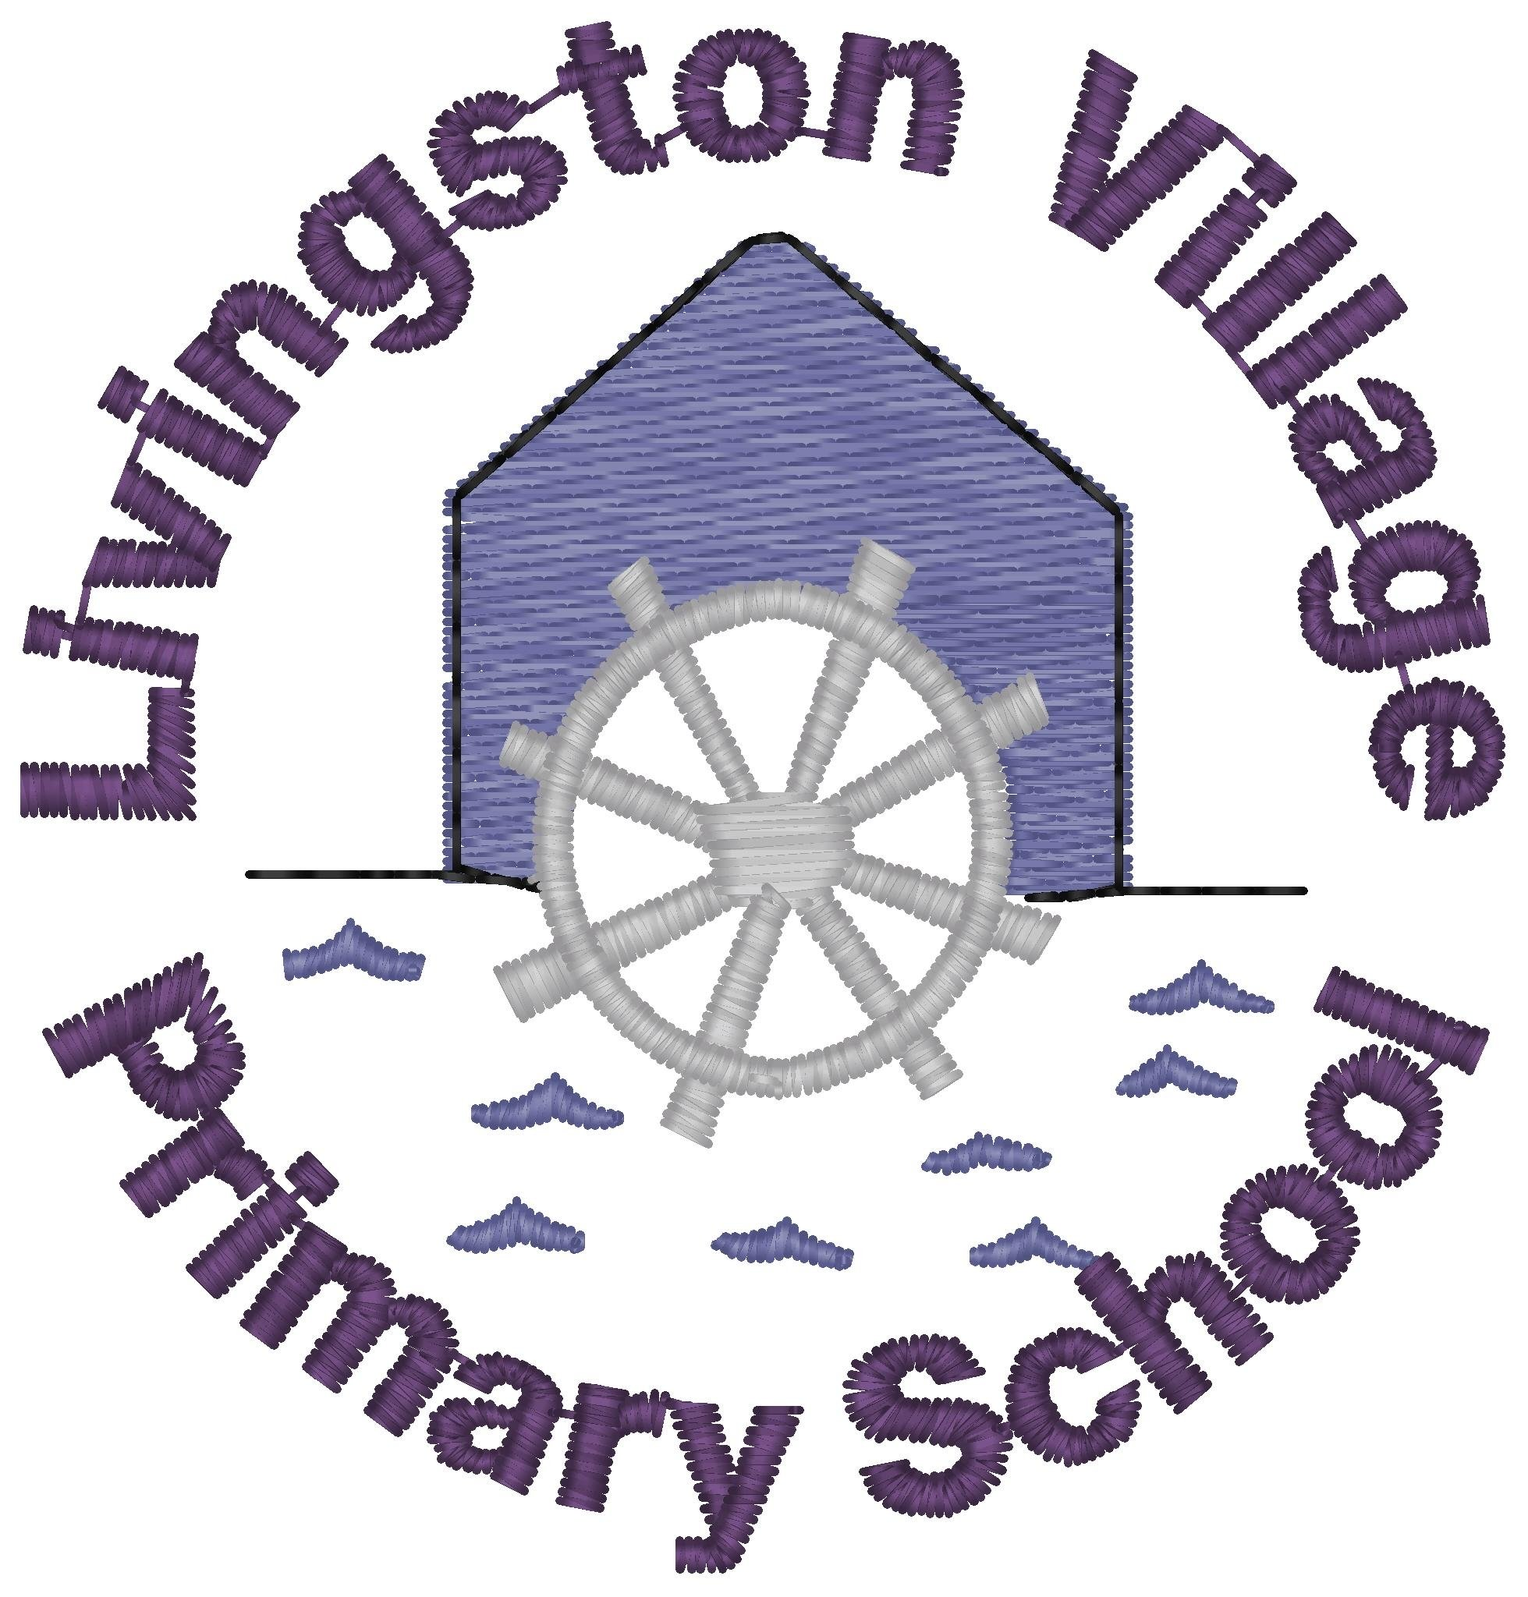
Holidays are coming. Here is a selection of fun activities for you to do. | We are now entering our last week of P1. What has been a magic moment for you this year? Write a couple of sentences about your magic moments. Draw a picture to go with your sentences. | Try the Chiming fork activity. What do you hear? What do you notice about the sound when it is far away from your ears/close to your ears? | Draw an outdoor picture. Draw a bumble bee for each spelling word. Inside each bee write one of your spelling words. Colour in your picture. | Have fun playing the floating ball game. Instructions attached.
 | Can you reveal the hidden summer pictures by working out the answers to the sums and then choosing the correct colour to colour each box? | Have a go at making your own soap powered fish. See the attached instructions. | Can you make your own butter and discover the science behind it? Instructions attached. | With a partner play the attached roll, add and colour game. You will need dice and two coloured pencils/pens.
Quote of the Week | Write an email to your teacher and tell them the best things about being a Marine Biologist this term. | In your family, take turns to say what you have seen in the sea. Start by saying when I went out in my submarine I saw…  Each person has to start the same way and repeat the list of things that have been seen before and then adding on something new. How many things can you remember? Can you find something for each letter of the alphabet? | Make an observation window for your bath! I am not sure that we are ready to swim in the sea yet so let’s stick to bath time or using a big bowl/bucket of water for our observations! Add some bubbles to your bath/bowl and then get your adult to hide/sink some objects in the water. Now find a glass jar/small bowl /a clear plastic container, that doesn’t have holes in it. Hold the sides of the container and push it through the top of the water just a little. Don’t let the water go over the sides of the container! You should be able to see what is at the bottom of the ocean without getting wet! | If you want to continue your journey as a marine biologist check out these websites which will give you lots of ideas how to help support the oceans and the sea creatures.  - https://www.mcsuk.org/explore-and-discover/  - https://www.wwf.org.uk/where-we-work/oceans  https://plasticoceans.uk/  https://oliveridleyproject.org/

