Follow the instructions for each day. There are no rules. Just use your imagination.

Day 11
Prince Charming hires you to build a castle for him and Cinderella.
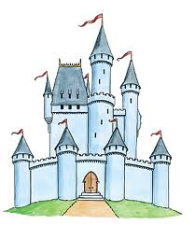

Don’t forget to share your photos with us.

