Livingston Village Primary School ‘At Home’ Sports Day
15th June 2020

Welcome everyone to our ‘At Home’ Sports Day, we realise this is not our usual Sports Day Event but hope that you enjoy taking part in the different activities. Although we can’t gather together, we can still compete for our houses.
There are 12 activities for you to choose from. The number of recommended activities you should complete depends on your age but you can complete extra activities for extra points! Please make sure you follow the instructions for each activity, record your score then upload your scores to the Microsoft Form at https://forms.office.com/Pages/ResponsePage.aspx?id=oyzTzM4Wj0KVQTctawUZKTNw_FEmcHVFlGESpNOHdVVUQ1VZMU1MSUg5RFJNWTBDTTlWQUdDSE9CMy4u

Stage Group | No. of Activities
P1 | 6
P2 | 6
P3 | 6
P4 | 8
P5 | 8
P6 | 10
P7 | 10

Ideally, our aim is to have everyone participate on Monday 15th June. However, we are aware that weather and time may play a factor in getting this completed so you will have until Thursday June 18th at noon to submit your scores on the Microsoft form at https://forms.office.com/Pages/ResponsePage.aspx?id=oyzTzM4Wj0KVQTctawUZKTNw_FEmcHVFlGESpNOHdVVUQ1VZMU1MSUg5RFJNWTBDTTlWQUdDSE9CMy4u

FOR YOUR SAFETY:
Please make sure that you take care while performing any of the Sports Day activities. You should wear clothing for PE, tie your laces and have adult supervision.

We hope you have fun. We cannot wait to see all you get up to and good luck to everyone taking part!
Sharing on Twitter: @LVPSsportandPE and on the blog.
Please upload photos to TEAMs or send to your teacher.

LVPS Staff (activities below)

Activities

Complete at least the recommended number of activities for your stage group below. There are 12 activities to choose and all of them have explanations to help you. Make sure you record your score.
Stage Group | Recommended number of Activities
P1 | 6
P2 | 6
P3 | 6
P4 | 8
P5 | 8
P6 | 10
P7 | 10

Example Score Card
You can use this table to keep your score or you can create your table. Remember that your scores need to be uploaded on the Microsoft Form at

Activity | Skipping | Balance Hold | Wall throw | Speed Bounce | Standing Long Jump | Underarm  Target Throw | Jumping Jacks
Your Score

Dribbling | Overarm target throw | Shuttle Run | Balance & Run | Egg & Spoon

Skipping
Equipment Needed:  Skipping rope  Timer/stopwatch | 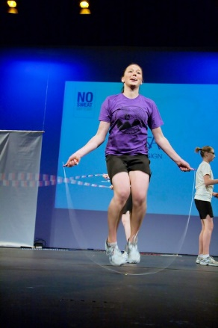
What you need to do;

You are going to skip non-stop for 1 minute counting how many skips you do.

Make sure you keep your hands wide
Give yourself plenty of space to skip
Keep going and don’t stop – Stamina and rhythm is key!

Balance Hold
Equipment Needed:  Space  Timer/stopwatch | 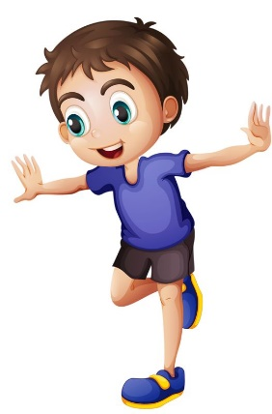
What you need to do;
Pick and hold a balance without falling over or touching anything to steady yourself.
1 point for holding the balance for 30 seconds
2 points for holding the balance for 1 minute
5 points for holding the balance for 2 minutes.

Wall Throw
Equipment Needed:  Ball that you can bounce against a wall  Clear wall and space  Timer/stopwatch | 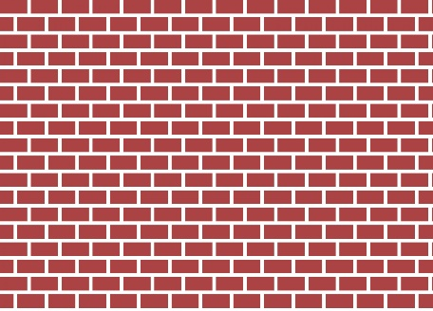  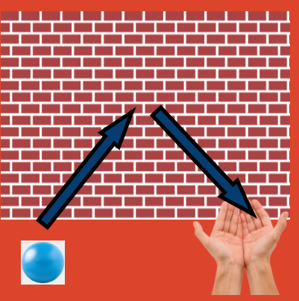
What you need to do;

You are going to see how many passes against the wall you can do in 1 minute.

Stand facing the wall then take 3 paces backwards away from the wall.
When the timer starts throw and catch the ball against the wall while keeping count of every successful catch. The number of successful catches you make is the number of points you have earned.

Speed Bounce
Equipment Needed:  Hurdle or towel or books  Timer/stopwatch | 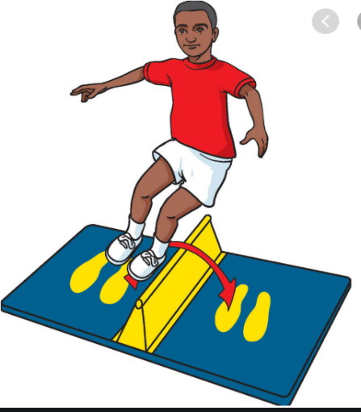
What you need to do;

How many times can you jump over the towel/books/hurdle in 1 minute? Use the video resource below to show you how to set this up correctly and safely,

Video Resource; https://youtu.be/jB1NWH0qpTA

Standing Long Jump
Equipment Needed:  Space  Marker to jump from  Clear landing spot  Measuring tape | 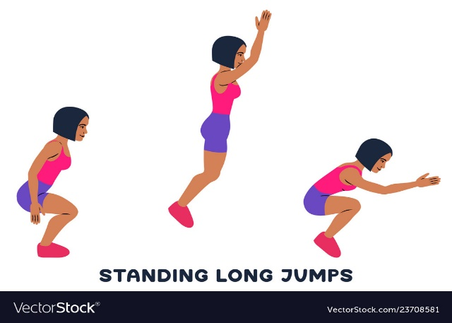
What you need to do;

How far can you jump? Using the link below to show you how to set this up, see how far you can jump from a standing position.

Remember to use your arms to help you jump and measure from the start point to the back of your heal where you first land.

Complete this task for 5 points.

Video resource: https://youtu.be/tf7YG9xwscA

Underarm Target Throw
Equipment Needed:  Space  Basket or object to throw into  Timer  10 balls, beanbags or rolled up socks | 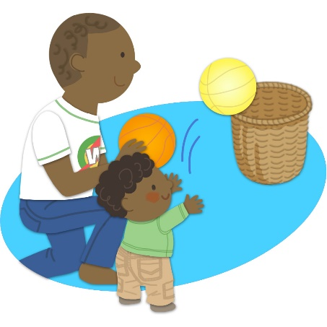
What you need to do;
You are going to see how many balls/socks you can get in to the target in 2 minutes.
Place your target/bin/washing basket 3 or 5 metres away from your start point.

P1 – 3:
Start: 3m Basket

P4 – 7:
Start: 5m Basket

Jumping Jacks
Equipment Needed:  Space  Timer/stopwatch | 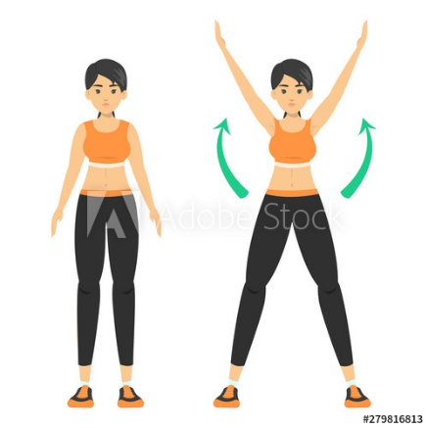
What you need to do;

You are going to complete a full jumping jack non-stop for 1 minute counting how many you do.

Make sure you move your arms and legs out then up and back in to count as ONE.

Dribbling – Your choice (Football, Basketball or Hockey)
Equipment Needed:  ball large enough to dribble  Stick or brush (if doing hockey dribble)  If you don’t have a ball you could use a rolled up pair of socks  2 markers  Timer/stopwatch | 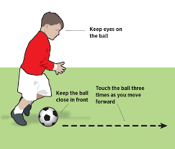  P1 – 3: 3m  P4 – 7: 5m
What you need to do;
You are going to dribbling the ball from the start point, round a marker and back to the start to for one point.

How many times can you do this in 1 minute?

P1 – 3:
Start: 3m Marker

P4 – 7:
Start: 5m Marker

Overarm Target Throw
Equipment Needed:  Space  Item of clothing/outdoor blanket or object to throw into  Timer  10 balls or rolled up socks | 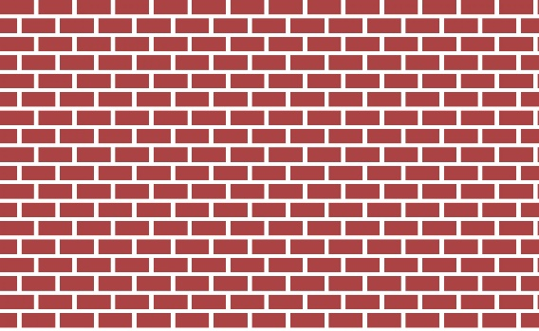
What you need to do;

You are going to see how many balls/socks you can land on the target in 2 minutes.
Place your target 3 or 5 metres away from your start point.

P1 – 3:
Start: 3m Flat Target

P4 – 7:
Start: 5m Flat Target

Shuttle runs
Equipment Needed:  Markers  Measuring tape  Timer/stopwatch | 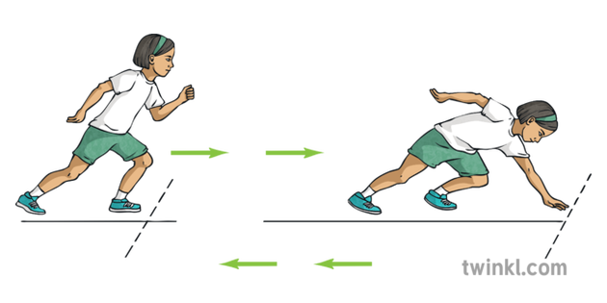
What you need to do;

How many times can you run a 5 metre shuttle in 1 minute? Use the link below to show you how to set this up.

You will need your speed and agility!

Video resource: https://youtu.be/_JlpNSOp8x8

Balance & Run
Equipment Needed:  Markers  Spoon  Pair of rolled up socks  Timer/stopwatch | 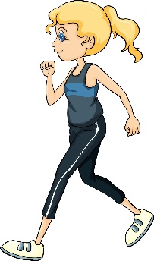
What you need to do;

You are going to balance your balled up socks on your head, run from the start point, round a marker and back to the start for one point.

How many times can you do this in 1 minute? Keep your head up!
P1 – 3:
Start: 3m Marker

P4 – 7:
Start: 5m Marker

EGG & SPOON
Equipment Needed:  Markers  Spoon  Boiled egg or small ball or pair of rolled up socks  Timer/stopwatch | 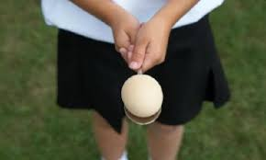
What you need to do;
Balance the egg on the spoon and travel from the start point, round a marker and back to the start. This counts as ONE

How many times can you do this in 1 minute? Try not to drop the egg

P1 – 3:
Start: 3m Marker

P4 – 7:
Start: 5m Marker

