Follow the instructions for each day. There are no rules. Just use your imagination.

Day 10
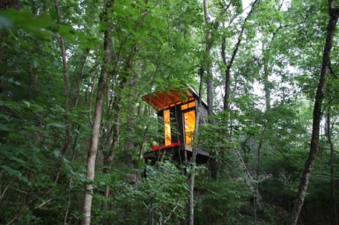
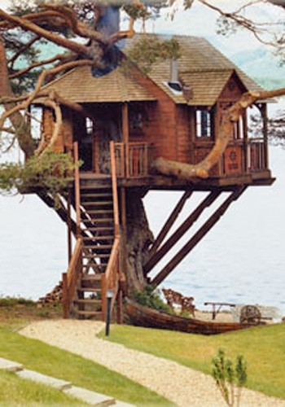
You and your friends decide to build a tree house.

Don’t forget to share your photos with us.

