Follow the instructions for each day. There are no rules. Just use your imagination.

Day 9
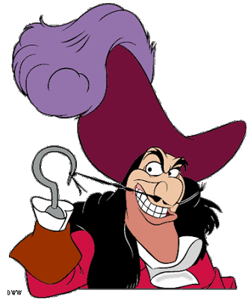
Captain Hook needs a new pirate ship. He wants you to build it.
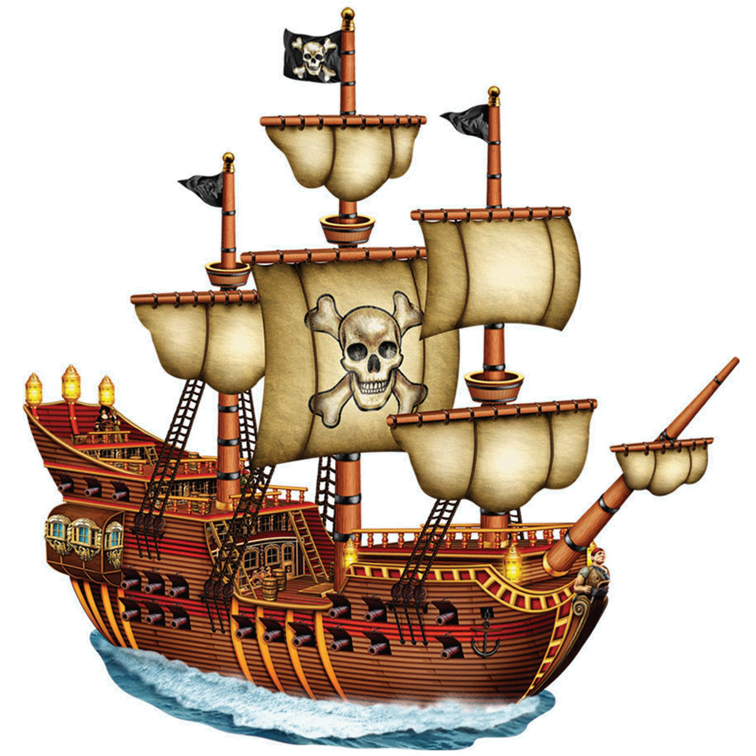
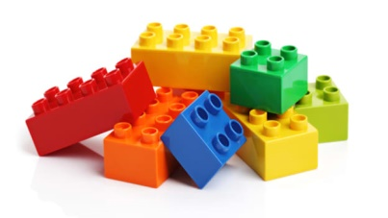

Don’t forget to share your photos with us.

