Weekly Focus
Spelling pattern – oo  Spelling Words  food  room  broom  moon  stood  shook  brook  stool  Maths: I can count forwards and backwards in 2s, 5s and 10s. I can say my 2x table. I can make equal groups from a number of items. I can count back in equal steps. | Spelling  Choose one of the spelling cards (outdoor or other) each day to help you learn your spelling words.  Extra challenge:  Write each of your spelling words in a sentence. | Punctuation  Question marks go at the end of a question. Watch the video below:  https://www.bbc.co.uk/bitesize/topics/z8x6cj6/articles/zcm3qhv  Then have a go at the attached worksheet. If you don’t have a printer have a go at writing your own questions. | Reading  Continue to use EPIC! Or Oxford Owls for reading.  Outdoor Writing  Have a go at activity 3 and 4 from the observation alphabet outdoor learning booklet. | French  Let’s learn the months of the year in French. Listen and then join in with the song  https://www.youtube.com/watch?v=7_u2SigckNQ  Try to play the snakes and ladders game(attached) saying the months in French
 | Lesson 1: Count in 2s  Watch the video  https://whiterosemaths.com/homelearning/year-1/  Complete the attached 2x table worksheets | Lesson 2: Count in 5s Watch the video https://whiterosemaths.com/homelearning/year-1/  Complete the attached counting in 5s worksheet | Lesson 3: Count in 10s  Watch the video  https://whiterosemaths.com/homelearning/year-1/  Complete the attached worksheet | Lesson 4: Add equal groups  Watch the video  https://whiterosemaths.com/homelearning/year-1/  Complete the attached worksheet  Friday’s Maths Challenge  https://whiterosemaths.com/homelearning/year-1/
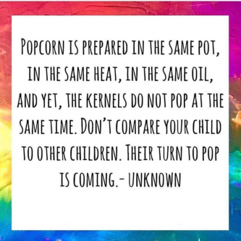  Quote of the Week | Read ‘Sharing a Shell by Julia Donaldson  https://www.youtube.com/watch?v=TCFKWeqb1pY  What is the story about? Could you guess what was going to happen?  Riddles – can you write some riddles and ask others to guess the answers?  E.g. I am a small fish with orange, white and black stripes. Anemones are my friend. | She sells sea shells by the sea shore  The shells she sells are sea shells I’m sure  For if she sells sea shells by the sea shore  Then I’m sure she sells sea shore shells.  https://www.youtube.com/watch?v=K27EpAhx9cc  Can you say it fast? | Draw a picture of some shells with pale wax crayons. Draw the spirals and stripes, and other patterns in the shell shape.  Make a watery paint with a sandy colour to wash over your picture.  If you don’t have paint try boiling some onion skins and use the water. | Play shell Kim’s game power point found on the blog.  What are shells?  https://www.youtube.com/watch?v=9pqe4-29IZA

