Weekly Focus | Write | Say | Make | Do  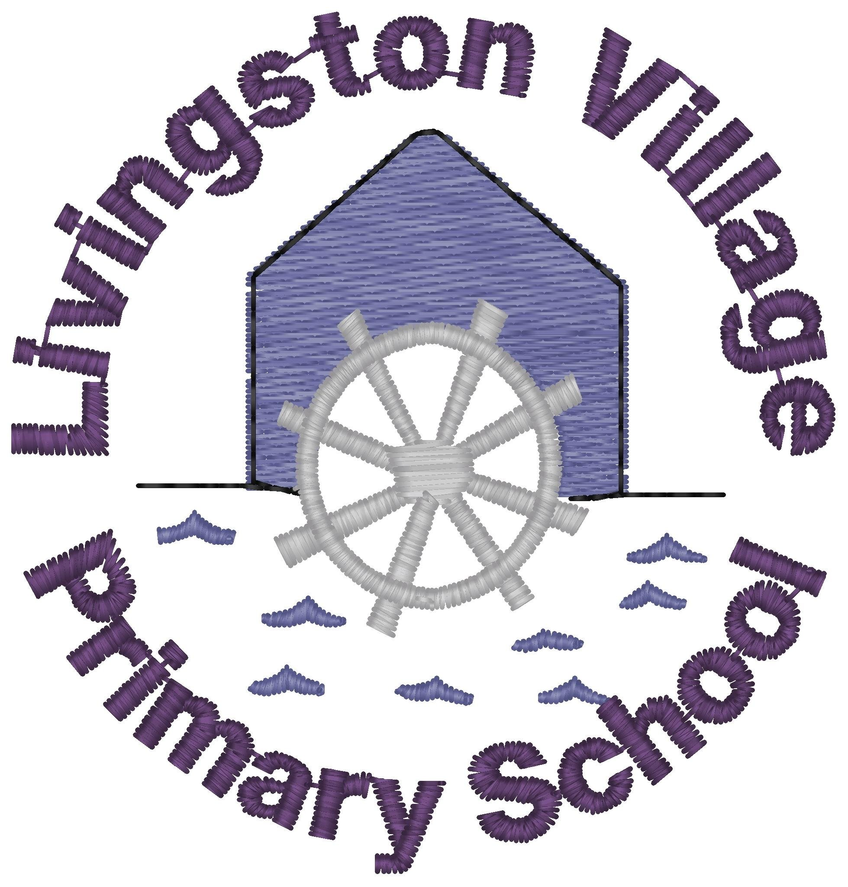
Sound: ear  Tricky Word: once  Spelling Words  hear  dear  fear  ear  near  year  tear  spear  Maths: Sharing- I can describe, make and organise equal groups. I can share out a group of items equally into smaller groups. | Count your spelling words. Draw one shape on the ground or paper for each word. Write a spelling word inside each shape. | Using a musical instrument can you say/sing your spelling words. Working with a grown up see if you can write a song including as many of your spelling words as possible. | Make a beard out of paper. Write out your spelling words and stick them on your beard. Challenge – Can you look sillier than Mrs Smith.(See attached photo) | Play the Buried Treasure game. Select phase 3 and then ‘ear’.  https://new.phonicsplay.co.uk/resources/phase/3/buried-treasure
 | Can you feed the baby owlets? Write how many mice each owlet gets in the circle. Complete the attached worksheet. | Watch the following Elmo videos. Discuss what makes a fair share? How can you share equally?  https://www.youtube.com/watch?v=MFrwrh1gEfk  https://www.youtube.com/watch?v=Nijaqk_yXus  https://www.youtube.com/watch?v=KTFJ9gjfAXg | Hold a tea party for 3 toys or your family. Use playdoh or real food. Start off with 3 items; share them equally, then 6 then 9. Each time think about if it is fair, how many pieces of food does each toy get? | The doorbell rang https://www.youtube.com/watch?v=HZpXuc735pg  Act out the story as you watch. Begin with 12 cookies share them evenly onto 2 plates for the 2 children. Follow the story asking: how many more plates? How do we share them equally? Let’s start with one each and share them? etc.
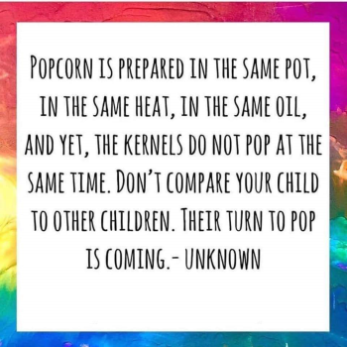  Quote of the Week | Read ‘Sharing a Shell by Julia Donaldson  https://www.youtube.com/watch?v=TCFKWeqb1pY  What is the story about? Could you guess what was going to happen?  Riddles – can you write some riddles and ask others to guess the answers?  E.g. I am a small fish with orange, white and black stripes. Anemones are my friend. | She sells sea shells by the sea shore  The shells she sells are sea shells I’m sure  For if she sells sea shells by the sea shore  Then I’m sure she sells sea shore shells.  https://www.youtube.com/watch?v=K27EpAhx9cc  Can you say it fast? | Draw a picture of some shells with pale wax crayons. Draw the spirals and stripes, and other patterns in the shell shape.  Make a watery paint with a sandy colour to wash over your picture.  If you don’t have paint try boiling some onion skins and use the water. | Play shell Kim’s game power point found on the blog.  What are shells?  https://www.youtube.com/watch?v=9pqe4-29IZA

