Follow the instructions for each day. There are no rules. Just use your imagination.

Day 8
You and 4 friends are stranded on an island. Build a boat to find a way home.
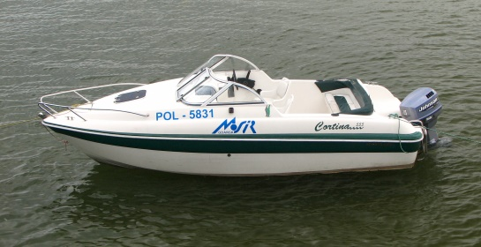

Don’t forget to share your photos with us.

