Follow the instructions for each day. There are no rules. Just use your imagination.

Day 7
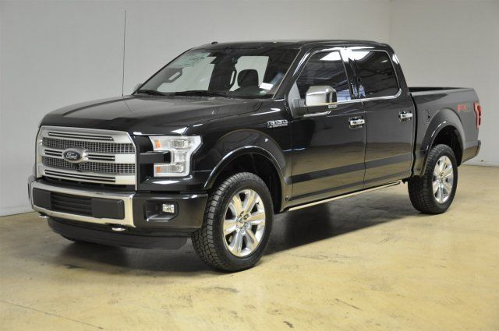
Ford hires you to create the toughest pick up truck in the world.
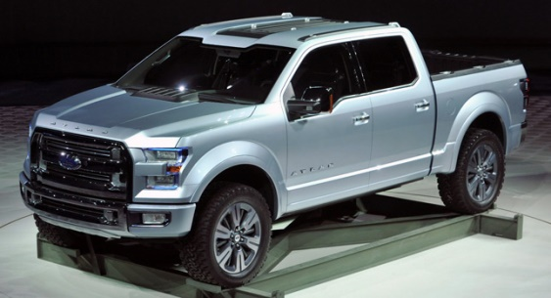

Don’t forget to share your photos with us.

