Weekly Focus | Write | Say | Make | Do  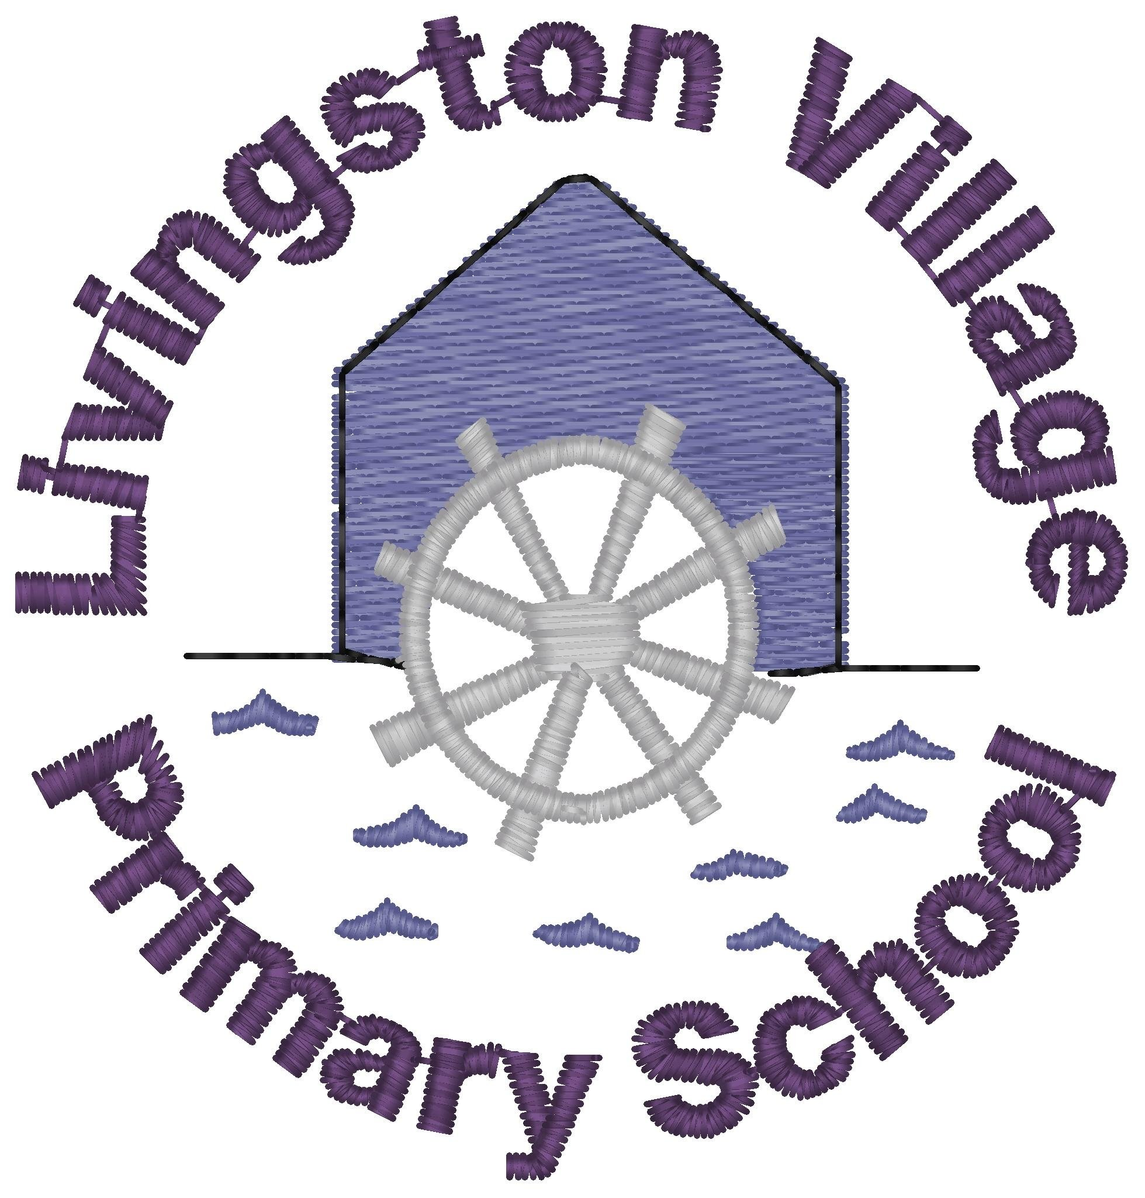
Sound: ire  Tricky Word: other  Spelling Words  fire  hire  wire  bonfire  inspire  admire  spire  tired  Maths: Capacity – Explore using non-standard units to measure how much a container holds. Use the vocabulary full, half full, nearly full and empty.- | In a darkened room use a torch to write your words on the wall, ceiling or in the air. | Can you tell a grown up a sentence using each of your spelling words?  The boy caught his shorts on the wire. | Make your spelling words using pasta, buttons, marbles, coins etc. Take a photo of your words. | Play roll and read using a dice and some counters or buttons. Roll the dice, look at the number, find that row on the grid and read the word in the box. If you can read the word you can cover it with your counter. Can you cover all the words?
 | Find a short wide container and a long thin container from around your house. Draw a picture of each of them. Which container do you think will hold the most? Fill the containers using a cup. Were you right? Complete the attached worksheet. | With a grown up look at Will the Wizard’s potions PowerPoint. Talk about how we know if a container is full, half full or empty. | Look at the Capacity Quiz PowerPoint for some inspiration then make your own Capacity Quiz. Can you share this with members of your family over video call? | Choose 3 containers. Take a cup or empty yoghurt pot and find out how many scoops of rice, sand or water it takes to fill each container. Line your containers up in order from smallest to largest.
Quote of the Week  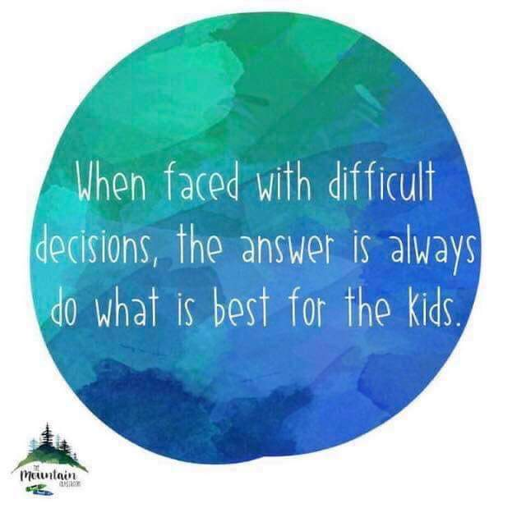 | Plastic Pollution  Write a story about a sea creature that gets into trouble because of the plastic rubbish in the sea. Who saves them?  Draw a picture linked to your story. | Watch https://www.youtube.com/watch?v=xFPoIU5iiYQ  Meal time chat – what ways do you/can you recycle, reduce, reuse and repair so the ocean doesn’t get full of plastic? | Make a poster to tell people how to look after our oceans.  Vocabulary bank:  protect rubbish in bins  recycle tidy up  reuse plastics  reduce danger  stop save  clean up | Keep recycling and tell others to recycle too.

