

Follow the instructions for each day. There are no rules. Just use your imagination.

Day 6

You are stuck on Mars and need to build a new space ship to get home.

C:\Program Files (x86)\Microsoft Office\MEDIA\CAGCAT10\j0215086.wmf

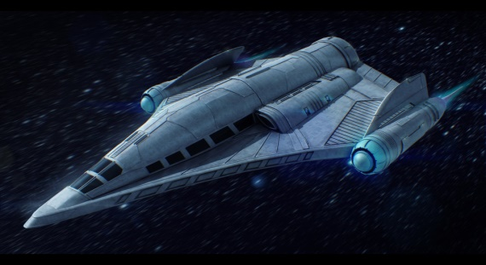

Don’t forget to share your photos with us.