Weekly Focus
Spelling pattern – o-e  Spelling Words  joke  home  hope  nose  broke  throne  smoke  froze  Maths: Shape – I can identify, name and sort 2D and 3D shapes. I can describe shapes by using their properties. I can make a pattern using shapes. | Spelling  Choose one of the spelling cards each day to help you learn your spelling words.  Extra challenge  Make a hopscotch board on the pavement or driveway. In each box write a spelling word. Hop your words. | Grammar  Adverbs  An adverb describes a verb. For example Veronica laughs loudly. Loudly is the adverb. Have a look at the attached PowerPoint then have a go at the worksheet. | Reading  Continue to use EPIC! Or Oxford Owls for reading.  Reading activity: Pick a story book to read. Who was your favourite character and why? Tell a grown up or write it down. | Writing  Can you use your five senses to write an acrostic poem about Spring? A template is attached if you want to use it.
 | Sort 2D and 3D shapes  Watch the videos  https://vimeo.com/420581566  https://vimeo.com/420581162  Complete the attached worksheets or find 2D and 3D shapes around your house and have a go at sorting them. | Name and recognise 2D and 3D shapes Watch the videos https://vimeo.com/420581449 https://vimeo.com/417729027  How many 2D and 3D shapes can you draw and then label? | Patterns with 3D and 2D shapes  Watch the video  https://vimeo.com/420698416  Create your own patterns using shapes. | 2D and 3D shapes  Watch the following clip about the properties of 3D shapes  https://www.bbc.co.uk/bitesize/topics/zjv39j6/articles/zgqpk2p  Play the draw the shapes game attached(either 2D or 3D)
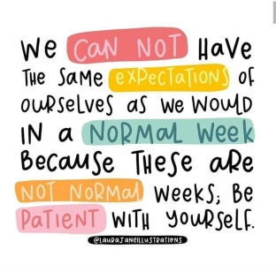  Quote of the Week | Whales  Write an acrostic poem for a whale,  See the template attached  Enjoy :https://www.bbc.co.uk/iplayer/episode/m000cslw/the-snail-and-the-whale. | Watch the videos  https://www.youtube.com/watch?v=W7IbcwcFSws  https://www.youtube.com/watch?v=JOJkvhSpBiQ&t=6s | Try the experiment :  Eating can be a strain. (pdf attached) | Measure the size of a grey whale (12m) (36 child walking steps approx.) on your pavement outside your house.  How big is it compared to you, or your family?  How much bigger is a blue whale?(25m) (75 child walking steps approx)

