**James Young High School **

**These are my concerns-**

* *What worries the young person, causes them stress or difficult behaviours.*

**These are my strengths and interests-**

* *Please detail strengths and interests including academic and out of school.*

P7-S1 Transition Passport

***Name –***

***What I like to be called -***

***Primary School –***

***Secondary School -***

***Date of Birth –***

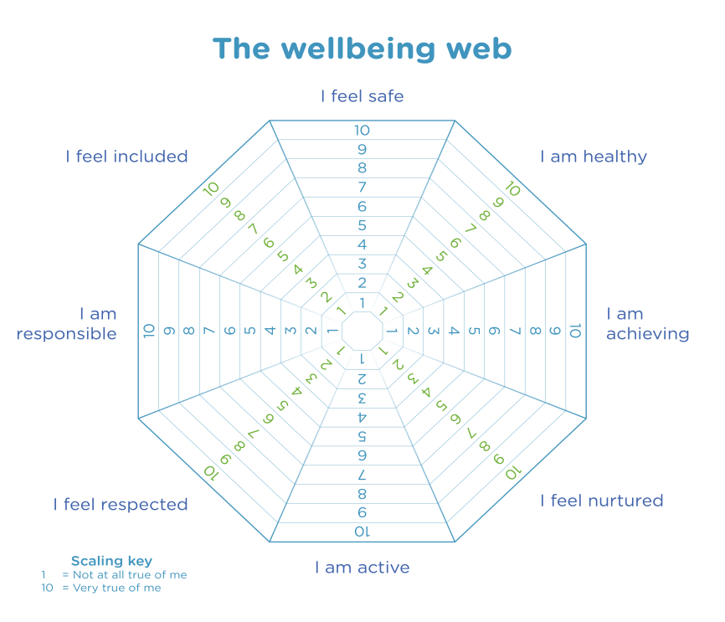

**These are strategies to support me-**

* *What does the young person feel they need? Are there any agencies working with the child? Preferred learning style? Also consult support list.*

**How I will travel to school (circle/highlight)**

* Bus
* Walk
* Taxi
* Car with family
* Bike
* Scooter

**My Favourite Subjects (circle/highlight)**

* Health and Wellbeing
* Literacy
* Numeracy
* Citizenship
* Enterprise
* Creativity
* Sustainable Development
* RME
* Social Studies
* Languages
* Expressive Arts
* Mathematics
* Technologies
* Sciences

***-***

**Who is at home?**

**During Lockdown I enjoyed….**

**During Lockdown I did not enjoy…**

**These are my medical issues-**

* *Detail any medical issues.*