**James Young High School **

**These are my concerns-**

* *What worries the young person, causes them stress or difficult behaviours.*
* I don’t like eye contact
* I don’t like to write too much
* I can get silly when excited
* Loud noise upsets me
* Music class upsets me
* Getting a row will upset me – I will be quiet after
* I need to have my turn to speak
* I don’t like being spoken over
* I need warning for the end of an activity.
* I can flip over tables when upset
* I sometimes like to annoy others
* Repetitive noise upsets me
* Getting a row will upset me -shouting
* I need to have my turn to speak
* I need warning for the end of an activity.
* I am not aware of danger
* I can get fixated on things
* Keeping myself calm
* Explaining how I am feeling
* Concentrating when I am not interested

I don’t understand facial expressions and how people are feeling.

* I get upset at the start of a task
* I am aware of comments made to me

P7-S1 Transition Passport

***Name –***  Joseph Bloggs

***What I like to be called -*** Joe

***Primary School –*** Midtown Primary School

***Secondary School –*** Oakwood High School

***Date of Birth –***  17th August 2008

**These are my strengths and interests-**

* *Please detail strengths and interests including academic and out of school.*
* I like to read, I read novels. I like Roald Dahl.
* I love animals.
* I do not like football
* I like to play basketball
* I like to play video games
* I like to build with Lego
* I like to wear jogging bottoms
* I can reflect after an event
* I like sparring.
* I like gardening and planting
* I am interested in History – the Vikings
* I really want to make friends
* I like science especially the body and planets
* I like art
* I like acting
* I like swimming
* I play my computer and Xbox. I like to play Minecraft, Zombie Gamer and The Escapist.
* I have a good self-awareness

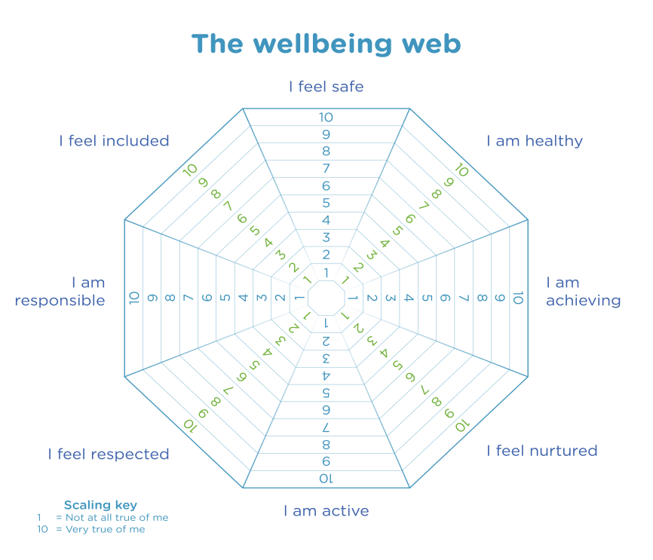

***-***

**My Favourite Subjects**

* Health and Wellbeing
* Literacy
* Numeracy
* Citizenship
* Enterprise
* Creativity
* Sustainable Development
* RME
* Social Studies
* Languages
* Expressive Arts
* Mathematics
* Technologies
* Sciences

**How I will travel to school**

* Bus
* Walk
* Taxi
* Car with family
* Bike
* Scooter

**These are strategies to support me-**

* *What does the young person feel they need? Are there any agencies working with the child? Preferred learning style? Also consult support list.*
* I like to read books to calm down
* I can calm myself in a quiet area
* I sometimes use a fidget toy
* I like to use traffic light faces flip card
* I often run around the building when upset
* **Don’t speak to me when I am trying to calm down**
* I might walk around the grounds if I am upset, staying away from the gates.
* Task and reward system
* I will ask for help when I am confused
* If I ask an adult to move away from me, please listen to me
* I like to listen to calming music.
* I can use social stories,
* I like to use IT equipment for writing.
* When adults are consistent in behavioural approaches
* Give instructions rather than choices when I am anxious
* Verbal time warning for end of task
* Say my name before instructions- get me to repeat instructions back.
* Show me the start and end of tasks.

**Who is at home.**

* I live with mum, dad and my big sister.

**During Lockdown I enjoyed….**

Drawing and painting pictures

Being in the garden

Cooking

**During Lockdown I did not enjoy…**

Feeling worried about high school

Not seeing my friends

Getting frustrated on X box

**These are my medical issues-**

* *Detail any medical issues.*
* ADHD – medicated at home during breakfast and dinner time.
* ASD
* Melatonin at night to sleep