Name Date

**Create a Mini beast**

C:\Users\Fisher\AppData\Local\Microsoft\Windows\Temporary Internet Files\Low\Content.IE5\DAMKSVF9\MC900394622[1].WMFDesign your own mini beast and draw it in the magnifying glass below. Think about how other mini beasts protect themselves from predators, and give your mini beast three special qualities that will help to prevent it being eaten!

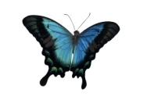

C:\Users\Fisher\AppData\Local\Microsoft\Windows\Temporary Internet Files\Low\Content.IE5\UBLEOONM\MC900436682[1].WMF

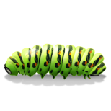

C:\Users\Fisher\AppData\Local\Microsoft\Windows\Temporary Internet Files\Low\Content.IE5\UBLEOONM\MC900346925[1].WMF

My mini beast is special in three ways. These are:

1)

2)

3)