**Playdough**

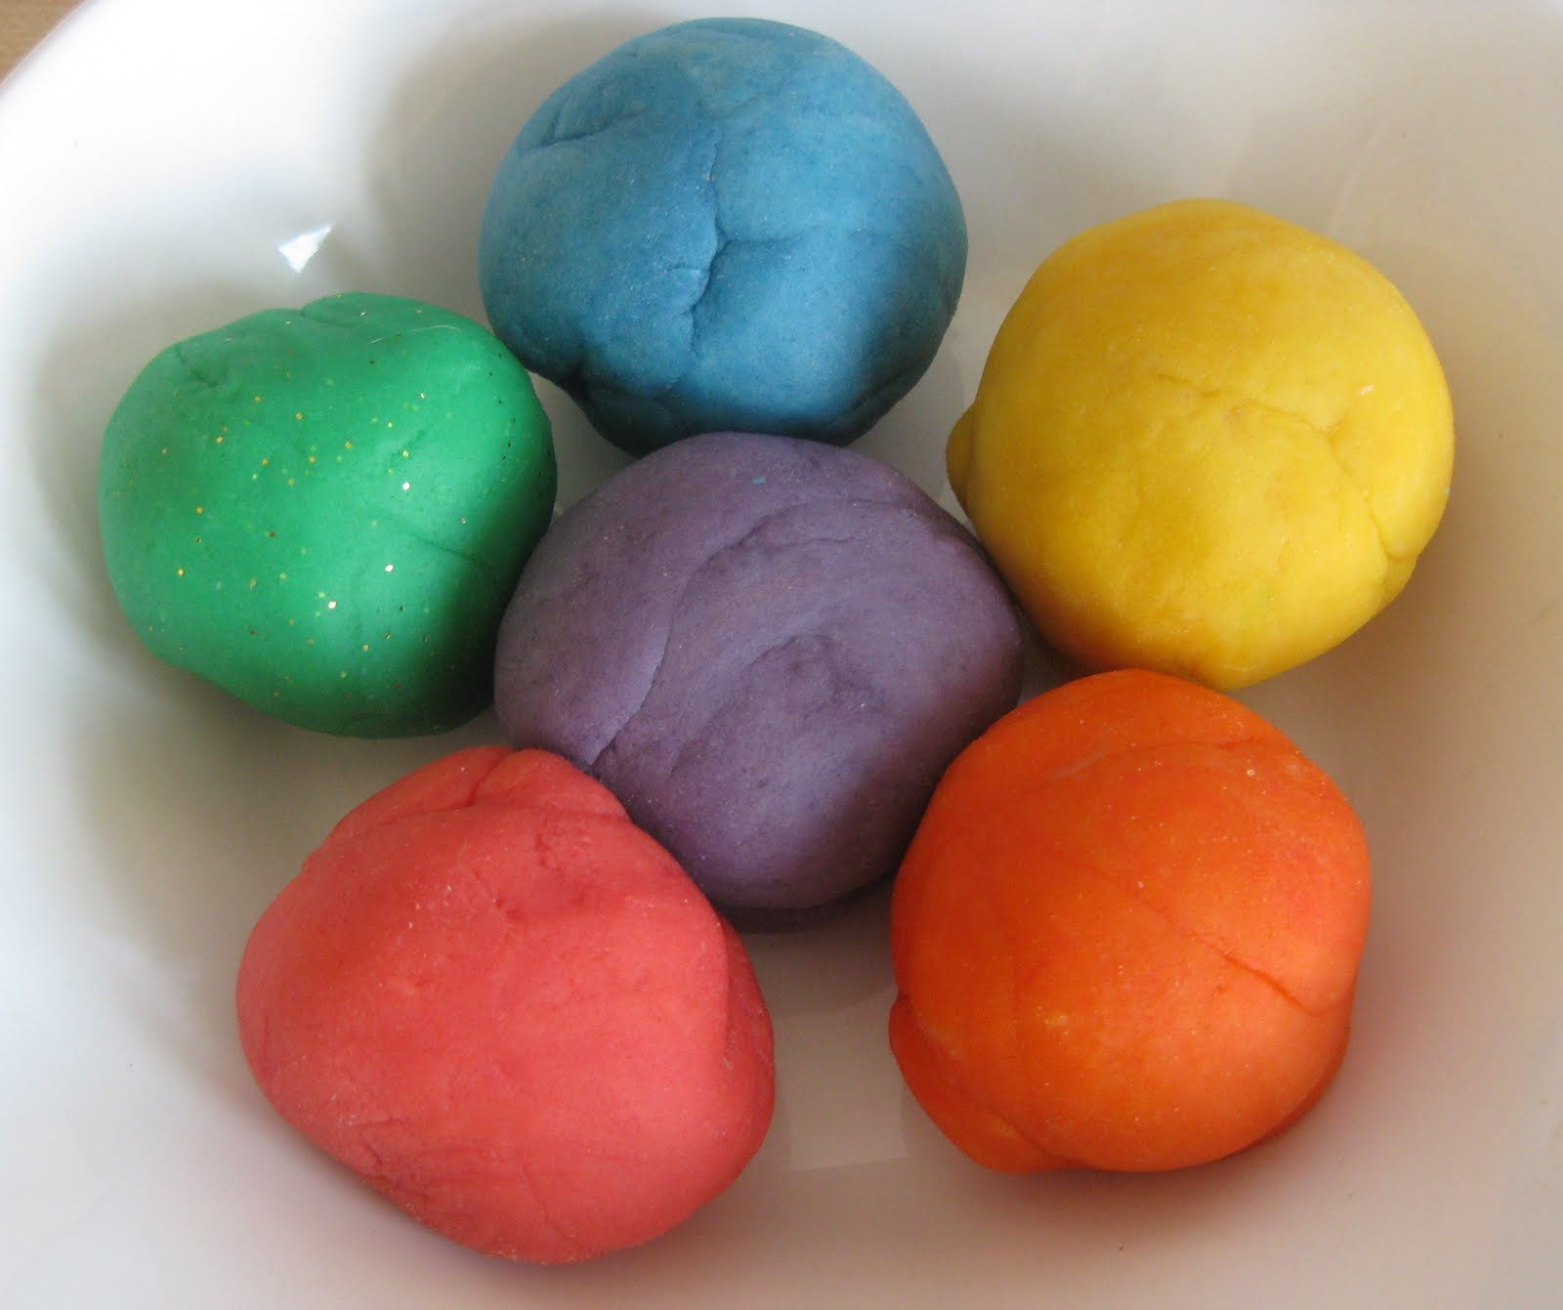

Ingredients:

* 2 cups flour
* I cup salt
* 3 dsp oil
* 1 tspn cream of tartar
* 2 cups water

Method:

1. Put all the ingredients in a pan.
2. Mix well.
3. Add a few drops of food colouring.
4. Cook until dough forms.
5. Allow dough to cool.
6. Store in an airtight container.

Have lots of fun!